 | MINISTRY OF EDUCATION AND TRAINING

FPT UNIVERSITY
Capstone Project Document
Electronic Training Record (ETR)

SU2026-GSU-ETR
Group Members | Nguyen Huu Nhat Trieu – SE170486 (Leader)  Vo Trong Nhan – SE171411 (Member)  Doan Trong Khoi – SE141053 (Member)  Tran Trong Nhan – SE171973 (Member)
Supervisor | Ngo Dang Ha An
Ext Supervisor | —
Capstone Project code | SU26SE104_GSU48

- Ho Chi Minh, August 2026 -

Table of Contents
Acknowledgement 3
Definition and Acronyms 3
I. Project Introduction 4
1. Overview 4
2. Product Background 4
3. Existing Systems 4
4. Business Opportunity 5
5. Software Product Vision 5
6. Project Scope & Limitations 6
II. Project Management Plan 10
1. Overview 10
2. Management Approach 17
3. Project Deliverables 21
4. Responsibility Assignments 22
5. Project Communications 23
6. Configuration Management 24
III. Software Requirement Specification 25
1. Product Overview 25
2. User Requirements 25
3. Functional Requirements 33
4. Non-Functional Requirements 40
5. Requirement Appendix 42
IV. Software Design Description 45
1. System Design 45
2. Database Design 50
3. Detailed Design 52
V. Software Testing Documentation 72
1. Scope of Testing 72
2. Test Strategy 72
3. Test Plan 73
4. Test Cases 74
5. Test Reports 74
VI. Release Package & User Guides 75
1. Deliverable Package 75
2. Installation Guides 75
3. User Manual 78
Appendix A — API Endpoint Reference (main routes) 97
Appendix B — System Administration (Admin portal) 98

Acknowledgement
The project team would like to express our sincere gratitude to FPT University and our supervisor, Ngo Dang Ha An, for the guidance and support provided throughout the capstone project. We also appreciate the efforts of all team members in requirements analysis, project management, software design, implementation, testing, and user-guide preparation. The completion of the Electronic Training Record (ETR) System was made possible through the team’s collaboration and continuous review of the project deliverables.

Definition and Acronyms
Acronym | Definition
ETR | Electronic Training Record
RBAC | Role-Based Access Control
API | Application Programming Interface
JWT | JSON Web Token
ERD | Entity Relationship Diagram
GUI | Graphical User Interface
SRS | Software Requirement Specification
SDD | Software Design Document
SPMP | Software Project Management Plan
UAT | User Acceptance Testing
QA | Quality Assurance
E2E | End-to-End
CRUD | Create, Read, Update, Delete
LMS | Learning Management System
SQL | Structured Query Language
EF Core | Entity Framework Core
CAA | Civil Aviation Authority

I. Project Introduction

1. Overview

1.1 Project Information
- Project name: Electronic Training Record (ETR)
- Project code: SU26SE104_GSU48
- Group name: SU2026-GSU-ETR
- Software type: Web

1.2 Project Team

Full Name | Role | Email | Mobile
Ngo Dang Ha An | Lecturer | anndh@fpt.edu.vn
Nguyen Huu Nhat Trieu | Leader | trieunhnse170486@fpt.edu.vn | 0334796465
Vo Trong Nhan | Member | nhanvtse171411@fpt.edu.vn
Doan Trong Khoi | Member | khoidtse141053@fpt.edu.vn
Tran Trong Nhan | Member | nhanttse171973@fpt.edu.vn

2. Product Background
Currently, aviation training records are managed through a combination of paper documents, Excel spreadsheets, PDF files, and email. Training information is distributed across different files, folders, and locations, making it difficult to search, verify, update, and track records efficiently. This results in problems such as inconsistent data, duplicate or missing documents, limited visibility into training progress, and time-consuming audit preparation.
The Electronic Training Record (ETR) System is proposed as a centralized web-based platform to digitalize and streamline the management of aviation training records. The system supports key training activities, including learner profile management, enrollment, attendance, assessments, training evidence, verification, approval, reporting, and audit tracking.
The project is proposed by an Aviation Training Academy to address the limitations of the current manual process and improve the efficiency, accuracy, traceability, and accessibility of training records. The primary stakeholders include Academic Staff, Instructors, QA Staff, Training Managers, Administrators, Auditors, and authorized Management Viewers.

3. Existing Systems

3.1 Current Manual Process (Paper, Excel, PDF & Email)

Current Manual Process (Paper, Excel, PDF & Email)
- Link: N/A – Offline/manual process
- System Type: Manual and file-based record management
- Description:
Training records are currently managed using paper documents, Excel spreadsheets, PDF files, shared folders, and email. Learner profiles, attendance records, assessment results, and training evidence are stored separately and exchanged between staff or departments through manual processes. There is no centralized system for managing training records, tracking record status, or maintaining a consistent audit history.

Pros
- Familiar process for existing staff
- Does not require specialized software or system implementation
- Can continue operating without dependence on a centralized application

Cons
- Records are distributed across multiple files, folders, and physical locations
- Difficult to search, verify, update, and maintain historical records
- Risk of inconsistent, duplicated, outdated, or missing information
- Limited visibility into learner training progress and record completeness
- Manual coordination is required for verification and approval
- No centralized approval status or workflow tracking
- No consistent audit trail or change history
- Audit and compliance preparation is time-consuming and labor-intensive
- High dependency on individual staff knowledge and file organization

4. Business Opportunity
Currently, aviation training records are managed using a combination of paper documents, Excel files, scanned documents, shared folders, and manual processes. As the number of learners, courses, and training activities increases, managing these records becomes more complex and time-consuming. Staff may face difficulties in tracking learner progress, verifying training evidence, retrieving historical records, and preparing for audits.
The Electronic Training Record (ETR) System provides a centralized platform for managing learner information, course enrollment, attendance, assessment results, training evidence, and approval workflows. By digitalizing the training record process, the system reduces paperwork, improves data accuracy and traceability, and makes training records easier to manage and retrieve.
The ETR System also helps organizations monitor training progress, ensure record completeness, maintain a clear audit trail, and improve the efficiency of compliance reviews and audit preparation. Overall, the system supports the aviation industry's digital transformation by improving operational efficiency, regulatory compliance, and training record management.

5. Software Product Vision
The Electronic Training Record (ETR) System aims to provide a centralized, secure, and efficient platform for managing aviation training records throughout the entire training lifecycle. By replacing fragmented paper-based and manual processes, the system enables training organizations to maintain accurate, complete, and traceable training records while improving operational efficiency, regulatory compliance, and audit readiness.
The vision of the ETR System is to become a reliable digital solution that supports learners, instructors, training staff, quality assurance personnel, and management in maintaining training data with transparency and accountability. Through automation, centralized data management, and standardized workflows, the system helps organizations reduce administrative effort, improve record accessibility, and ensure that training records are always available for operational and compliance purposes.

6. Project Scope & Limitations
This section defines the scope and boundaries of the proposed Electronic Training Record (ETR) System. It identifies the main capabilities included in the project and clearly states the functions that are excluded from the current implementation. This establishes a common understanding among stakeholders and provides a basis for evaluating requirements and future change requests.
Project Scope
The Electronic Training Record (ETR) System is a centralized web-based platform for managing aviation training records and supporting the training record lifecycle from enrollment through completion and approval.
The system includes the following key capabilities:
- User account, role, and access management.
- Learner profile and training history management.
- Course, subject, class, and instructor assignment management.
- Learner enrollment management.
- Electronic Training Record (ETR) creation and management.
- Attendance and training session management.
- Assessment and practical checklist result management.
- Training evidence upload, verification, and management.
- ETR validation, submission, review, and approval workflows.
- Amendment and record correction workflows.
- Dashboard monitoring and training status tracking.
- Reporting and training record export.
- Audit trail and activity history management.
- Certificate status and expiry tracking.
The system supports the operational needs of Academic Staff, Instructors, QA Staff, Training Managers, Administrators, Auditors, and authorized Management Viewers. It is intended to improve the accuracy, traceability, accessibility, and efficiency of aviation training record management while supporting audit and compliance activities.

6.1 Major Features

ID | Role | Module | Feature
F-01 | Administrator | User & Access Management | Manage user accounts, authentication, authorization and RBAC
F-02 | Administrator | System Administration | Manage departments and system configuration
F-03 | Administrator | System Monitoring | View platform statistics, dashboard and action items
F-04 | Administrator | Audit Management | View audit logs and activity history
F-05 | Academic Staff | Learner Management | Create, update, search and maintain learner profiles and training history
F-06 | Academic Staff | Course & Class Management | Manage courses, classes, subjects and instructor assignments
F-07 | Academic Staff | Enrollment Management | Enroll learners into courses/classes and manage enrollment records
F-08 | Academic Staff | Data Import & Export | Import learner/class data and export training-related reports
F-09 | Academic Staff | Learner Monitoring | Track learner training progress and expiring students
F-10 | Instructor | Class Management | View assigned classes and manage training session schedules
F-11 | Instructor | Attendance Management | Record attendance, confirm sessions and calculate attendance rates
F-12 | Instructor | Assessment Management | Record assessment results and practical checklist results
F-13 | Instructor | Training Evidence Management | Upload, download and manage training evidence
F-14 | Instructor | Subject Completion | Publish/sign off subject results
F-15 | QA Staff | Evidence Verification | Verify, reject and bulk-verify training evidence
F-16 | QA Staff | ETR Review | Review, verify and return ETR records for correction
F-17 | QA Staff | Compliance & History | View retake history and search/export training records
F-18 | Training Manager | Training Monitoring | Monitor class status and training dashboard
F-19 | Training Manager | ETR Approval | Approve ETR completion and freeze records
F-20 | Training Manager | Amendment Management | Approve or reject amendment/unlock requests
F-21 | Auditor | Advanced Search | Search learners, courses, classes and ETR records
F-22 | Auditor | Audit Review | View locked ETRs, approval history and audit logs
F-23 | Auditor | Audit Export | Export training record packages for audit/compliance
F-24 | Student / Learner | Personal Training Record | View own ETR status, assessment results and attendance
F-25 | Student / Learner | Certificate Management | View certificate status and validity
F-26 | Student / Learner | Profile Management | View and manage personal profile
F-27 | System | ETR Generation | Automatically generate ETR course records and subject results upon enrollment
F-28 | System | Attendance Calculation | Automatically calculate attendance rates from confirmed sessions
F-29 | System | Retake Tracking | Automatically create and maintain retake history for failed assessments
F-30 | System | ETR Validation | Pre-validate ETR completion requirements before submission
F-31 | System | Record Locking | Freeze completed ETR records and enforce immutability
F-32 | System | Audit Trail | Automatically record system changes, actions, timestamps and actors
F-33 | System | Bulk Import Processing | Validate and commit Excel bulk imports through dry-run workflow
F-34 | System | Export Processing | Generate PDF, Excel and training package export jobs
F-35 | System | Certificate Expiry Tracking | Track certificate expiry and trigger notification emails

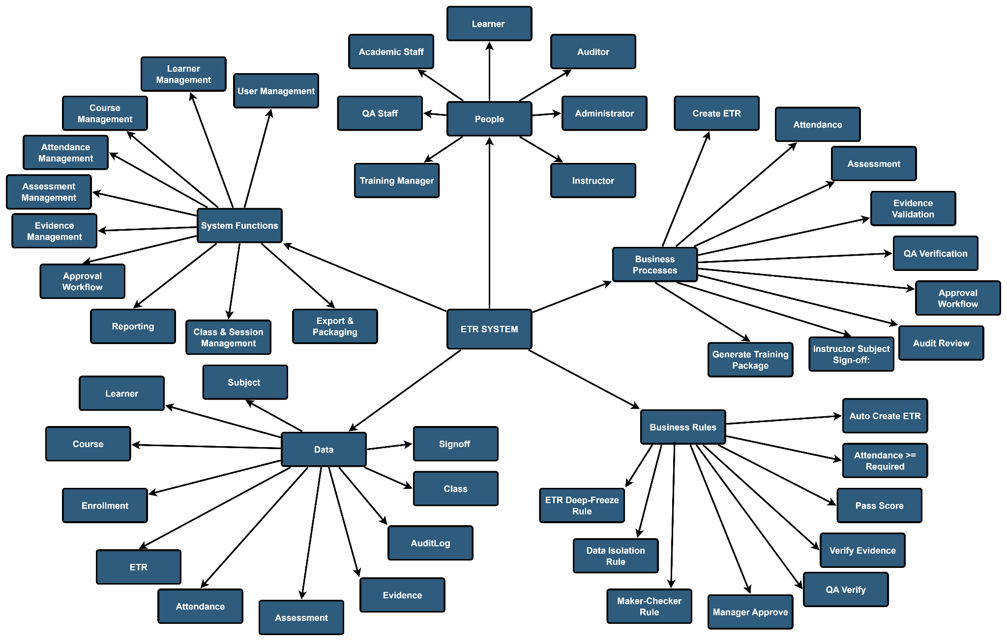
Figure 1-1. System Mind Map

6.2 Limitations & Exclusions
The following functions are outside the scope of the current project:
- Online learning delivery, including e-learning and Learning Management System (LMS) functionality.
- Online examinations and automated examination grading.
- Integration with external aviation authority or regulatory systems.
- Native mobile applications for Android or iOS.
- Advanced analytics, predictive analytics, or AI-based recommendations.
- Learner-side payment processing or online course registration.
- Two-factor authentication (2FA) and advanced security mechanisms beyond the standard authentication and authorization implemented in the system.
Requirements that fall outside the defined scope will not be included in the current implementation. They may be considered as future enhancements or subsequent project phases, subject to business priorities and project constraints.

6.2.1 Limitations
LI-01 – The ETR System is a web-based solution and requires a stable network connection and system availability for users to access its functions.
LI-02 – Learner access is restricted to viewing their own training records, including ETR status, attendance, assessment results, and certificate information, and updating their personal profile. Learners cannot create, modify, verify, or approve official training records.
LI-03 – Legacy training records stored in paper documents, spreadsheets, scanned files, or other existing formats are not automatically migrated into the system. Any required migration must be performed through a separate manual or controlled data-import process.
LI-04 – The accuracy and completeness of training records depend on the quality of data entered by authorized users and the verification of submitted training evidence.
LI-05 – Access to training records and system functions is subject to role-based permissions and the user's assigned responsibilities.

LI-05 – The system requires internet access and service availability.
LI-06 – Record accuracy depends on accurate data entry and evidence verification by staff.

6.2.2 Exclusions
EX-01 – Online learning delivery, virtual classrooms, and Learning Management System (LMS) functionality are excluded.
EX-02 – Online examinations, quiz delivery, and automated grading of examinations are excluded.
EX-03 – Integration with external aviation authorities, airlines, third-party training providers, or external training platforms is excluded.
EX-04 – Payment processing, training fee management, and learner-side course registration are excluded.
EX-05 – Advanced analytics, predictive analytics, and AI-based recommendations are excluded.
EX-06 – Multi-factor authentication (MFA) and advanced enterprise security integrations beyond the implemented authentication and authorization mechanisms are excluded.
EX-07 – Instructor payroll, human resource management, and other staff administration functions are excluded.
EX-08 – Public learner self-registration is excluded. Learner accounts are created and managed by authorized system users.
EX-09 – Native mobile applications for Android and iOS are excluded from the current project scope.

II. Project Management Plan

1. Overview

1.1 Scope & Estimation
The capstone project is planned for approximately 90 calendar days (about 13 weeks). The team uses a phase-based project structure with Agile/Scrum development iterations. For planning purposes, the workload is estimated at 120 person-days across four members. Using 1 person-day = 8 working hours, this corresponds to about 960 team-hours, or roughly 3.7 hours per member per working day over a 5-day working week. This is a planning assumption for an academic project in which members balance capstone work with other academic commitments. The WBS below defines the planned effort and provides a basis for schedule and progress control.

STT | WBS Item | Complexity | Est. Effort (person-days)
1 | Project Initialization | Medium | 5
2 | Define project scope | Simple | 1
3 | Determine project requirements and objectives | Medium | 2
4 | Research existing solutions | Simple | 1
5 | Create Project Introduction document (Report 1) | Simple | 0.5
6 | Review project with mentor | Simple | 0.5
7 | Project Planning | Medium | 5
8 | Create Project Management Plan document (Report 2) | Medium | 2
9 | Set up project management and collaboration tools | Simple | 1
10 | Schedule project meetings and sprint reviews | Simple | 1
11 | Review project plan with mentor | Simple | 1
12 | Project Execution | Complex | 100
13 | Requirement Analysis Phase | Medium | 13
14 | Analyze requirements | Medium | 5
15 | Create Software Requirement Specification | Complex | 6
16 | Review requirements with mentor and stakeholders | Simple | 2
17 | Design Phase | Medium | 12
18 | Create Software Design Document | Medium | 4
19 | Create UI/UX design prototype | Medium | 4
20 | Review software design with mentor | Simple | 1
21 | Database design | Medium | 3
22 | Implementation Phase | Complex | 53
23 | User & Role Management | Medium | 5
24 | Login, Logout, Change Password | Simple | 1
25 | Google Login | Simple | 0.5
26 | Forgot / Reset Password | Simple | 0.5
27 | User Management (CRUD, status) | Medium | 1.5
28 | Role & Permission Management | Medium | 1.5
29 | Learner Management | Medium | 7
30 | Learner CRUD | Medium | 2
31 | Search & Filter Learners | Simple | 1
32 | Learner Training History | Simple | 1
33 | Learner Status Management | Simple | 1
34 | Import / Export Learner and class-roster Data | Medium | 1
35 | Track Expiring Students | Simple | 1
36 | Course & Class Management | Medium | 7
37 | Course Management | Medium | 2
38 | Subject Management | Medium | 2
39 | Class Management | Medium | 1.5
40 | Session Management | Simple | 0.5
41 | Enrollment Management | Simple | 1
42 | Attendance Management | Medium | 6
43 | Attendance Recording | Medium | 2
44 | Confirm Session | Simple | 1
45 | Attendance Statistics | Simple | 1
46 | Attendance Import (Excel) | Medium | 1.5
47 | Attendance Evidence Capture | Simple | 0.5
48 | Assessment Management | Medium | 7
49 | Assessment Creation & Scoring | Medium | 2
50 | Pass/Fail Calculation & PassingScore Snapshot | Medium | 1.5
51 | Practical Checklist Management | Medium | 1.5
52 | Instructor Evaluation & Sign-off | Simple | 1
53 | Retake Management | Simple | 1
54 | Evidence Management | Medium | 5
55 | Upload Evidence Files | Medium | 1.5
56 | Verify / Reject Evidence | Medium | 1.5
57 | Bulk Verify Evidence | Simple | 0.5
58 | Evidence Version Control | Simple | 1
59 | Evidence Type Management | Simple | 0.5
60 | ETR Workflow | Complex | 8
61 | Auto-generate ETR & Subject Results | Medium | 1.5
62 | Submit / Verify / Return ETR | Medium | 2
63 | Approve / Complete ETR (Freeze Data) | Medium | 1.5
64 | Completion Requirements & Pre-validation | Medium | 1.5
65 | Amendment / Unlock Request | Medium | 1.5
66 | Reporting & Dashboard | Medium | 4
67 | Role-based Dashboard | Medium | 1.5
68 | Reports & Export PDF/Excel | Medium | 1.5
69 | Training Package Export | Simple | 1
70 | Audit, Logging & Certificate Tracking | Medium | 1.5
71 | Audit Log | Medium | 0.5
72 | Activity History | Simple | 0.5
73 | Certificate Validity & Grounded Status | Simple | 0.5
74 | Cross-module Integration & Automated Processes | Medium | 2.5
75 | Cross-module integration validation | Medium | 1
76 | Background processing and notification checks | Simple | 0.5
77 | Regression automation and data consistency checks | Simple | 0.5
78 | Locking and audit enforcement validation | Simple | 0.5
79 | Testing Phase | Complex | 20
80 | Prepare Software Test Documentation | Complex | 5
81 | Write and execute unit tests | Complex | 7
82 | Perform integration and system tests | Complex | 5
83 | Perform acceptance testing and defect verification | Medium | 3
84 | Deployment Phase | Medium | 2
85 | Deploy software to application/server environment | Medium | 2
86 | Project Monitoring & Controlling | Medium | 3
87 | Monitor schedule, risks, issues, and changes | Medium | 3
88 | Project Closing | Medium | 5
89 | Prepare user guides, final report, and close project | Medium | 5

1.2 Project Objectives
Quality
STT | Testing Stage | Test Coverage | No. of Defects | % of Defects | Notes
1 | Reviewing | 100% of documents | 0 | 0% | Review of all requirements, design, and code documents.
2 | Unit Test | ≥ 90% code coverage | ≤ 5 major defects | ≤ 2% | Focus on individual module functionality (ETR.Application.Tests).
3 | Integration Test | ≥ 80% of module integrations | ≤ 10 major defects | ≤ 4% | Testing interactions between integrated modules (Enrollment, Attendance, Assessment, ETR).
4 | System Test | ≥ 70% of system functionality | ≤ 10 major defects | ≤ 5% | Ensuring overall system stability and performance.
5 | Acceptance Test | 100% of critical features | ≤ 5 minor defects | ≤ 3% | Final validation against user requirements.

1.3 Project Risks
The main project risks are identified below with their potential impact, likelihood, and planned mitigation actions. Risks are reviewed during weekly project monitoring and updated when conditions change.
STT | Risk Description | Impact | Possibility | Notes
1 | Requirements change or clarification causes rework. | High | Medium | Maintain an approved baseline; refine backlog items during sprint planning and record approved changes.
2 | Incorrect or incomplete training data affects record accuracy and audit readiness. | High | Medium | Use mandatory validation, QA evidence verification, and dry-run validation for bulk imports.
3 | Schedule pressure in a 90-day semester limits contingency time. | High | Medium | Prioritize MUST-have features, track weekly milestones, and reserve the final period for stabilization and acceptance testing.
4 | Frontend, backend, and database integration issues delay development. | Medium | Medium | Use documented API contracts, Swagger/OpenAPI, shared data models, and early integration testing.
5 | Unauthorized access or data leakage affects personal training records. | High | Low | Use JWT authentication, role-based authorization, least-privilege access, input validation, and secure password hashing.
6 | Team member unavailability reduces available capacity. | Medium | Low | Share knowledge, avoid single-owner critical tasks, and reassign work when necessary.

2. Management Approach
The ETR project adopts an Agile (Scrum) software development approach to deliver the system incrementally through short development iterations. The project is divided into several phases, including requirements analysis, system design, implementation, testing, and deployment. Regular progress reviews and testing are conducted throughout development to ensure the system meets the business requirements and quality objectives.

2.1 Project Process
The software development lifecycle combines phase-based planning with Agile development iterations. Requirements and design are baselined early, then implementation, testing, and refinement proceed through short 1-2 week sprints. Each sprint has a defined goal, working increment, review, and defect-fixing activities. Critical changes are prioritized and approved before being added to the active sprint.
Key components:
Requirement Analysis:
The team defines the core requirements and project scope early enough to establish the SRS and implementation baseline. During development, detailed user stories and acceptance criteria are refined as the team receives feedback. Changes are prioritized through the backlog and do not automatically change the approved scope or deadline.
Project Design:
The team prepares the system architecture, database design, API structure, and key UI flows before major implementation. Detailed design decisions may be refined during development when required by validated requirements or technical findings, while maintaining consistency with the approved architecture.
Project Implementation (Development Iterations):
Development is organized into short 1-2 week sprints. Each sprint delivers a selected set of prioritized features, together with unit tests and integration work. Work is distributed among the four members in parallel, subject to dependencies between frontend, backend, and database tasks.
Project Testing:
Testing is performed throughout development and is also consolidated into a dedicated final testing period for system-wide regression and acceptance. Developers perform unit and integration tests during implementation, followed by system and acceptance testing against the approved requirements.
Project Deployment (Incremental Delivery):
The team maintains deployable builds during development and performs controlled deployments for integration and acceptance purposes. The final deployment milestone is completed before project closure, with the backend hosted on Azure App Service, the frontend on Vercel, and the database on Azure SQL Database.
Post-deployment Stabilization:
Within the capstone period, post-deployment work is limited to defect fixing, stabilization, documentation, and minor approved adjustments required for acceptance. New feature requests outside the agreed scope are recorded as future enhancements and are not added to the final delivery without impact assessment.

2.2 Quality Management
Quality management is integrated throughout the project. The team combines preventive practices (requirements and design reviews, coding standards, peer reviews) with verification practices (unit, integration, system, and acceptance testing). Quality gates are applied before baselining major deliverables and before final deployment.
Defect Prevention:
Code Reviews:
Peer Reviews: Pull requests and significant changes are reviewed by another team member before merge or baseline approval.
Coding Standards: The team follows agreed conventions across the ASP.NET Core and React codebases to improve consistency and maintainability.
Reviewing:
Design Reviews:
Approach: Architecture, database, API contracts, and major UI flows are reviewed before implementation and revisited when material changes are introduced.
Requirements Reviews:
Approach: Requirements are reviewed during planning and sprint review activities; approved changes are prioritized and documented before implementation.
Testing:
Unit Testing:
Approach: Developers write tests for core business logic during implementation and execute them as part of the development cycle.
Integration Testing:
Approach: Integration tests validate critical interactions among frontend, API, database, and cross-module business processes.
System Testing:
Approach: System testing is performed on integrated builds during development and expanded into a final regression cycle before acceptance, covering critical role-based workflows and end-to-end ETR processes.
Acceptance Testing:
Approach: Acceptance testing is conducted with the supervisor and designated business representatives to confirm that critical requirements and workflows are satisfied before final delivery.
Documentation:
Test Documentation:
Approach: Test strategy, cases, execution results, defect records, and acceptance evidence are maintained for the project and updated as the system evolves.
Defect Tracking:
Approach: Defects are recorded in GitHub Issues, prioritized by severity and impact, assigned to responsible members, and verified after correction.

2.3 Training Plan

Training Area | Participants | When, Duration | Waiver Criteria
Git, GitHub | All members | week 1 | Mandatory
React + Vite (Frontend) | All members | week 2 - week 6 | Mandatory
ASP.NET Core & EF Core (Backend) | All members | week 2 - week 6 | Mandatory
SQL Server (Azure SQL Database) | All members | week 3 - week 5 | Mandatory
UI/UX Design | Nhan - SE171973 | week 1 - week 5

3. Project Deliverables
The main project deliverables, both internal and external, are listed in the table below with their planned due dates.

STT | Deliverable | When, Duration | Waiver Criteria
1 | Project Introduction (Report 1) | 06/2026 | Project introduction document
2 | Project Management Plan (Report 2) | 06/2026 | Project management plan document
3 | Software Requirement Specification (Report 3) | 07/2026 | Context diagram, use case diagram, functional requirements
4 | Software Design Document (Report 4) | 07/2026 | System architecture, class diagram, sequence diagram
5 | Software Test Documentation (Report 5) | 08/2026 | Test strategy, test plan, test cases
6 | Software User Guides (Report 6) | 08/2026 | Installation guides, user manual guides
7 | Final Project Report | 08/2026 | Include all project documents
8 | Code Package Back-end | 08/2026 | ASP.NET Core source code (ETR_Record_BE)
9 | Code Package Front-end | 08/2026 | React source code (ETR_FE)
10 | Deployed System | 08/2026 | Azure App Service, Azure SQL Database, Vercel

4. Responsibility Assignments
The responsibility assignment matrix below describes the main responsibilities of each team member for the project outputs.
D~Do; R~Review; S~Support; I~Informed; <blank>- Omitted

Responsibility | Nguyen Huu Nhat Trieu (Leader) | Vo Trong Nhan | Doan Trong Khoi | Tran Trong Nhan
Project Introduction (Report 1) | R | D | D | D
Project Management Plan (Report 2) | R | D | D | D
Software Requirement Specification (Report 3) | R | D | D | D
Software Design Document (Report 4) | R | D | D | D
Software Test Documentation (Report 5) | R | D | D | D
Software User Guides (Report 6) | R | D | D | D
Final Project Report | D | D | D | D
Code Package Back-end | D | I | D | I
Code Package Front-end | I | D | I | D
UI/UX design prototype | I | D | I | D
Database Design & Migrations | D | S | D | S

5. Project Communications

Communication Item | Description | When, Frequency | Type, Tool, Method(s)
Supervisor (Lecturer) | Provide document template; instruct the project team; review deliverables; supervise project status; receive project report | Weekly | Zalo / Google Meet
Weekly team meeting | All team members collaborate on mutual tasks; plan the next sprint | Weekly (during class) | Offline / Google Meet
Sprint review & demo | Demo completed features and collect feedback | End of each sprint | Offline / Google Meet
Code review | Review pull requests and ensure code quality | Per pull request | GitHub
Status report | Leader reports overall progress and risks to the supervisor | Weekly | Email / Google Docs
Messages / face-to-face meeting | Share daily progress on project tasks; share current and potential roadblocks | Daily | Zalo

6. Configuration Management

6.1 Document Management
• Document tools: Google Docs, Microsoft Office.
• File management: Google Drive (reports and working documents); project documentation is also versioned in the GitHub repositories (docs/ folder).

6.2 Source Code Management
- Our team uses GitHub to manage the source code version (ETR_Record_BE and ETR_FE repositories), using Git branching and pull requests.

6.3 Tools & Infrastructures

Category | Tools / Infrastructure
Technology | React + Vite (Frontend); ASP.NET Core / .NET 9 (Backend)
Database | SQL Server / Azure SQL Database
IDEs / Editors | Visual Studio Code; Antigravity, OpenAI
Diagramming | Draw.io
Documentation | Microsoft Office; Google Docs/Sheets/Slides
Version Control | GitHub repositories with branches and pull requests
Document Storage | Google Drive with controlled naming/versioning
Deployment | Vercel (Frontend); Azure App Service (Backend); Azure SQL Database

III. Software Requirement Specification

1. Product Overview
The Electronic Training Record (ETR) System is a centralized, web-based platform for managing aviation training records for an aviation training academy. The system digitalizes the training-record process from learner enrollment and training execution through evidence verification, ETR approval, record locking, and audit access.
Currently, training records are managed through paper forms, separate Excel files, scanned documents, shared folders, and email. This creates fragmented records and makes it harder to maintain consistent information, verify evidence, track completion, and prepare records for audit review. The ETR System addresses these problems through a centralized and traceable electronic workflow and is focused on training-record management rather than full Learning Management System (LMS) delivery.
The system supports the training-record lifecycle, including user and role management (RBAC), learner and training-structure management, enrollment with automatic ETR generation, session and attendance management, assessment and practical-checklist results, evidence management and QA verification, subject result publication/sign-off, ETR validation and submission, QA review, final approval and record locking, controlled amendment handling, retake history with carry-over of previously satisfied subjects, dashboards, audit trails, certificate-expiry tracking and notifications, bilingual interface support, and PDF/Excel/training-package exports.
Seven user roles interact with the system: Administrator, Academic Staff (Training Coordinator), Instructor, QA Staff, Training Manager, Auditor, and Student (Learner). Access rights are assigned according to each role’s responsibilities, maintaining separation between training-data entry, quality verification, final approval, system administration, and independent audit access.
The system is implemented as a single-page web application (React) backed by a RESTful API (ASP.NET Core) and a centralized SQL Server database. Evidence files are uploaded directly to Cloudinary, while the backend stores the related evidence metadata. The application is deployed as a web solution and accessed through modern browsers.

2. User Requirements

2.1 Actors
Primary actors

NO | Actor | Description
1 | Administrator | Manages user accounts, roles, departments and system configuration; reviews audit logs and can reopen completed ETR records when a controlled correction is required. records, and can perform administrative overrides (e.g., Admin force unlock) when business rules require it.
2 | Academic Staff (Training Coordinator) | Manages learner profiles, courses, subjects, classes, sessions and enrollments; supports evidence management, ETR submission, imports/exports and certificate-expiry monitoring.
3 | Instructor | Manages assigned classes and sessions; records attendance, assessments and practical-checklist results; publishes subject results and manages training evidence.
4 | QA Staff | Verifies or rejects evidence, reviews submitted ETRs, returns records for correction, and searches/exports training records and audit information.
5 | Training Manager | Monitors training status, performs final ETR approval and locking, and manages amendment/unlock decisions.
6 | Auditor | Performs independent read-only compliance review of locked ETRs, approval history, audit logs, advanced search results and export packages.
7 | Student (Learner) | Views personal ETR status, attendance, assessment results, certificate validity and training history, and manages the personal profile.

2.2 Use Cases

2.2.1 Diagram(s)
The use case diagram groups all system functionality around the eight actors. The core workflow is a chain of custody: Academic Staff creates the learner, course, class and enrollment (which auto-generates the ETR); Instructor records attendance, assessment and evidence, then signs off subject results; QA Staff verifies evidence and the ETR; Training Manager approves and freezes the ETR; Auditor reads the final locked record and exports audit packages; Student views only his/her own records; Management Viewer monitors dashboards; Administrator manages accounts and can force-unlock or reopen records when required.
Use cases are organized into the following groups: (1) Authentication & Account Management; (2) Learner & Organization Management (departments, courses, subjects, classes, sessions, enrollments); (3) Training Execution (attendance, assessment, practical checklists, evidence, subject sign-off); (4) ETR Lifecycle (validation, submission, verification, return, approval, freezing, reopening, force unlock); (5) Amendment Workflow; (6) Quality & Audit (retake history, audit logs, advanced search, dashboards); (7) Reporting & Export; (8) Student Portal.

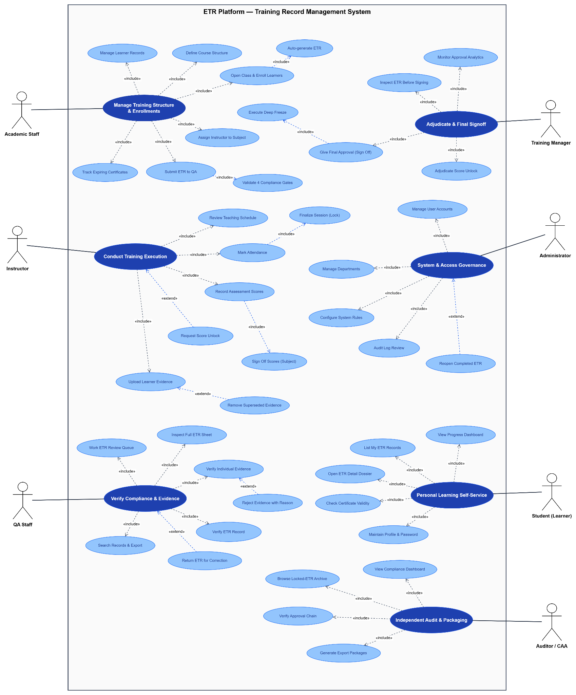
Figure 2-1. Use Case Diagram

2.2.2 Descriptions

ID | Use Case | Primary Actor(s) | Goal | Description
UC-01 | Manage Training Structure & Enrollments | Academic Staff | Oversee academic setups and cohorts. | Central portal use case managing academic programs, cohort classes, student registrations, and submission flows.
UC-02 | Manage Learner Records | Academic Staff | Maintain learner profiles. | Create, search, update, and manage biographical records, student codes, and enrollment histories.
UC-03 | Define Course Structure | Academic Staff | Configure training curriculum. | Define courses, syllabus modules, training hour thresholds, passing marks, and versioned completion criteria.
UC-04 | Open Class & Enroll Learners | Academic Staff | Schedule cohort delivery and enroll trainees. | Create class cohorts, set scheduled timelines, and register learners into classes.
UC-05 | Auto-generate ETR | System (Included) | Generate digital dossier automatically. | Triggered upon learner enrollment to automatically provision master ETR records and subject result shells.
UC-06 | Assign Instructor to Subject | Academic Staff | Allocate teaching faculty. | Assign designated instructors to deliver specific class-subject modules.
UC-07 | Track Expiring Certificates | Academic Staff | Monitor certification validity. | Filter and identify learners whose course certificates are expiring or up for recurrent training.
UC-08 | Submit ETR to QA | Academic Staff | Forward completed dossier for verification. | Submits an ETR dossier to the QA review queue after training delivery concludes.
UC-09 | Validate 4 Compliance Gates | System (Included) | Pre-validate regulatory criteria before submission. | Evaluates attendance rates, passing scores, checklist items, and formal instructor sign-offs before allowing submission.
UC-10 | Conduct Training Execution | Instructor | Deliver classroom and practical training. | Primary entry point for instructors to execute class sessions, attendance, evaluations, and compliance uploads.
UC-11 | Review Teaching Schedule | Instructor | Access personal timetables. | View allocated classes, scheduled sessions, classroom venues, and syllabus milestones.
UC-12 | Mark Attendance | Instructor | Capture learner presence. | Record individual student presence/absence statuses and remarks for scheduled class sessions.
UC-13 | Finalize Session (Lock) | Instructor (Included) | Confirm session completion. | Confirms session delivery and freezes attendance entries, triggering automatic attendance rate recalculation.
UC-14 | Record Assessment Scores | Instructor | Grade student evaluations. | Input component test marks and practical checklist results; automatically registers retake attempts upon failure.
UC-15 | Sign Off Scores (Subject) | Instructor (Included) | Endorse subject completion. | Formally signs off evaluated subject grades, marking the subject result as complete and locking modifications.
UC-16 | Upload Learner Evidence | Instructor | Attach digital proof artifacts. | Upload physical attendance sheets, test papers, and practical rubrics to Cloudinary external storage.
UC-17 | Remove Superseded Evidence | Instructor (Extended) | Clean up invalid upload drafts. | Deletes or replaces obsolete evidence artifacts prior to formal review verification.
UC-18 | Request Score Unlock | Instructor (Extended) | Request post-signoff correction. | Submits an amendment request with formal justification to reopen an already signed-off subject score.
UC-19 | Verify Compliance & Evidence | QA Staff | Audit training integrity. | Dedicated portal use case for quality assurance personnel auditing evidence artifacts and trainee dossiers.
UC-20 | Work ETR Review Queue | QA Staff | Process pending dossiers. | View and claim incoming ETR records submitted by academic staff awaiting compliance review.
UC-21 | Inspect Full ETR Sheet | QA Staff | Review comprehensive dossier. | Examine complete audit sheets including attendance rates, assessment breakdowns, checklist rubrics, and sign-offs.
UC-22 | Verify Individual Evidence | QA Staff | Check uploaded proof artifacts. | Inspect uploaded files against syllabus compliance rules; approve valid digital artifacts.
UC-23 | Reject Evidence with Reason | QA Staff (Extended) | Reject non-compliant files. | Flags invalid or illegible evidence files with mandatory audit comments explaining rejection reasons.
UC-24 | Verify ETR Record | QA Staff | Endorse compliant training dossier. | Formally verifies the ETR after all evidence files and checklist items are verified, forwarding it for manager approval.
UC-25 | Return ETR for Correction | QA Staff (Extended) | Return incomplete dossiers. | Rejects non-compliant dossiers back to Academic/Instructor with detailed corrective action instructions.
UC-26 | Search Records & Export | QA Staff | Audit search and extract records. | Multi-filter search across courses, classes, and trainees with compliance export capabilities.
UC-27 | Adjudicate & Final Signoff | Training Manager | Executive approval and oversight. | Executive portal for monitoring academy throughput, approving final ETR dossiers, and adjudicating exceptions.
UC-28 | Inspect ETR Before Signing | Training Manager | Conduct final executive inspection. | Review dossier history, QA verification notes, and compliance metrics prior to executing formal sign-off.
UC-29 | Monitor Approval Analytics | Training Manager | Track operational KPIs. | View real-time dashboards of pending approvals, verification bottlenecks, and cohort completion trends.
UC-30 | Adjudicate Score Unlock | Training Manager | Decide on amendment requests. | Reviews instructor unlock requests, granting approval to reopen locked subject results or rejecting unjustified changes.
UC-31 | Give Final Approval (Sign Off) | Training Manager | Grant institutional approval. | Executes final endorsement of the verified ETR, transitioning its lifecycle state to Completed.
UC-32 | Execute Deep Freeze | System (Included) | Lock record permanently. | Automatically sets IsLocked = true, enforcing immutability across the completed dossier and all child results.
UC-33 | Personal Learning Self-Service | Student (Learner) | Track individual training progress. | Trainee portal use case for accessing personal training milestones, attendance summaries, and dossier statuses.
UC-34 | View Progress Dashboard | Student (Learner) | Monitor training metrics. | View active enrolled courses, cumulative attendance percentages, and upcoming session schedules.
UC-35 | List My ETR Records | Student (Learner) | Access personal dossiers. | Browse all historical and current ETR records associated with the learner's account.
UC-36 | Open ETR Detail Dossier | Student (Learner) (Included) | Inspect personal results sheet. | View read-only breakdown of completed subjects, assessment scores, sign-off timestamps, and dossier states.
UC-37 | Check Certificate Validity | Student (Learner) | Verify credentials. | View certificate status, issued dates, and expiry countdowns for completed training courses.
UC-38 | Maintain Profile & Password | Student (Learner) | Manage account details. | Review biographical profile data, verify contact details, and update login credentials.
UC-39 | System & Access Governance | Administrator | Platform administration and security. | Administrative portal managing user identity lifecycles, institutional departments, security parameters, and audit trails.
UC-40 | Manage User Accounts | Administrator | Administer accounts and RBAC. | Create, update, view, and deactivate user accounts, linking accounts to system roles and organizational units.
UC-41 | Manage Departments | Administrator | Structure organizational units. | Create and maintain academic and operational departments within the training academy.
UC-42 | Configure System Rules | Administrator | Manage platform settings. | Maintain completion requirement templates, global thresholds, and application system parameters.
UC-43 | Audit Log Review | Administrator | Inspect system activity trails. | Filter and review immutable audit log records tracking critical data operations, actors, IP addresses, and timestamps.
UC-44 | Reopen Completed ETR | Administrator (Extended) | Exceptional administrative override. | Controlled override allowing an administrator to reopen a frozen ETR upon formal institutional review.
UC-45 | Independent Audit & Packaging | Auditor / CAA | Regulatory compliance auditing. | Dedicated portal for internal quality auditors and civil aviation inspectors to audit locked archives and extract packages.
UC-46 | View Compliance Dashboard | Auditor / CAA | Monitor compliance statistics. | High-level analytics tracking locked vs active dossiers, verification pass rates, and regulatory compliance metrics.
UC-47 | Browse Locked-ETR Archive | Auditor / CAA | Inspect immutable dossiers. | Read-only access to historical archives of deep-frozen ETR dossiers and verified evidence files.
UC-48 | Verify Approval Chain | Auditor / CAA | Trace decision accountability. | Review sequential approval histories, reviewer identities, timestamps, and justification remarks.
UC-49 | Generate Export Packages | Auditor / CAA | Export audit dossier packages. | Request asynchronous generation of complete audit dossier packages (PDF/Excel) for regulatory inspections.

3. Functional Requirements

3.1 System Functional Overview

3.1.1 Screens Flow
The application is a single-page web application. After login, the user lands on the role-based dashboard, from which each module is reached through the navigation menu. The primary flows are:
- Authentication flow: Login → role-based Dashboard → module screens. Token expiry returns the user to the Login screen.
- Learner & organization flow: Learner/Course/Subject/Class/Session management → Enrollment → automatic ETR generation.
- Training execution flow: Session scheduling → Attendance recording/import → Assessment recording/import → Evidence upload → Subject sign-off.
- Quality flow: QA Dashboard → Evidence verification → ETR review → Return for correction / Verify → Training Manager approval → Completed (frozen).
- Correction flow: Completed/locked record → Amendment request → Training Manager/Admin approval → Unlock → Re-edit → Re-verify → Re-approve.
- Audit & export flow: Advanced search → ETR detail / Audit log → Export job creation → Job list → Download package.
- Student flow: Student Dashboard → View ETR status / results / certificates → Update profile.

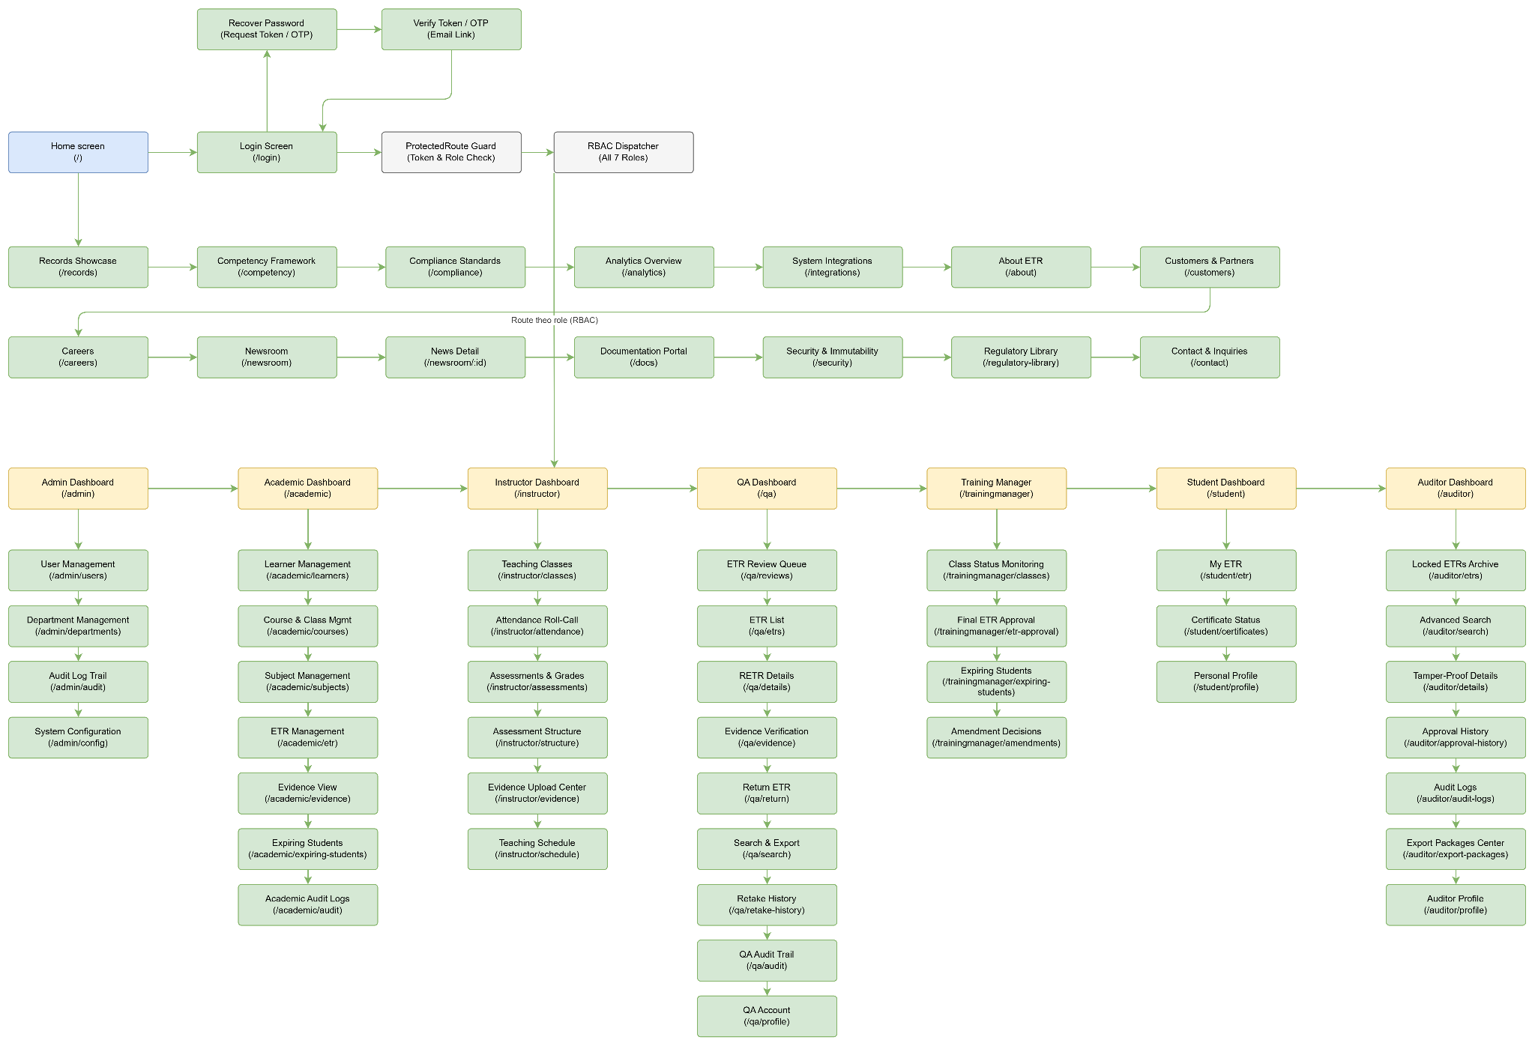
Figure 3-1. Screens Flow Diagram
Screens are guarded by role-based authorization (see 3.1.3); the same URL renders role-appropriate actions and hides unauthorized controls.

3.1.2 Screen Descriptions

NO | Feature | Screen | Description
1 | User Authentication | Login & Reset Password Screen | Allows users to log in and request password recovery (token/OTP via email) with validation feedback.
2 | Dashboard | Role-Based Dashboard Screen | Provides role-specific statistics, pending actions and training status using live system data.
3 | User Profile | Profile Screen | Displays the signed-in user's profile information, role and account details.
4 | User Profile | Change Password Screen | Allows authenticated users to change their own password after verifying the current password.
5 | User Administration | User Management Screen | Administrator creates, updates and deactivates accounts, assigns roles/departments, and bulk-imports accounts through the validate-then-commit Excel flow (/Import/accounts).
6 | Organization | Department Management Screen | Administrator creates, updates and views departments.
7 | Learner Management | Learner List / Profile Screen | Academic Staff creates, views, updates and searches learner profiles and training history.
8 | Course Management | Course Management Screen | Academic Staff creates and updates courses and their training structure.
9 | Course Management | Subject Management Screen | Academic Staff creates, updates and views subjects, associates them with courses, and configures the passing score and minimum attendance rate for each subject.
10 | Class Management | Class Management Screen | Academic Staff creates and updates classes, assigns instructors by subject and monitors class status (Scheduled / In Progress / Completed).
11 | Enrollment Management | Enrollment Screen | Academic Staff enrolls learners into classes; successful enrollment automatically creates the ETR and subject-result records.
12 | Enrollment Management | Classes & Roster Import Screen | Academic Staff imports class and learner-roster data from Excel using the validate-then-commit flow (/import/classes-roster).
13 | Attendance Management | Attendance Recording Screen | Instructor records attendance per session for assigned classes (Present / Absent / Excused) and confirms sessions.
14 | Attendance Management | Attendance Import Screen | Instructor bulk-imports attendance from Excel with dry-run validation before commit.
15 | Assessment Management | Assessment Recording Screen | Instructor records theory scores and practical-checklist results; a retake must be authorized by an account different from the one recording the score, and published results become immutable.
16 | Assessment Management | Assessment Import Screen | Instructor bulk-imports assessment results from Excel with dry-run validation before commit.
17 | Evidence Management | Evidence Upload Screen | Instructor and Academic Staff upload supported evidence files (stored on Cloudinary) linked to subject results.
18 | Evidence Verification | Evidence Verification Screen | QA Staff verifies or rejects evidence; rejection requires a reason and verified evidence is immutable.
19 | ETR Management | ETR List / Search Screen | Authorized users locate ETR records according to their role permissions and filters.
20 | ETR Management | ETR Detail / Checklist Screen | Shows completion requirements, attendance, results, evidence, approval history and current status.
21 | ETR Workflow | Submit ETR Screen | Academic Staff submits an ETR after completion requirements are pre-validated.
22 | ETR Workflow | ETR Review Screen | QA Staff verifies a Submitted ETR or returns it for correction with a mandatory reason.
23 | ETR Workflow | Approval Screen | Training Manager performs final approval and locks the class/ETR; authorized Admin users may also use the Training Manager portal.
24 | Correction Workflow | Amendment Management Screen | Training Manager reviews and decides pending amendment/unlock requests.
25 | Correction Workflow | Reopen ETR Screen | Administrator reopens a Completed/Locked ETR with a recorded reason; the action is written to the Audit Trail.
26 | Quality | Retake History Screen | Shows automatically generated retake records for failed assessments, including score changes and authorization details, to authorized roles.
27 | Audit | Audit Trail Screen | Displays the append-only history of critical actions with timestamps and actors.
28 | Search | Advanced Search Screen | Provides Auditor-focused multi-criteria search across learners, courses, classes and locked ETR records.
29 | Export | Export Center Screen | Authorized users create export jobs, monitor status and download completed outputs (QA Search & Export and Auditor Export Packages).
30 | Student Portal | Student ETR / Certificate Screen | Student views own ETR status, results, attendance, certificate validity and training history in read-only mode, including carried-over versus retake-required subjects.
31 | Management | System Configuration Screen | Administrator maintains global parameters (security/token policies, maximum retake attempts, notification gateway), while subject-level passing scores, attendance minimums and practical-checklist templates are configured by authorized academic users.

3.1.3 Screen Authorization
ADM = Administrator AST = Academic Staff INS = Instructor MGR = Training Manager QA = QA Staff AUD = Auditor VIW = Management Viewer STD = Student

Screen / Screen Activity | ADM | AST | INS | MGR | QA | AUD | STD
Login & Reset Password | X | X | X | X | X | X | X
Role-Based Dashboard | X | X | X | X | X | X | X
User Profile | X | X | X | X | X | X | X
└ Change Password | X | X | X | X | X | X | X
User Management | X
└ Create / Update / Deactivate User | X
└ Assign Role | X
Department Management | X
Learner Management |  | X
└ View Learner |  | X | X | X | X | X
└ Search Learner |  | X | X | X | X | X
Course Management |  | X
└ View Course |  | X | X | X | X | X
Subject Management |  | X
Class Management |  | X
└ View Class |  | X | X | X | X | X
Session Management |  | X | X
Enrollment Management |  | X
└ View Enrollment |  | X | X | X | X | X
Classes & Roster Import |  | X
Attendance Recording |  |  | X
└ Confirm Session |  |  | X
└ Import Attendance (Excel) |  |  | X
└ View Attendance |  | X | X |  | X | X
Assessment Recording |  |  | X
└ Practical Checklist Result |  |  | X
└ Import Assessment (Excel) |  |  | X
└ View Assessment |  | X | X |  | X | X
Evidence Upload |  | X | X
└ View / Download Evidence |  | X | X |  | X | X
Evidence Verification |  |  |  |  | X
└ Bulk Verify |  |  |  |  | X
Subject Sign-off |  |  | X
ETR List / Search / Detail |  | X |  | X | X | X
└ View ETR Checklist |  | X |  | X | X | X
Submit ETR |  | X
Verify ETR |  |  |  |  | X
Return ETR for Correction |  |  |  |  | X
Approve ETR (Complete/Freeze) | X |  |  | X
Reopen ETR | X
Amendment Management |  |  |  | X
└ Approve / Reject Amendment |  |  |  | X
Retake History | X | X | X | X | X
Advanced Search |  |  |  |  |  | X
Audit Trail | X | X |  |  | X | X
Reports & Dashboard Analytics | X | X | X | X | X | X | X
Export Center (Export Jobs) |  | X |  |  | X | X
└ Download Export Package |  | X |  |  | X | X
Student Portal (Own ETR / Certificates) |  |  |  |  |  |  | X
Completion Requirements | X | X |  | X
Evidence Types / Practical Checklists | X | X
└ Language Switch / Activity Feed | X | X | X | X | X | X | X

3.1.4 Non-Screen Functions

NO | Feature | System Function | Description
1 | Enrollment Management | Auto-Generate ETR | Automatically creates the learner ETR course record and subject results when an enrollment succeeds.
2 | Attendance Management | Attendance Rate Calculator | Recalculates attendance from confirmed sessions and flags learners below the 80% threshold.
3 | Assessment Management | Retake History Generator | Creates retake-history entries for failed assessments and carries forward previously satisfied subjects according to the retake rules.
4 | ETR Validation | Completion Validator | Checks mandatory submission requirements including attendance, subject status, sign-off, evidence and practical-checklist completion.
5 | Evidence Management | Missing Evidence Checker | Identifies missing mandatory evidence and reflects the result in the ETR completion checklist.
6 | Evidence Management | File Validation | Validates supported evidence formats and the maximum 10 MB file size.
7 | Workflow Management | ETR Status Workflow | Enforces valid ETR transitions: Draft → Submitted → Verified → Completed/Locked, with Return for Correction and Admin Reopen transitions.
8 | Approval Management | Freeze Completed ETR | Locks approved ETR data and prevents normal mutations after completion.
9 | Correction Management | Amendment Request Processor | Tracks controlled amendment/unlock requests for signed-off results and their decisions before final ETR completion.
10 | Audit Management | Audit Trail Logger | Records critical actions with actor, action and timestamp, including create, update, submit, verify, approve, reject, lock, unlock, import and export.
11 | Security | Role-Based Access Control | Enforces role permissions on screens, functions and API access; Auditor access is read-only.
12 | Import Management | Excel Import with Dry-Run | Validates attendance, assessment, account, and class/roster Excel imports before committing valid data.
13 | Export Management | Export Job Generator | Creates PDF, Excel and training-package export jobs and tracks their status.
14 | Certificate Management | Certificate Expiry Tracker | Tracks certificate validity and classifies certificates as Valid, Expiring Soon or Expired; expiry notifications use the configured schedule.
15 | Dashboard | Dashboard Statistics Generator | Provides role-specific dashboard statistics from live system data.
16 | Search | Advanced Search | Provides multi-criteria search for the Auditor compliance repository and supporting operational search functions where available.
17 | Cross-Cutting UX | Language & Activity Support | Persists Vietnamese/English language preference and exposes recent user activity through the notification/activity feed.

3.1.5 Entity Relationship Diagram

The core data model is centered on the ETR_Course_Record. The main entities and their relationships are:
- Account (User) – 1:1 – UserProfile (learner/staff profile); 1:N – AuditLog; 1:N – ApprovalHistory; 1:N – ExportJob.
- Department – 1:N – Account / UserProfile.
- Course – 1:N – Subject (via course subjects); 1:N – Class; a Course must have Subjects before enrollment.
- Class – 1:N – Session; 1:N – Enrollment; 1:N – ClassSubject (assigns InstructorAccountId per subject).
- Enrollment – N:1 – Class; N:1 – Account (learner); 1:1 – ETR_Course_Record (auto-generated on enrollment).
- ETR_Course_Record – 1:N – SubjectResult; 1:N – EvidenceFile; 1:N – ApprovalRequest; 1:N – ApprovalHistory; 1:N – AuditLog (ETRRecordId); 1:N – ExportJob (optional); has Status (Draft/Submitted/Verified/Completed/ReturnedForCorrection/Cancelled), IsLocked, ExpiryDate, CompletedAt.
- SubjectResult – N:1 – ETR; N:1 – Subject; holds AttendanceRate and Status (evaluated/signed-off); 1:1 – SubjectSignoff (optional).
- Assessment / PracticalChecklist – 1:N – AssessmentResult / PracticalChecklistResult (per learner).
- EvidenceFile – N:1 – ETR_Course_Record; N:1 – EvidenceType; N:1 – Account (uploader); has VerificationStatus (Verified/Rejected).
- ApprovalRequest – 1:N – ApprovalHistory (Submit/Review/Verify/Approve/Reject/Return with ActionAt and ActionByAccountId).
- AmendmentRequest – N:1 – SubjectResult/ETR; N:1 – Account (requester); decided by Training Manager/Admin.
- RetakeHistory – N:1 – SubjectResult/ETR; created automatically for failed assessments.
- CompletionRequirement – N:1 – Course/Subject; defines the mandatory checklist applied during ETR validation.
- ExportJob – N:1 – Account (requester); optional N:1 – ETR; tracks ExportType, Status, RequestedAt, CompletedAt.
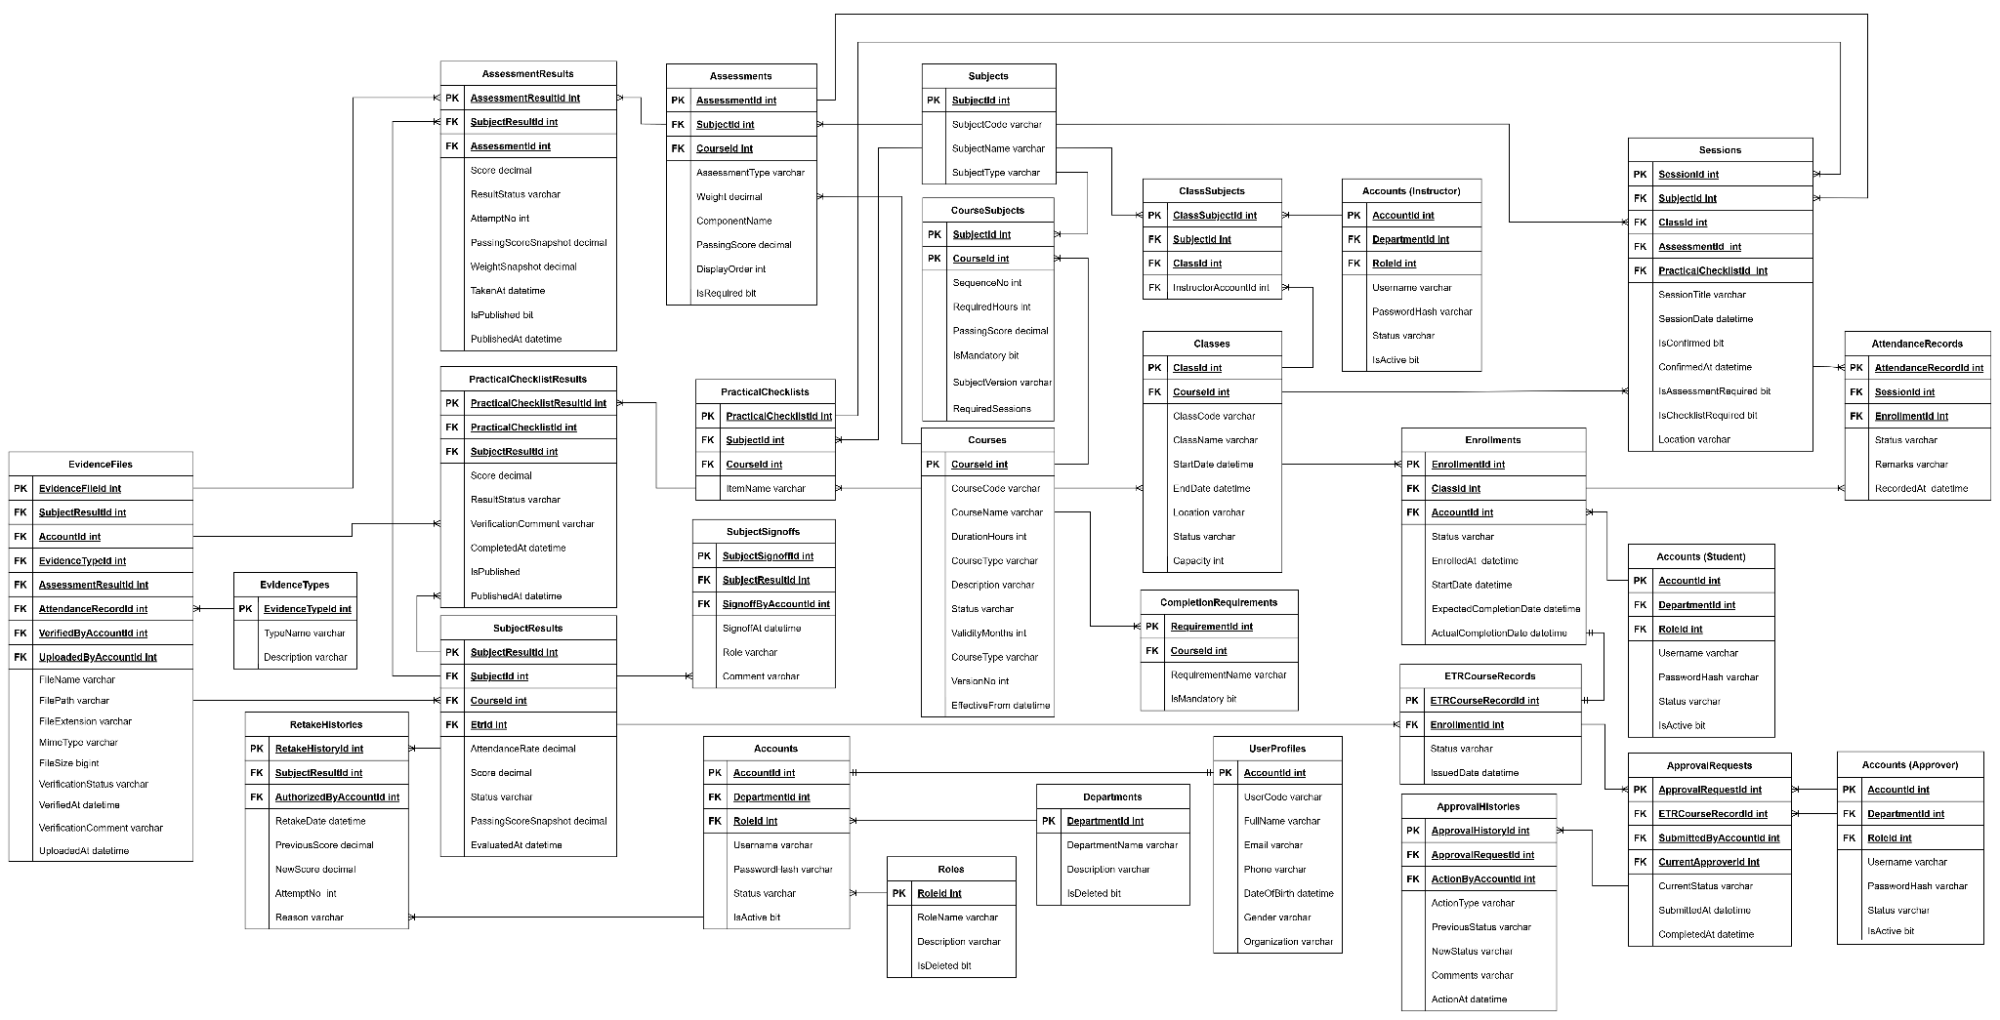
Figure 3-2. Entity Relationship Diagram
Integrity rules: an ETR is Completed only after verification and approval; approved ETRs are frozen (IsLocked) and become read-only; every state transition is persisted in ApprovalHistory and AuditLog to guarantee a full audit trail.

4. Non-Functional Requirements

4.1 External Interfaces

Interface | Description
Web Browser | The system is accessed through modern evergreen web browsers.
REST API | The React frontend communicates with the ASP.NET Core backend through HTTPS/JSON and JWT bearer authentication.
Cloudinary Upload API | Evidence files are uploaded directly from the browser to Cloudinary; the backend stores the resulting evidence metadata and URL.
SMTP / Email Service | The backend sends account-related and certificate-expiry notifications; email failures do not roll back the primary transaction.
Excel Import Interface | Attendance, assessment, account and class/roster data can be imported through validate-then-commit Excel flows.
File Export Interface | The system creates tracked PDF, Excel and training-package export jobs.
SQL Server Database | Training and workflow data are stored in a centralized relational SQL Server database.

4.2 Quality Attributes

Quality Attribute | Specification
Availability | The application should remain usable during normal operation and show a clear error state when backend services are unavailable.
Performance | API requests use a 20-second timeout (12 seconds for authentication); large lists are paginated and dashboards use aggregated live data.
Reliability | Critical actions preserve data integrity; failures show controlled error states rather than blank screens or crashes.
Security | JWT authentication, role-based route guards and backend authorization enforce permissions. Auditor access is read-only and destructive actions require confirmation or a reason.
Usability | Interfaces are role-oriented, provide clear outcome messages, support search/filtering and provide meaningful loading, empty and error states.
Maintainability | The application is organized into role-based modules and shared utilities, with automated tests available for supported modules.
Portability | The application targets modern evergreen browsers and is deployed as a web-based SPA.
Data Integrity | Validation prevents incomplete records from being submitted or approved; grading configuration is snapshotted and completed ETRs are immutable.
Auditability | Critical actions are recorded in an append-only audit trail and forbidden access attempts are flagged.
Localization | The interface supports Vietnamese and English with a persisted language preference.

4.2.1 Usability

US-01: The system shall provide role-oriented navigation and dashboards so users see functions relevant to their responsibilities.
US-02: Validation and business-rule errors shall be presented clearly; raw exceptions shall not be shown as the primary user feedback.
US-03: Search and filtering shall be available on major management and audit screens.
US-04: The interface shall support Vietnamese and English with a persisted language preference.
US-05: Major list and dashboard screens shall provide clear loading, empty and error states.
US-06: Interactive controls shall have clear labels and accessible names for icon-only actions.
US-07: The web interface shall support the target modern browser environment and project-defined responsive layouts.

4.2.2 Reliability

ID | Reliability Requirement
RE-01 | The system shall show a controlled error state when an API or list request fails, without crashing the page.
RE-02 | Required data shall be validated before save, import, submission or approval.
RE-03 | Completed/Locked ETR data shall remain immutable until the controlled Admin reopen path is used.
RE-04 | Critical actions shall be recorded in the audit trail with timestamp and actor information.
RE-05 | Email notification failures shall not roll back or fail the primary business transaction.
RE-06 | Excel bulk imports shall validate in dry-run mode before valid rows are committed.

4.2.3 Performance

ID | Performance Requirement
PE-01 | API requests shall use a 20-second timeout; authentication requests shall use a 12-second timeout.
PE-02 | List views shall use pagination rather than rendering unbounded result sets.
PE-03 | Role dashboards shall load summary metrics from the designated aggregated dashboard endpoint.
PE-04 | Export operations shall run as tracked jobs so users can monitor completion instead of blocking on long-running downloads.
PE-05 | Excel import validation shall run as a dry-run before commit so invalid rows are identified before data changes are applied.
PE-06 | Evidence files shall be uploaded directly to the configured evidence-storage provider rather than passing file bytes through the backend API.

5. Requirement Appendix

5.1 Business Rules

ID | Rule Definition
BR-001 | The minimum attendance rate for each subject required to submit an ETR is 80%.
BR-002 | The maximum number of assessment attempts allowed (including retakes/reassessments) is 3 attempts.
BR-003 | The attendance grace period after the class session date is 48 hours.
BR-004 | A learner cannot enroll if their user profile is incomplete.
BR-005 | A learner cannot enroll in the same class more than once.
BR-006 | A learner can have only one active ETR per course — an enrollment request is rejected if the learner is already in an active class of that course with an incomplete ETR.
BR-007 | A course must have at least one configured subject before a learner can enroll.
BR-008 | An enrollment record with an ETR in Completed/Locked status cannot be deleted.
BR-009 | Creating an enrollment record automatically creates the learner's ETR; there is no manual ETR creation process.
BR-010 | The class code must be unique; class codes belonging to soft-deleted classes may be reused.
BR-011 | A class cannot be marked as Completed while there are still unconfirmed attendance sessions.
BR-012 | The assigned InstructorAccountId must reference an account with the Instructor role.
BR-013 | Instructors are assigned per subject within a class through InstructorAssignments , rather than to the entire class.
BR-014 | The course code must be unique; codes belonging to soft-deleted courses may be reused.
BR-015 | A subject can be assigned to the same course only once.
BR-016 | Changing the course's ValidityMonths increases the VersionNo, allowing already-enrolled learners to continue being assessed against the previous course version.
BR-017 | The class start date and end date are required — the system defaults them to Today / Today + 30 days on the Frontend when they are left blank.
BR-018 | Assessment results are evaluated using the PassingScoreSnapshot recorded at the time of enrollment, not the current CourseSubject.PassingScore. Configuration changes do not retroactively affect already-enrolled learners.
BR-019 | The assessment Weight used for calculation is stored as a snapshot when the result is first recorded.
BR-020 | The result is considered Passed when score >= passingScore; an Exempted result is also considered to satisfy the completion requirement.
BR-021 | A published assessment result cannot be updated or republished.
BR-022 | Each assessment allows a maximum of 3 attempts (BR-002); any subsequent retake attempt is rejected.
BR-023 | A retake must be authorized by an account different from the account that entered the score; self-authorization is not allowed.
BR-024 | Recording an assessment result requires the learner to be currently enrolled in a class belonging to the assessment's course.
BR-025 | Attendance can only be recorded within 48 hours after the session date (BR-003); attendance recorded after this period requires intervention by Academic Staff.
BR-026 | Once the attendance record for a session has been finalized/confirmed, it becomes read-only and cannot be modified or deleted.
BR-027 | There must be exactly one attendance record per (session, enrollment); duplicate attendance records are rejected.
BR-028 | Attendance can only be recorded for a learner enrolled in the corresponding class.
BR-029 | Learners with an attendance rate below 80% are automatically displayed in the Low Attendance Monitoring list on the dashboard and Academic Staff/TM screens.
BR-030 | Each subject result must be signed off by the assigned instructor before the ETR can be submitted.
BR-031 | A request to adjust/reopen a signed-off result must include a reason.
BR-032 | Adjustment requests apply only to signed-off results; unsigned results can be edited directly. Adjustments are allowed only before the ETR reaches Completed status. Completed ETR records must go through the Admin Reopen process.
BR-033 | Only one pending adjustment request is allowed for each subject result at any given time.
BR-034 | Rejecting an adjustment request requires a comment; a decided request cannot be modified afterward.
BR-035 | A request to unlock a published result is redirected to the Training Manager.
BR-036 | Evidence files are uploaded directly from the browser to Cloudinary; the backend receives only JSON metadata (URL, publicId, fileName, mimeType, fileSize) and never receives file bytes.
BR-037 | Only the following file formats are allowed: .jpg, .jpeg, .png, .gif, .webp, .pdf, subject to the MIME-type whitelist. The Frontend blocks invalid files before any network request is made.
BR-038 | The stored fileUrl must be an absolute HTTPS URL.
BR-039 | Evidence is associated with the learner through SubjectResultId, rather than directly through the ETR ID.
BR-040 | Verified evidence is immutable and cannot be deleted by any role.
BR-041 | Evidence associated with a Completed/Locked ETR cannot be Verified or Rejected (ETR Locked).
BR-042 | Rejecting evidence requires a VerificationComment, and the reason is displayed to the uploader.
BR-043 | File downloads redirect to the Cloudinary URL. When exporting an evidence ZIP for an Auditor, unavailable files are skipped with a warning instead of causing the entire export process to fail.
BR-044 | ETR Submission Condition – Step 1: The learner's personal information/profile must be complete.
BR-045 | ETR Submission Condition – Step 2: The attendance rate for every subject must be at least 80% (BR-001).
BR-046 | ETR Submission Condition – Step 3: All subject results must have been signed off by the instructor.
BR-047 | ETR Submission Condition – Step 4: All evidence files must be Verified — at least one evidence file must be linked, and no evidence file may remain pending.
BR-048 | ETR Submission Condition – Step 5: All required subjects must be Passed or Exempted.
BR-049 | ETR Submission Condition – Step 6: All required practical checklists must be signed off and have a score greater than or equal to the passing threshold.
BR-050 | ETR Submission Condition – Step 7: The completion-condition processor must confirm that all specified mandatory requirements have been satisfied.
BR-051 | Only the following ETR status transitions are allowed: Submitted → Verified, Submitted → ReturnedForCorrection, and Verified → Completed. All other transitions are rejected.
BR-052 | Each ETR submission creates a new ApprovalRequest; previous requests are not modified. Only requests with Pending status can be updated or deleted.
BR-053 | Rejecting or returning an ApprovalRequest requires a comment.
BR-054 | When an ETR is approved, it transitions to Completed, IsLocked is set to true, a certificate is issued, and an audit log entry is created. A locked ETR rejects all modification operations.
BR-055 | Only an Admin can reopen a locked ETR, and a reason must be provided.
BR-056 | The Reopen operation can only be performed on ETR records that are currently locked.
BR-057 | The Username must be unique.
BR-058 | A user cannot deactivate or delete their own account, whether through soft deletion or hard deletion.
BR-059 | The department assigned to an account must exist in the system.
BR-060 | The account-creation notification email is sent after successful account creation; email delivery failure does not roll back or fail the account creation operation.
BR-061 | Login validation requires Username ≥ 3 characters and Password ≥ 6 characters. An unknown or expired token automatically causes the login session to be deleted.
BR-062 | The user's role determines their permissions and Portal routing. Admin and Training Manager share the TM Portal, while Auditor has GET-only/read-only access.
BR-063 | Name/code/email must be unique among active records for each entity; values from soft-deleted records may be reused.
BR-064 | Completing an ETR issues a certificate whose expiration date is calculated based on the course's versioned validity period snapshot.
BR-065 | Certificate-expiration notifications are automatically sent 3 days, 7 days, and 1 month before expiration.
BR-066 | Consecutive certificates are linked through PreviousRecordId, forming a verifiable certificate history.
BR-067 | The Auditor Portal does not support write/update/delete operations and is strictly GET-only/read-only. When exporting an evidence ZIP from Cloudinary, unavailable files are skipped with a warning.
BR-068 | Destructive or irreversible actions such as delete, soft delete, complete, sign-off, reopen, and return require explicit confirmation or a reason before execution.
BR-069 | All critical actions are recorded in an immutable, append-only audit trail, including the actor, action, timestamp, and old → new values. Denied access attempts are also logged as warnings.
BR-070 | Dashboards display live data directly from APIs; hard-coded or simulated statistics are prohibited. When an API error occurs, the UI displays 0 or — instead.

5.2 Common Requirements

ID | Common Requirement
CR-01 | Users must log in before using the system.
CR-02 | Users can only access functions based on their assigned role.
CR-03 | Required fields must be completed before saving data.
CR-04 | The system shall display success and error messages after user actions.
CR-05 | The system shall record important user activities in the audit log.
CR-06 | The system shall support searching and filtering records.
CR-07 | The system shall allow file uploads in supported formats (JPG, JPEG, PNG, GIF, WEBP, PDF).
CR-08 | The system shall allow exporting reports and ETR packages to PDF and Excel.
CR-09 | The system shall prevent unauthorized users from viewing or editing restricted data.
CR-10 | Role-based dashboards shall reflect each role's pending tasks and key statistics.

5.3 Application Messages List

NO | Message Code | Message Type | Context | Content
1 | MSG01 | Inline | No records found | No records found.
2 | MSG02 | Inline | Required field is empty | This field is required.
3 | MSG03 | Inline | Invalid login | Invalid username or password.
4 | MSG04 | Toast | Login successful | Login successful.
5 | MSG05 | Toast | Record created | Record created successfully.
6 | MSG06 | Toast | Record updated | Record updated successfully.
7 | MSG07 | Toast | Record deleted | Record deleted successfully.
8 | MSG08 | Toast | Evidence uploaded | Evidence uploaded successfully.
9 | MSG09 | Toast | ETR submitted | ETR submitted successfully.
10 | MSG10 | Toast | ETR approved | ETR approved successfully.
11 | MSG11 | Toast | ETR rejected | ETR rejected successfully.
12 | MSG12 | Inline | Missing required evidence | Please upload all required evidence before submitting.
13 | MSG13 | Inline | Unauthorized action | You do not have permission to perform this action.
14 | MSG14 | Toast | Report exported | Report exported successfully.
15 | MSG15 | Toast | Password changed | Password changed successfully.
16 | MSG16 | Inline | Duplicate enrollment | This learner is already enrolled in an active class for this course and has an ongoing ETR.
17 | MSG17 | Inline | No subjects configured | The course has no subjects configured; please configure subjects before enrollment.
18 | MSG18 | Inline | Export blocked | Cannot export the training package: the ETR is not in Completed status.
19 | MSG19 | Inline | Self-verification blocked | You cannot verify evidence uploaded by your own account.
20 | MSG20 | Inline | Checklist published | This practical checklist result is already published and cannot be edited.
21 | MSG21 | Inline | Unconfirmed sessions | Cannot complete the class while sessions are still unconfirmed.
22 | MSG22 | Inline | Record locked | This ETR record is Completed/Locked and cannot be modified; contact an Administrator to unlock it.
23 | MSG23 | Inline | File too large | File exceeds the maximum allowed size of 10 MB.
24 | MSG24 | Inline | File type not allowed | File extension or content type is not allowed.
25 | MSG25 | Inline | Low attendance | Learner attendance is below the 80% minimum threshold.
26 | MSG26 | Inline | Import validation | The Excel import contains invalid rows; please review the dry-run result before committing.
27 | MSG27 | Inline | Session expired | Your session has expired. Please log in again.

IV. Software Design Description

1. System Design

1.1 System Architecture
The ETR System follows a classic three-tier web architecture: a single-page React front-end, a RESTful ASP.NET Core back-end organized in Clean Architecture layers, and a centralized SQL Server database. The front-end is deployed on Vercel and the back-end on Microsoft Azure; the API is the single entry point for all business logic and data access.
The back-end is split into four projects following Clean Architecture, with dependencies pointing inward:
- ETR.Domain – the innermost layer, containing 30 entity definitions (including BaseEntity) and 13 domain enums (governing account, enrollment, ETR, attendance, and evaluation lifecycles). It has no dependencies on other layers or external libraries.
- ETR.Application – contains core business logic: 23 application services, their interfaces, comprehensive DTOs, the ComplianceEvaluator rule engine, and domain exceptions.
- ETR.Infrastructure – persistence and external concerns: AppDbContext (EF Core 8), concrete repositories, Unit of Work pattern, BCrypt password hashing, TokenService (JWT authentication), and MailKit SMTP email delivery.
- ETR.API – the presentation layer: 27 RESTful controllers exposing endpoints to the frontend, background jobs (CertificateExpiryNotificationJob), custom middleware (GlobalExceptionHandler, CurrentUserService), and host bootstrapping configurations.
Authentication uses JWT bearer tokens (issuer/audience/lifetime/signing-key validation). Every controller action is protected with role-based authorization attributes (e.g. [Authorize(Roles = "Admin,Academic,QA,Audit,Instructor")]). A global exception handler converts unhandled exceptions into ProblemDetails responses, and the compliance interceptor ensures every critical data change is persisted to the AuditLog automatically.

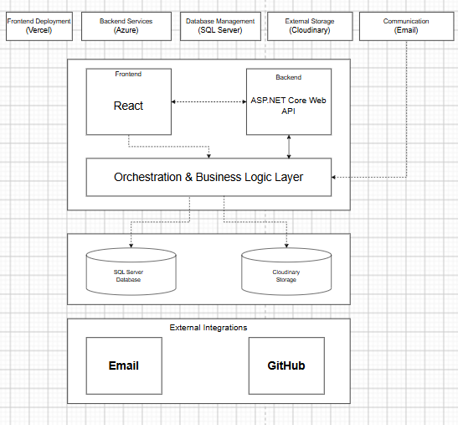
Figure 1-1. System Architecture

1.2 Package Diagram

1.2.1 Front-end Package Diagram

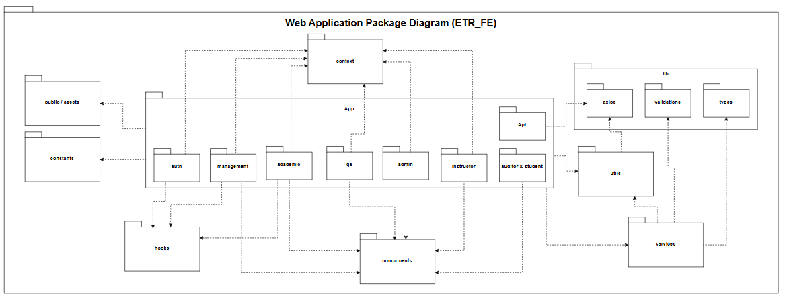
Figure 1-2. Front-end Package Diagram

No | Package | Description
01 | App (Pages) | Contains all role-based views and screen workflows, including auth, academic, instructor, qa, admin, management, and auditor & student. Each page aggregates reusable UI components, consumes shared contexts, and triggers domain services to render role-specific interfaces.
02 | App.Api | Encapsulates endpoint-specific API caller definitions mapped directly to backend controller routes.
03 | Context | Manages global application states, including authentication session state (AuthContext), user claims/roles, and multi-language translation providers across the UI.
04 | Components | Contains modular and reusable UI building blocks such as custom tables, action modals, confirmation dialogs, notification toasts, and pagination controls used across multiple pages.
05 | Services | Implements domain-specific frontend business logic, bridging the UI views with API endpoints to fetch, manipulate, and mutate training record entities.
06 | Utils | Houses cross-cutting utility functions, data formatting helpers (date, strings, status badges), and the core Axios client instance (api.js) configured with automatic JWT interceptors and error handling.
07 | Hooks | Encapsulates reusable custom React hooks for stateful UI logic, such as debounced search filters, dynamic form bindings, and modal visibility management.
08 | Constants | Stores system-wide immutable values, including operational status enums, role definitions, standard error messages, and application route paths.
09 | Lib | Wraps third-party client libraries and cross-cutting specifications, including axios networking instances, client-side data schema validations, and global TypeScript/data types.
10 | Public / Assets | Stores uncompiled static resources, including institutional logos, document templates, favicons, and graphic assets.

1.2.2 Back-end Package Diagram

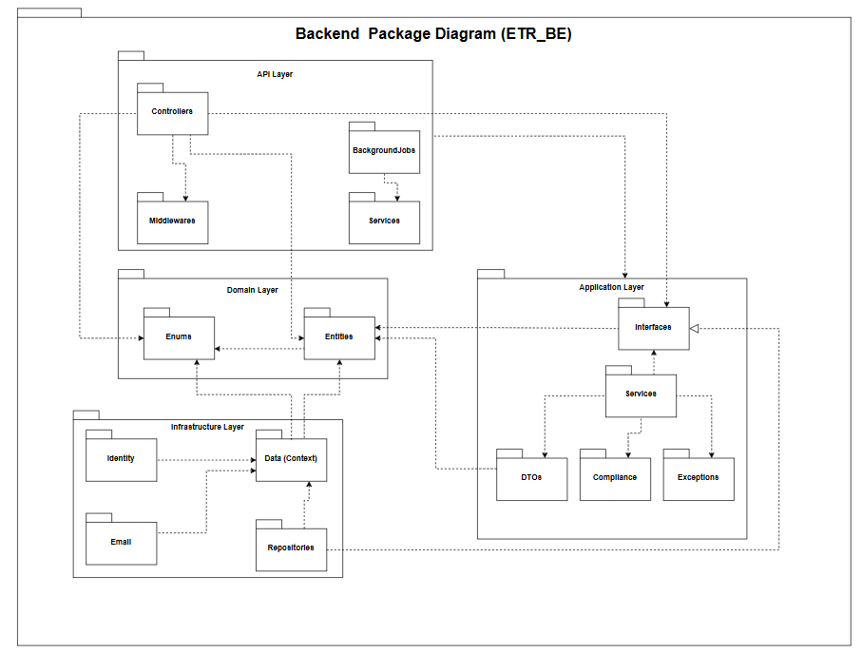

Figure 1-3. Back-end Package Diagram
No | Package | Description
01 | ETR.API.Controllers | Exposes RESTful HTTP endpoints that receive client requests, validate payloads, and delegate execution to application service interfaces.
02 | ETR.API.Middlewares | Intercepts HTTP request/response pipelines to handle global exception handling, structured request logging, and JWT authentication challenge management.
03 | ETR.API.BackgroundJobs | Executes recurring background tasks and asynchronous batch processing for scheduled notifications and periodic record compliance updates.
04 | ETR.API.Services | Provides host-level presentation services and dependency injection configuration modules required to bootstrap the web API runtime
05 | ETR.Application.Interfaces | Defines domain service abstractions and repository contract interfaces (e.g., IUnitOfWork, IETRCourseRecordRepository), fulfilling the Dependency Inversion Principle.
06 | ETR.Application.Services | Implements core use cases, business validation logic, orchestration flows, and report generation workflows.
07 | ETR.Application.DTOs | Encapsulates Data Transfer Objects used for API request/response payloads, isolating domain entities from outer presentation layers
08 | ETR.Application.Compliance | Houses institutional compliance rule engines and audit assessment algorithms governing training records.
09 | ETR.Application.Exceptions | Defines custom domain and application exception classes for centralized fault handling and descriptive API responses.
10 | ETR.Infrastructure.Data | Implements Entity Framework Core database contexts (AppDbContext), entity configurations, and database connection lifecycles.
11 | ETR.Infrastructure.Repositories | Implements abstract repository interfaces and Unit of Work patterns for concrete SQL Server data access and querying.
12 | ETR.Infrastructure.Identity | Manages user identity verification, password hashing with BCrypt, and security token issuance (TokenService).
13 | ETR.Infrastructure.Email | Implements notification delivery interfaces via SMTP/MailKit for automated verification and audit alerts.
14 | ETR.Infrastructure.Migrations | Contains EF Core database schema migration scripts versioning the underlying relational database structure.
15 | ETR.Domain.Entities | Contains enterprise business entities (e.g., Course, Class, TraineeRecord, Evidence) representing core domain data models.
16 | ETR.Domain.Enums | Defines domain enumeration types representing domain-level statuses, evaluation grades, and role classifications.

1.2.3 Package Dependencies & Interface Implementations
The system enforces strict Clean Architecture layering through explicit project references and interface implementations:
Interface Realizations (-|>):
- [ETR.API.Services] -|> [ETR.Application.Interfaces]
- [ETR.Application.Services] -|> [ETR.Application.Interfaces]
- [ETR.Infrastructure.Repositories] -|> [ETR.Application.Interfaces]
- [ETR.Infrastructure.Identity] -|> [ETR.Application.Interfaces]
- [ETR.Infrastructure.Email] -|> [ETR.Application.Interfaces]
Internal Backend Dependencies (->):
- [ETR.API.Controllers] -> [ETR.Application.Interfaces], [ETR.Application.DTOs], [ETR.Domain.Entities], [ETR.Domain.Enums]
- [ETR.API.Middleware] -> [ETR.Application.Exceptions]
- [ETR.API.BackgroundJobs] -> [ETR.Application.Interfaces], [ETR.Domain.Entities], [ETR.Domain.Enums]
- [ETR.Application.Services] -> [ETR.Application.Interfaces], [ETR.Application.DTOs], [ETR.Application.Compliance], [ETR.Application.Exceptions], [ETR.Domain.Entities], [ETR.Domain.Enums]
- [ETR.Application.Compliance] -> [ETR.Domain.Entities], [ETR.Domain.Enums], [ETR.Application.DTOs]
- [ETR.Infrastructure.Repositories] -> [ETR.Infrastructure.Data], [ETR.Application.Interfaces], [ETR.Domain.Entities], [ETR.Domain.Enums]
- [ETR.Infrastructure.Data] -> [ETR.Domain.Entities], [ETR.Domain.Enums]
- [ETR.Infrastructure.Identity] -> [ETR.Application.Interfaces], [ETR.Domain.Entities]
- [ETR.Domain.Entities] -> [ETR.Domain.Enums]
Frontend-to-Backend Inter-layer Communication:
- [ETR_FE (Utils/api.js)] -> [ETR.API.Controllers] (via HTTP REST APIs with JWT Bearer Authorization)

2. Database Design
The database is a relational SQL Server schema managed by EF Core. The model is centered on the ETR_Course_Record: enrolling a learner into a class auto-generates the ETR record and one SubjectResult per subject; attendance, assessment, evidence and sign-off data accumulate on the record; approval and amendment history plus the audit log provide full traceability. Approved records are frozen (IsLocked) and become read-only.

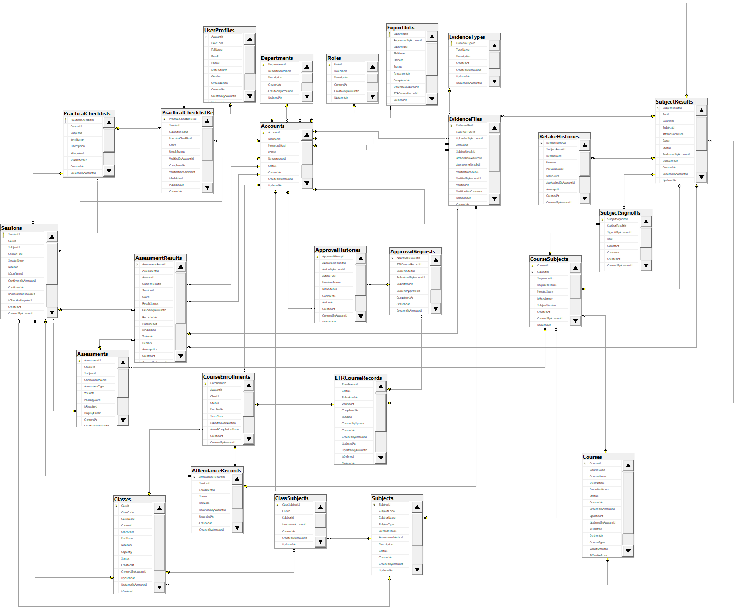

Figure 2-1. Database Design

Table Descriptions

No | Table | Description
01 | Roles | Defines system access roles governing permission scopes and functionality access across the application.  -Primary keys: RoleId  -Foreign keys: CreatedByAccountId, UpdatedByAccountId  .
02 | Accounts | Stores system authentication credentials, active account statuses, and foreign key references linking each user to their designated Role and Department.  -Primary keys: AccountId  -Foreign keys: RoleId, DepartmentId, CreatedByAccountId, UpdatedByAccountId
03 | UserProfiles | Houses extended biographical and personal details of users mapped directly to system accounts.  -Primary keys: AccountId  -Foreign keys: AccountId, CreatedByAccountId, UpdatedByAccountId
04 | Departments | Stores organizational unit and departmental structures within the institution to which accounts belong.  -Primary keys: DepartmentId  -Foreign keys: CreatedByAccountId, UpdatedByAccountId
05 | Courses | Represents master training programs, tracking course metadata, total duration hours, validity periods, and lifecycle states.  -Primary keys: CourseId  -Foreign keys: CreatedByAccountId, UpdatedByAccountId
06 | Subjects | Represents standalone academic or technical training modules, containing syllabus codes, training hours, and assessment modes.  -Primary keys: SubjectId  -Foreign keys: CreatedByAccountId, UpdatedByAccountId
07 | CourseSubjects | Junction entity mapping curriculum subjects into specific courses with sequencing orders, mandatory criteria, and passing thresholds.  -Primary keys: CourseId, SubjectId  -Foreign keys: CourseId, SubjectId, CreatedByAccountId, UpdatedByAccountId
08 | Assessments | Defines component evaluation criteria and formal examinations under a specific course and subject.  -Primary keys: AssessmentId  -Foreign keys: CourseId, SubjectId, CreatedByAccountId, UpdatedByAccountId
09 | PracticalChecklists | Defines itemized practical competency rubrics and task criteria required during specialized training sessions.  -Primary keys: PracticalChecklistId  -Foreign keys: CourseId, SubjectId, CreatedByAccountId, UpdatedByAccountId
10 | Classes | Represents specific cohort deliveries of a course, detailing scheduled timelines, classroom venues, and execution statuses.  -Primary keys: ClassId  -Foreign keys: CourseId, CreatedByAccountId, UpdatedByAccountId
11 | ClassSubjects | Links scheduled classes with their curriculum subjects, assigning designated instructors to deliver each module.  -Primary keys: ClassSubjectId  -Foreign keys: ClassId, SubjectId, InstructorAccountId, CreatedByAccountId, UpdatedByAccountId
12 | Sessions | Tracks scheduled class training sessions, recording timetables, locations, and linked evaluation rubrics.  -Primary keys: SessionId  -Foreign keys: ClassId, SubjectId, ConfirmedByAccountId, AssessmentId, PracticalChecklistId, CreatedByAccountId, UpdatedByAccountId
13 | Enrollments | Tracks trainee registration records into specific classes, monitoring enrollment progress lifecycles and completion dates.  -Primary keys: EnrollmentId  -Foreign keys: AccountId, ClassId, CreatedByAccountId, UpdatedByAccountId
14 | AttendanceRecords | Records individual trainee attendance logs for scheduled sessions, capturing presence statuses and justification remarks.  -Primary keys: AttendanceRecordId  -Foreign keys: SessionId, EnrollmentId, RecordedByAccountId, CreatedByAccountId, UpdatedByAccountId
15 | ExportJobs | Manages background queue tasks processing downloadable ETR dossier documents and exported audit packages.  -Primary keys: ExportJobId  -Foreign keys: RequestedByAccountId, ETRCourseRecordId, CreatedByAccountId, UpdatedByAccountId
16 | ETRCourseRecords | Represents the master Electronic Training Record dossier per enrollment, managing multi-tier review and verification states.  -Primary keys: ETRCourseRecordId  -Foreign keys: EnrollmentId, PreviousRecordId, CreatedByAccountId, UpdatedByAccountId
17 | SubjectResults | Aggregates subject-level performance metrics per trainee, tracking total attendance rates, cumulative scores, and completion statuses.  -Primary keys: SubjectResultId  -Foreign keys: EtrId, CourseId, SubjectId, EvaluatedByAccountId, CarriedOverFromSubjectResultId, CreatedByAccountId, UpdatedByAccountId
18 | AssessmentResults | Stores trainee assessment outcomes, recording raw marks, attempt numbers, grading timestamps, and evaluation statuses.  -Primary keys: AssessmentResultId  -Foreign keys: AssessmentId, AccountId, SubjectResultId, SessionId, GradedByAccountId, CreatedByAccountId, UpdatedByAccountId
19 | PracticalChecklistResults | Captures evaluation records of trainee practical skill checklists, including verification scores, evaluator feedback, and publish statuses.  -Primary keys: PracticalChecklistResultId  -Foreign keys: SessionId, SubjectResultId, PracticalChecklistId, VerifiedByAccountId, CreatedByAccountId, UpdatedByAccountId
20 | SubjectSignoffs | Tracks formal sign-off endorsements for completed subjects executed by authorized academic authorities.  -Primary keys: SubjectSignoffId  -Foreign keys: SubjectResultId, SignoffByAccountId, CreatedByAccountId, UpdatedByAccountId
21 | EvidenceType | Master catalog categorizing supported physical and digital compliance evidence types.  -Primary keys: EvidenceTypeId  -Foreign keys: CreatedByAccountId, UpdatedByAccountId
22 | EvidenceFiles | Manages uploaded digital compliance records, linking evidence entries to attendance, assessment, or dossier entities.  -Primary keys: EvidenceFileId  -Foreign keys: EvidenceTypeId, UploadedByAccountId, AccountId, SubjectResultId, AttendanceRecordId, AssessmentResultId, VerifiedByAccountId, CreatedByAccountId, UpdatedByAccountId
23 | RetakeHistories | Maintains an immutable audit log of reassessment attempts, recording score deltas, retake justifications, and authorizing supervisors.  -Primary keys: RetakeHistoryId  -Foreign keys: SubjectResultId, AuthorizedByAccountId, CreatedByAccountId, UpdatedByAccountId
24 | ApprovalRequests | Tracks formal submission approval workflows for training dossiers across evaluation checkpoints.  -Primary keys: ApprovalRequestId  -Foreign keys: ETRCourseRecordId, SubmittedByAccountId, CurrentApproverId, CreatedByAccountId, UpdatedByAccountId
25 | ApprovalHistories | Stores sequential decision steps, reviewer remarks, and transition states throughout an approval workflow lifecycle.  -Primary keys: ApprovalHistoryId  -Foreign keys: ApprovalRequestId, ActionByAccountId, CreatedByAccountId, UpdatedByAccountId

3. Detailed Design

3.1 Authentication & Authorization
Authentication is implemented with JWT bearer tokens. The involved classes are: AuthController (login/logout/change-password endpoints), AccountService (validates credentials and returns the account with its role), ITokenService/JwtTokenService (issues the signed JWT), CurrentUserService (resolves the current account id and role from the token principal), and the JWT bearer middleware configured in Program.cs (issuer/audience/lifetime/signing-key validation). A rate limiter (AuthPolicy: 5 requests/minute per IP) protects the sensitive auth endpoints against brute-force attacks.

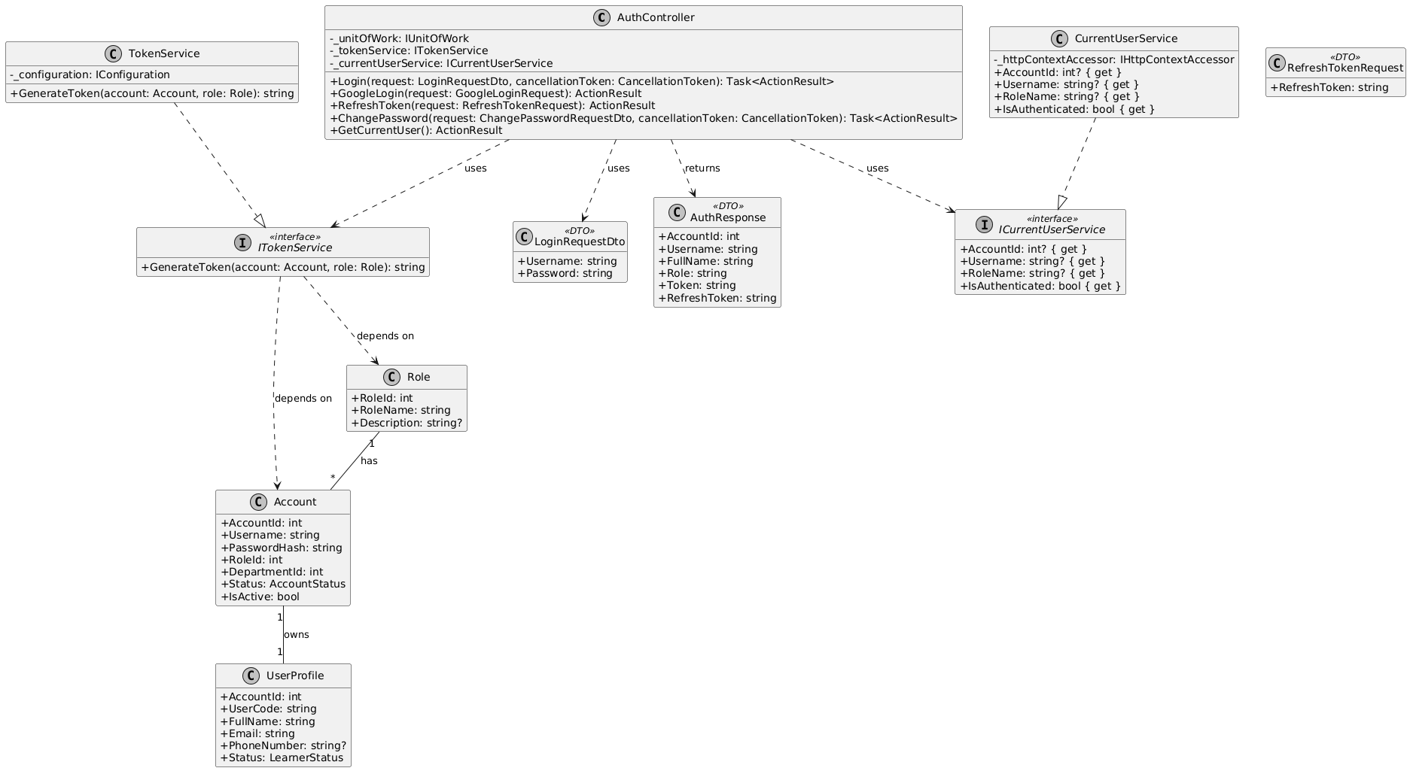Figure 3-1. Class Diagram – Authentication & Authorization
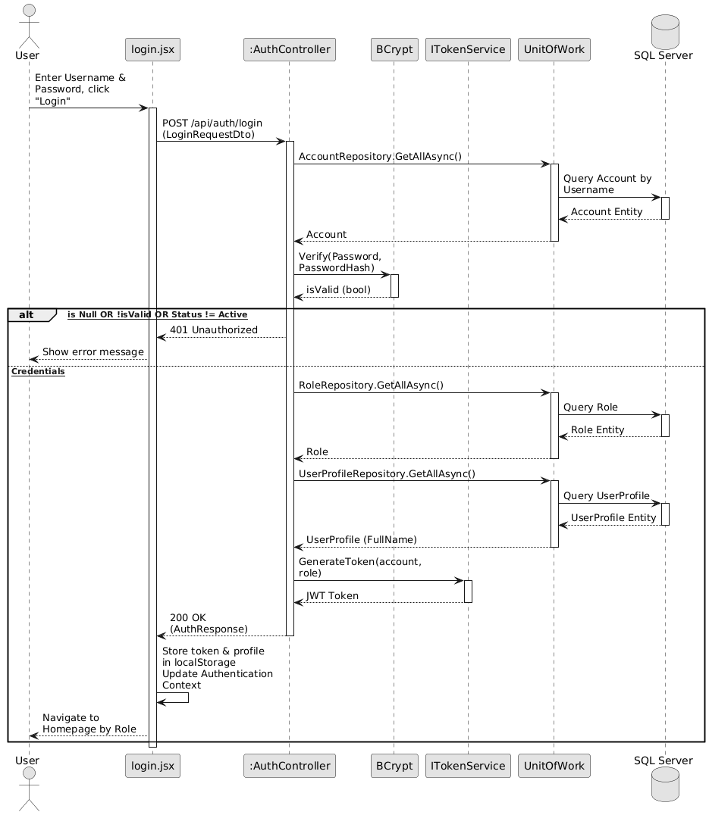

Figure 3-2. Sequence Diagram – Login & JWT Authentication

3.2 Class Creation & Auto-Provisioning
The class creation process is managed by the ClassesController and ClassService. To guarantee data consistency, the entire workflow is wrapped in a database transaction (BeginTransactionAsync). The service validates the course existence and class code uniqueness before persisting the Class entity. It then iterates through instructor assignments, verifying the instructor role, and maps them via ClassSubject. Crucially, the system executes an auto-provisioning mechanism: based on the RequiredSessions configuration of each subject, it automatically generates empty Session stubs (IsConfirmed = false) to prepare the class schedule. The transaction concludes by automatically writing to the AuditLog.

Figure 3-3. Class Diagram – Master Data & Course Structure

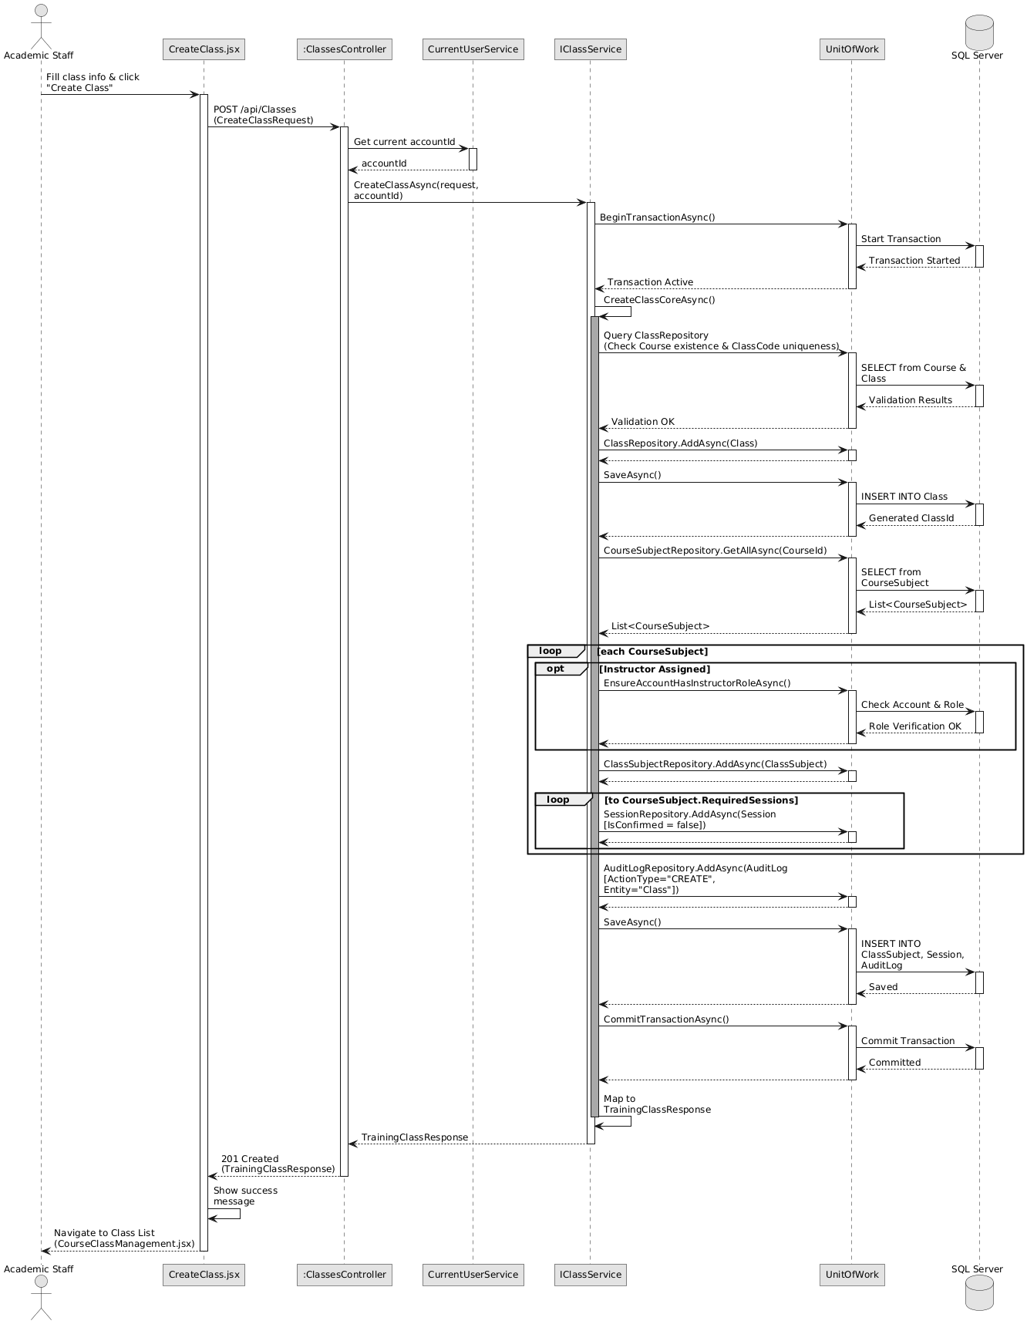

Figure 3-4. Sequence Diagram – Class Creation & Auto-Provisioning Sessions

3.3 Enrollment & ETR Generation
Enrollment operations are handled by the EnrollmentsController and EnrollmentService. The service enforces strict aviation compliance gates, notably the "Single Active ETR" rule, preventing learners from having overlapping active records for the same course. Upon validation, a single transaction generates the CourseEnrollment and automatically scaffolds the ETRCourseRecord (Status = "InProgress", IsLocked = false). The system evaluates a "Retake Rule": it either inherits past SubjectResult data for previously passed subjects or initializes new pending SubjectResult stubs containing a snapshot of the current passing score.

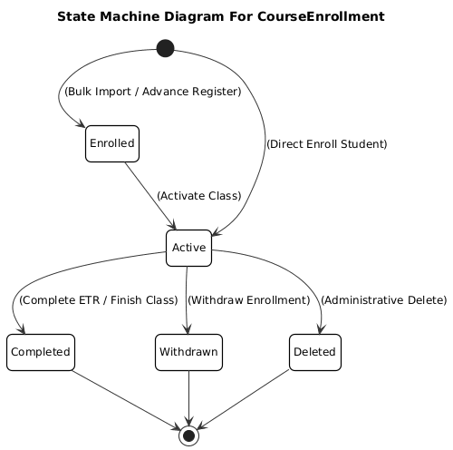

Figure 3-5. State Machine Diagram – Course Enrollment Lifecycle

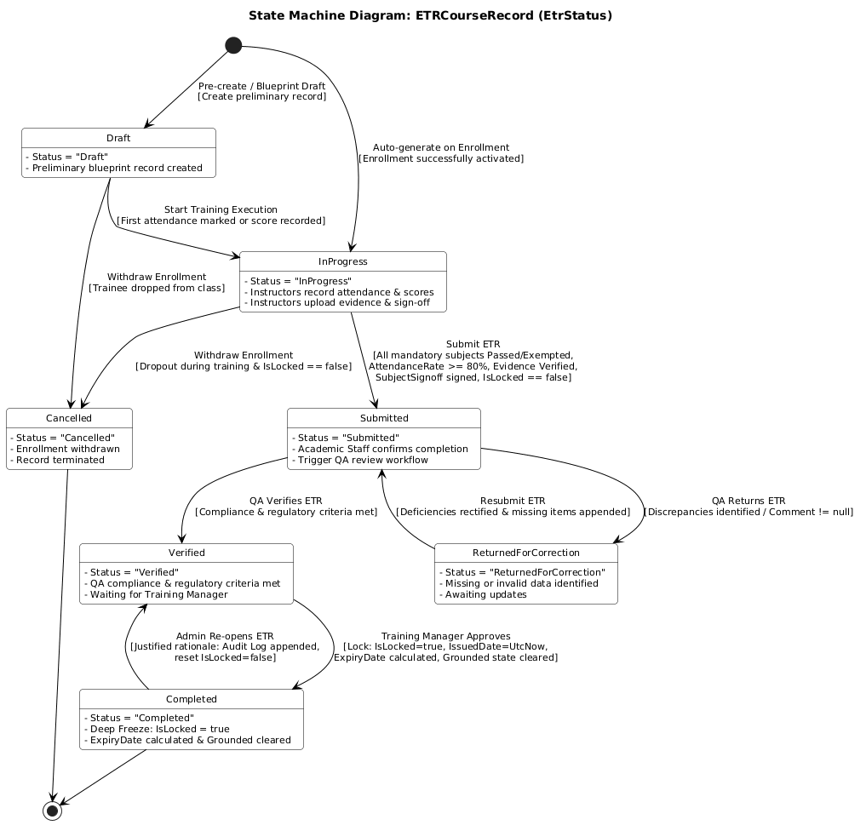

Figure 3-6. State Machine Diagram – ETR Lifecycle
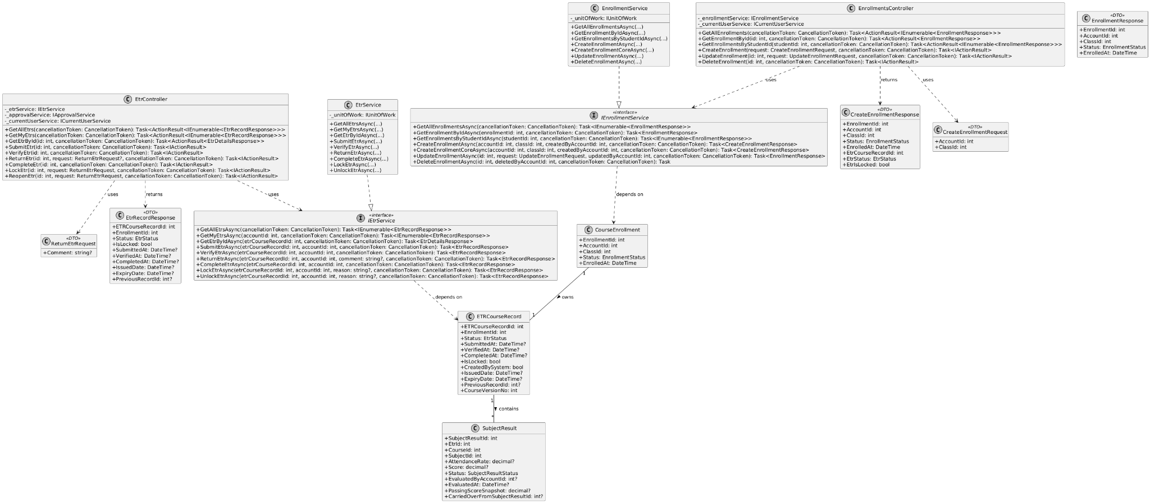

Figure 3-7. Class Diagram – Enrollment & ETR Entities
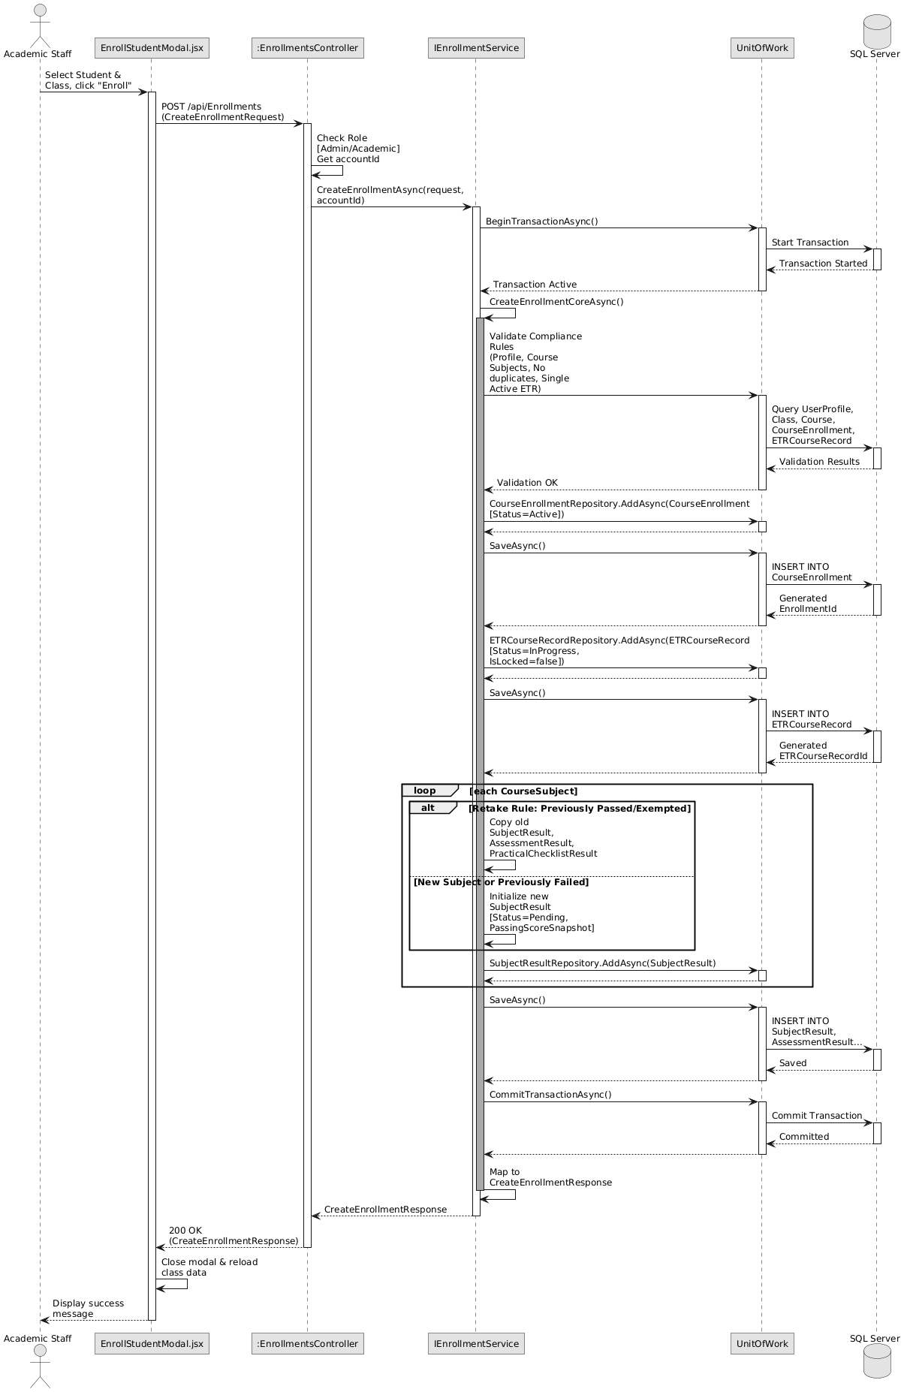

Figure 3-8. Sequence Diagram – Enrollment & ETR Auto-Generation

3.4 Attendance Recording & Auto-Calculation
Attendance tracking relies on the AttendanceController and AttendanceService. The service applies an "Immutability Validator" to ensure the targeted ETR is active and not locked. After validating the session and the instructor's class ownership, it persists the AttendanceRecord. Immediately within the same transaction, the service invokes an internal recalculation engine (RecalculateAttendanceRateAsync) which aggregates the learner's present sessions against the mandatory requirements and dynamically updates the aggregate AttendanceRate percentage on the SubjectResult.

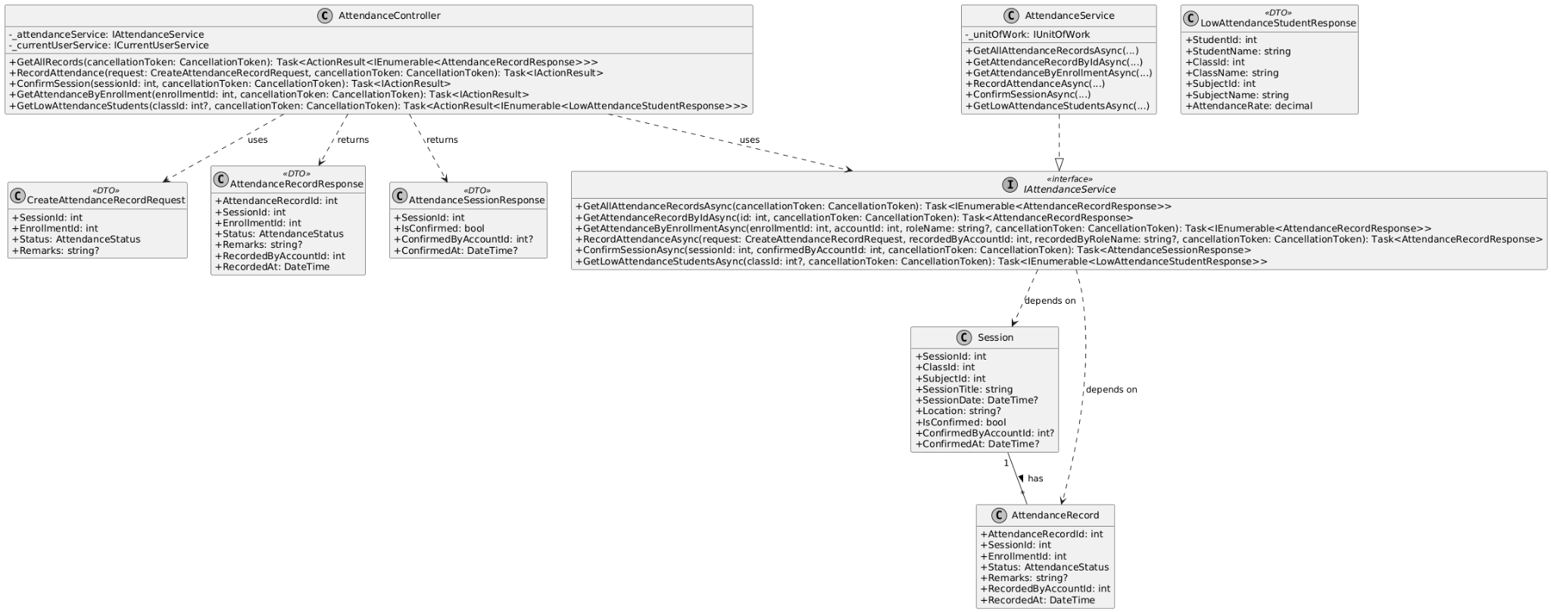

Figure 3-9. Class Diagram – Attendance Recording & Auto-Calculation

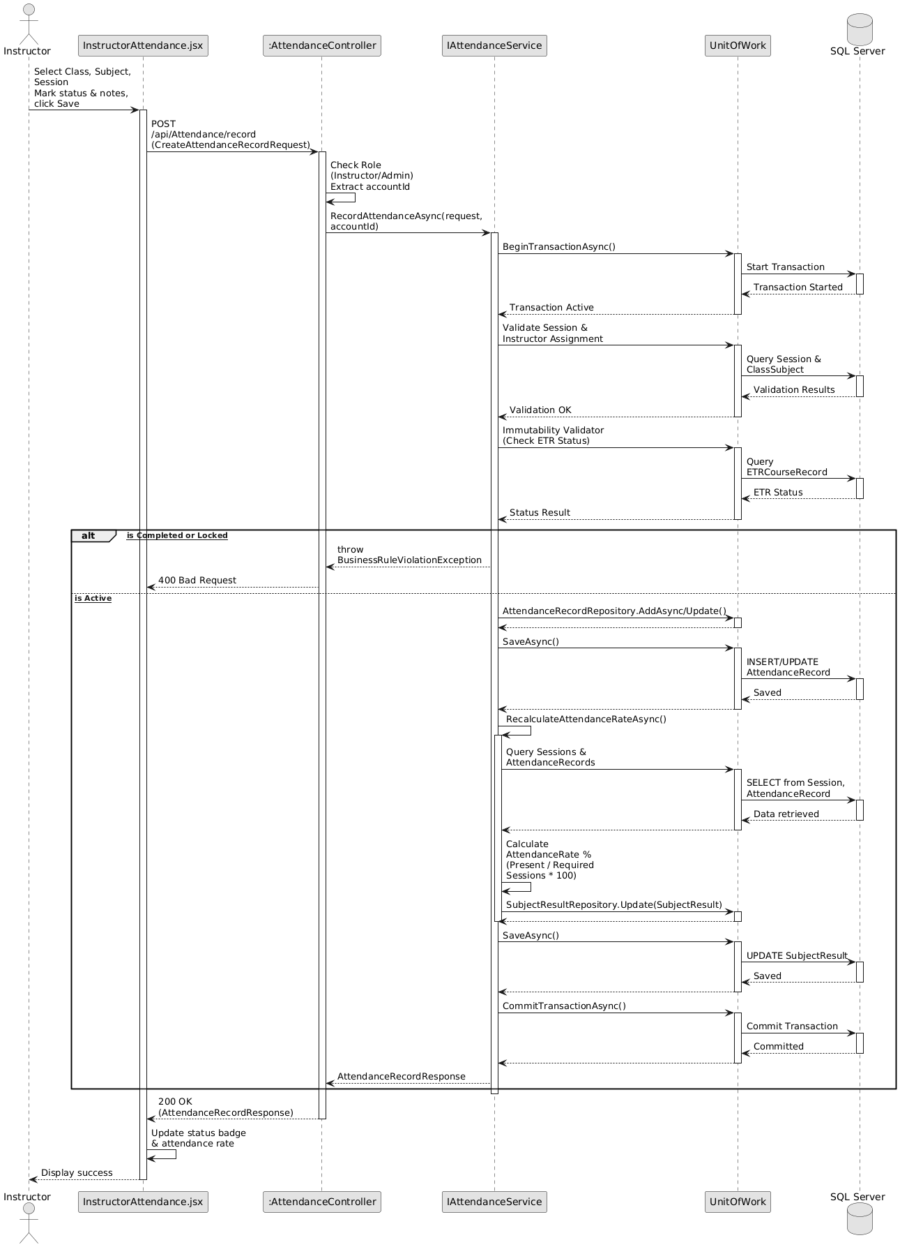

Figure 3-10. Sequence Diagram – Attendance Recording & Auto-Calculation

3.5 Assessment Grading & Subject Sign-off
This module is orchestrated by the AssessmentResultsController, SubjectSignoffController, and AssessmentResultService. For grading, the service validates ETR mutability, records the score, and automatically recalculates the overall SubjectResult.Score based on component weights. For subject sign-off, the service enforces four rigid Compliance Gates: AttendanceRate >= 80%, Practical Checklist passed, Evidence Files uploaded, and Total Score >= PassingScoreSnapshot. If all gates pass, the system generates a SubjectSignoff record containing the digital signature timestamp and officially transitions the subject status to "Passed".

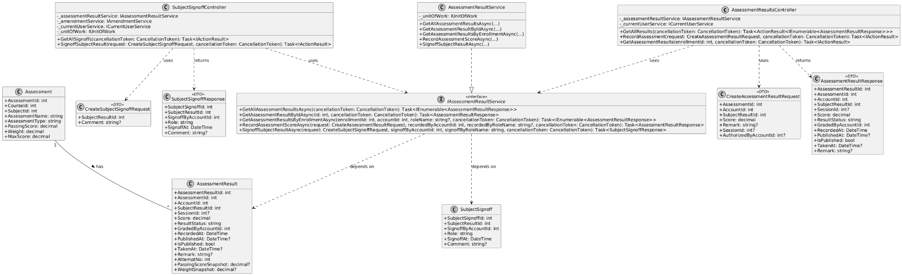

Figure 3-11. Class Diagram – Assessment Grading & Subject Sign-off

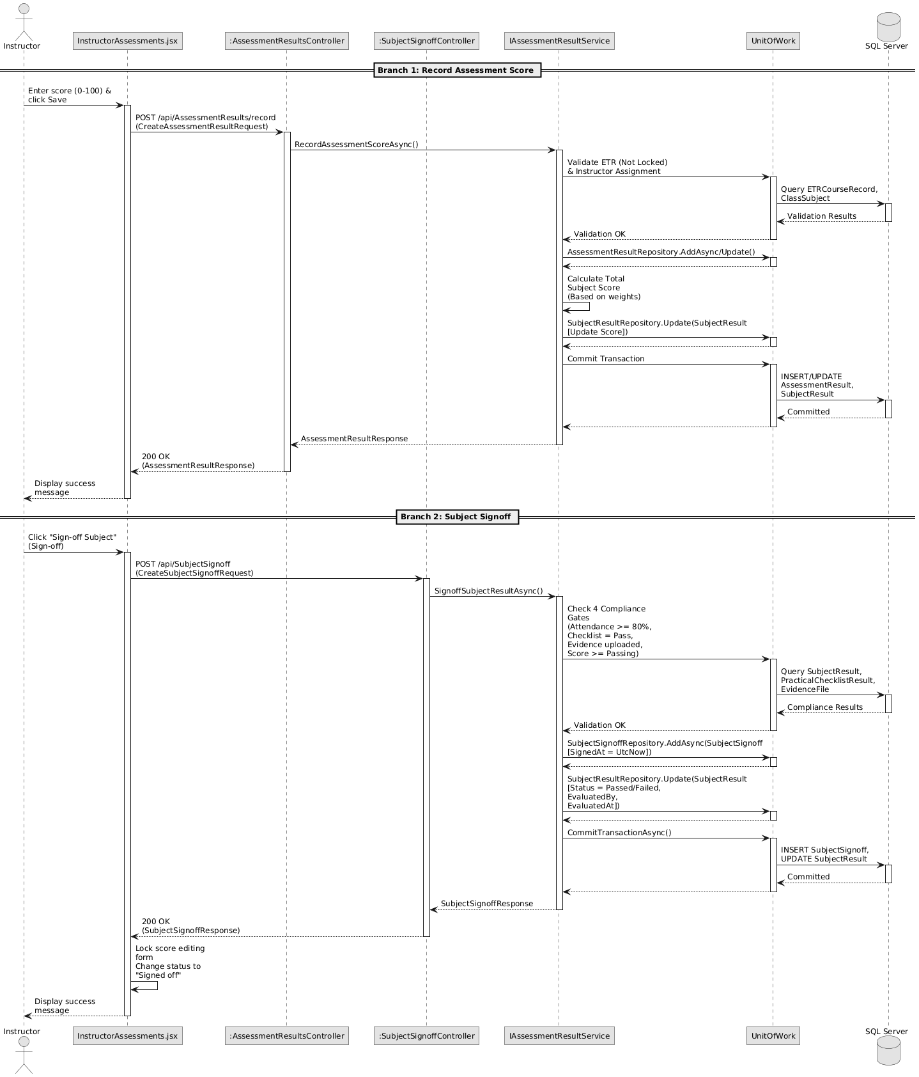

Figure 3-12. Sequence Diagram – Assessment Grading & Subject Sign-off

3.6 Evidence Upload & QA Verification
Evidence management utilizes the EvidencesController, EvidenceService, and a third-party Cloudinary integration. During Phase 1 (Upload), the frontend uploads binary files securely to Cloudinary, while the API stores the returned metadata, mapping it to an EvidenceFile (VerificationStatus = "Pending") and an Attachment entity. In Phase 2 (QA Verification), the service strictly enforces a "Separation of Duties" business rule (EnsureVerifierDidNotUploadEvidence), preventing the uploader from approving their own evidence. Verification actions automatically trigger updates to the EvidenceFile status and generate permanent AuditLog entries.

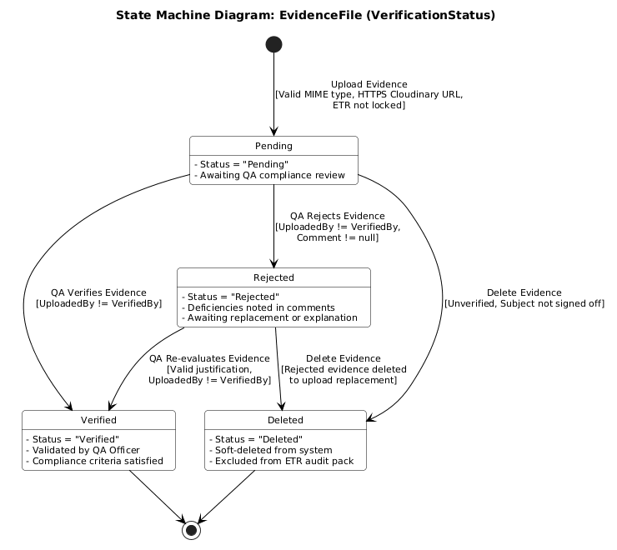

Figure 3-13. State Machine Diagram – Evidence File Lifecycle

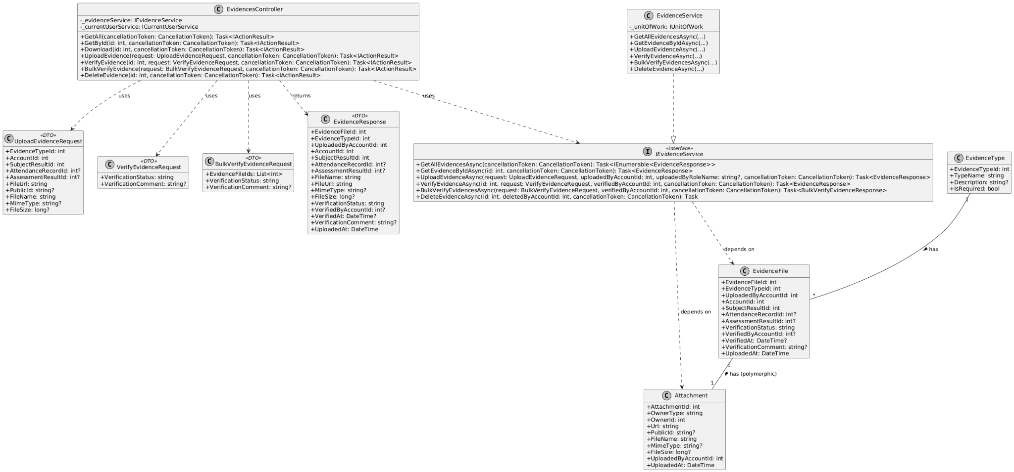

Figure 3-14. Class Diagram – Evidence Upload & Verification

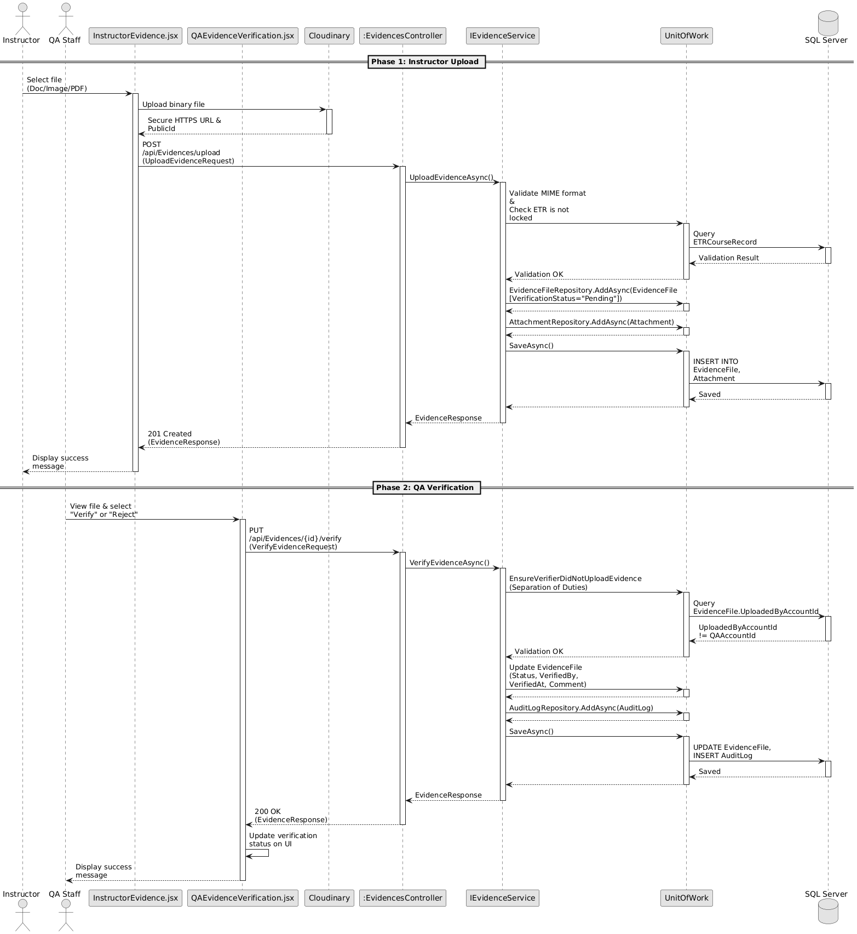

Figure 3-15. Sequence Diagram – Evidence Upload & QA Verification

3.7 ETR Approval Lifecycle & Deep Freeze
The macro-lifecycle of an ETR is driven by the EtrController, ApprovalsController, EtrService, and ApprovalService. The workflow transitions through a structured state machine via ApprovalRequest entities: Submission (by Academic Staff), Verification (by QA), and Final Approval (by the Training Manager). Upon final approval, the service executes a "Deep Freeze" mutation (CompleteEtrAsync): it forcefully sets ETRCourseRecord.Status = Completed, toggles IsLocked = true to permanently disable further edits, applies the completion timestamp, and writes an immutable COMPLETED action to the AuditLog before committing the transaction.

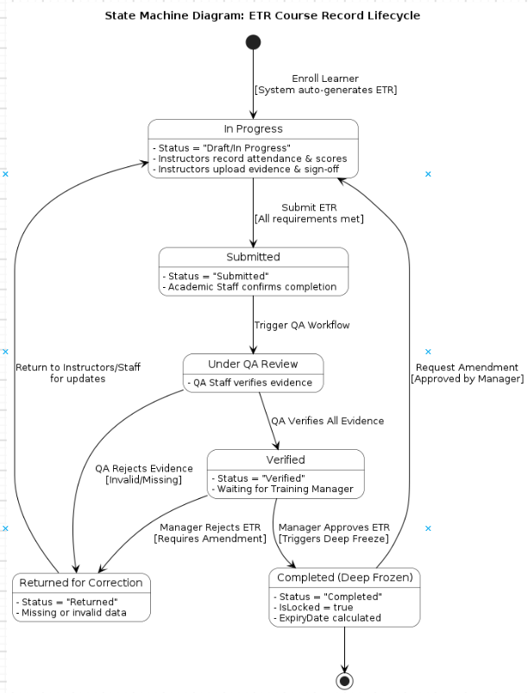

Figure 3-16. State Machine Diagram – ETR Course Record Lifecycle

To manage this complex transition, the system utilizes a dedicated ApprovalRequest entity. The following micro state machine details the specific workflow and status transitions of an Approval Request as it bounces between Academic Staff, QA Staff, and the Training Manager.

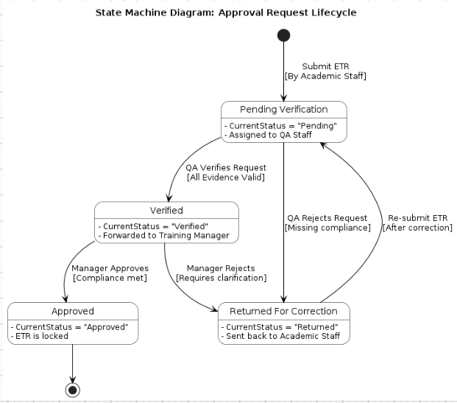

Figure 3-17. State Machine Diagram – Approval Request Lifecycle
The final ETR approval workflow is orchestrated by the ApprovalService. When a Training Manager initiates approval via ApprovalController, the system enforces a strict security role check (requiring "TrainingManager" or "Admin" roles). The service updates the ApprovalRequest, adds an ApprovalHistory row, and invokes CompleteEtrAsync. This triggers the ETR Pre-Validation Compliance Checks: the ETR status must be "Verified", all mandatory subjects must be "Passed/Exempted", and all attached EvidenceFiles must be "Verified". Upon passing, the system executes the "Deep Freeze" data mutation: setting ETR.Status = "Completed", locking the record (IsLocked = true), calculating the certificate ExpiryDate, and updating the CourseEnrollment.ActualCompletionDate. A permanent AuditLog is automatically generated before the transaction commits.

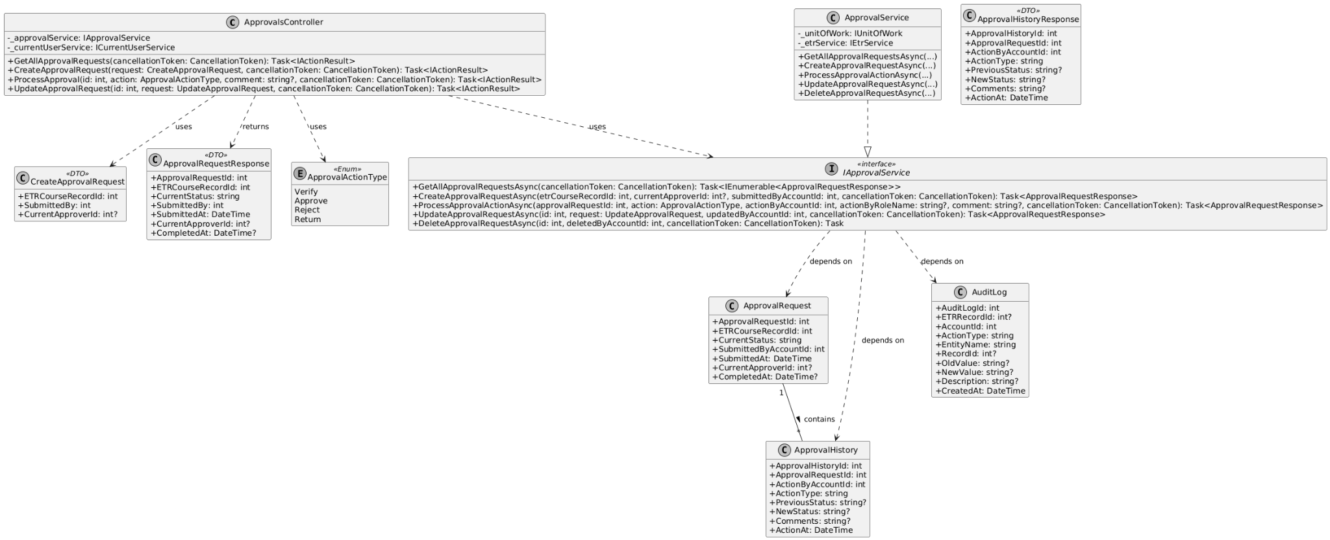

Figure 3-18. Class Diagram – Manager Approval & ETR Deep Freeze

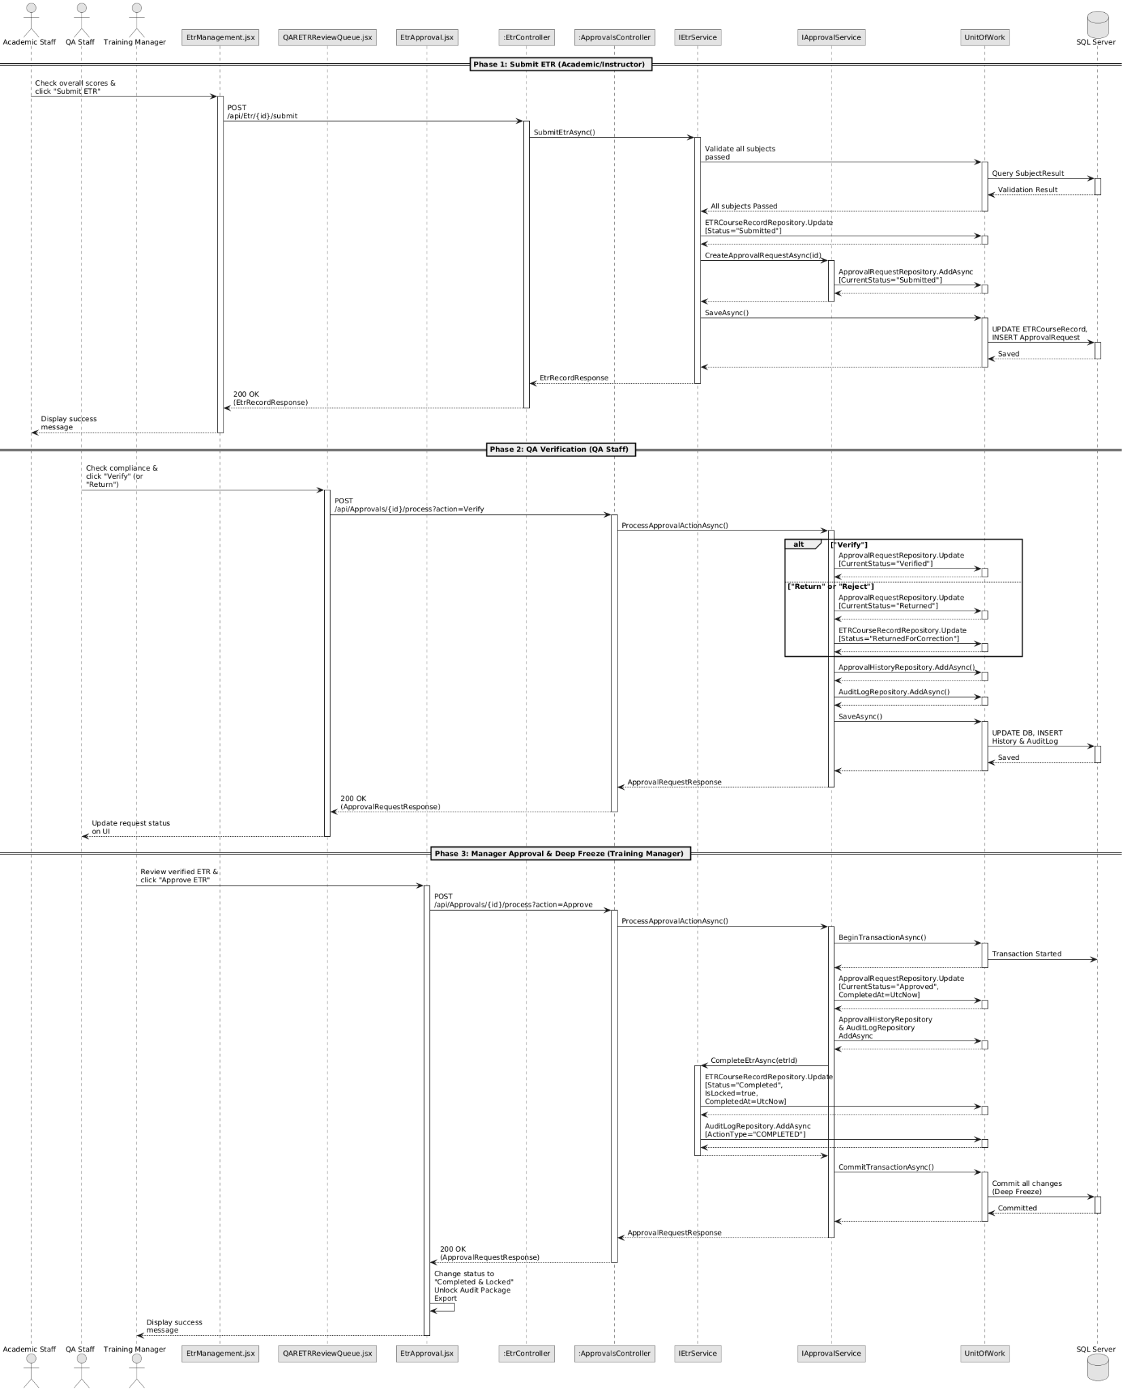

Figure 3-19. Sequence Diagram – ETR Approval Lifecycle & Deep Freeze

3.8 Audit Logs & Training Package Export

Export functionalities are managed by the ExportsController and ExportService. The service first enforces a "Completion Gate," throwing a BusinessRuleViolationException if the requested ETR is not fully completed. Upon passing, it aggregates massive relational datasets (User, Class, Subjects, Evidence, ApprovalHistory). The system dynamically generates an ETR Summary PDF and Audit History PDF (via QuestPDF), alongside a detailed Excel spreadsheet (via ClosedXML) in-memory. It then fetches binary evidence files from Cloudinary, bundles everything into a physical ZIP archive on the server, and creates a tracked ExportJob for the Auditor to download.
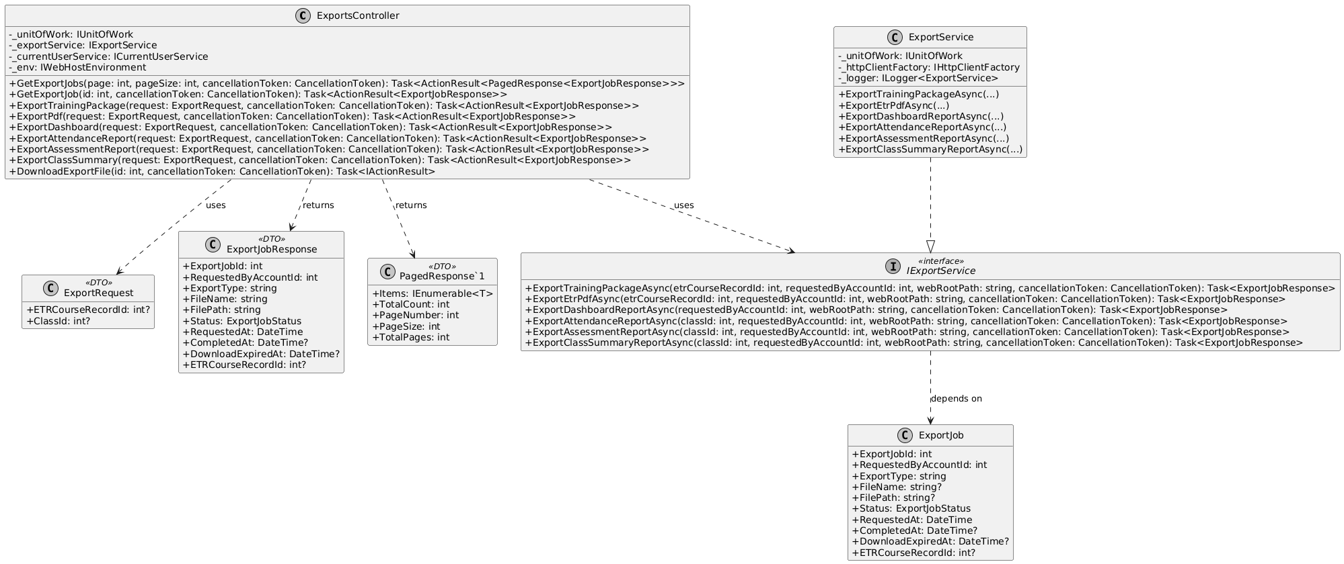

Figure 3-20. Class Diagram – Training Package Export & Audit Logging

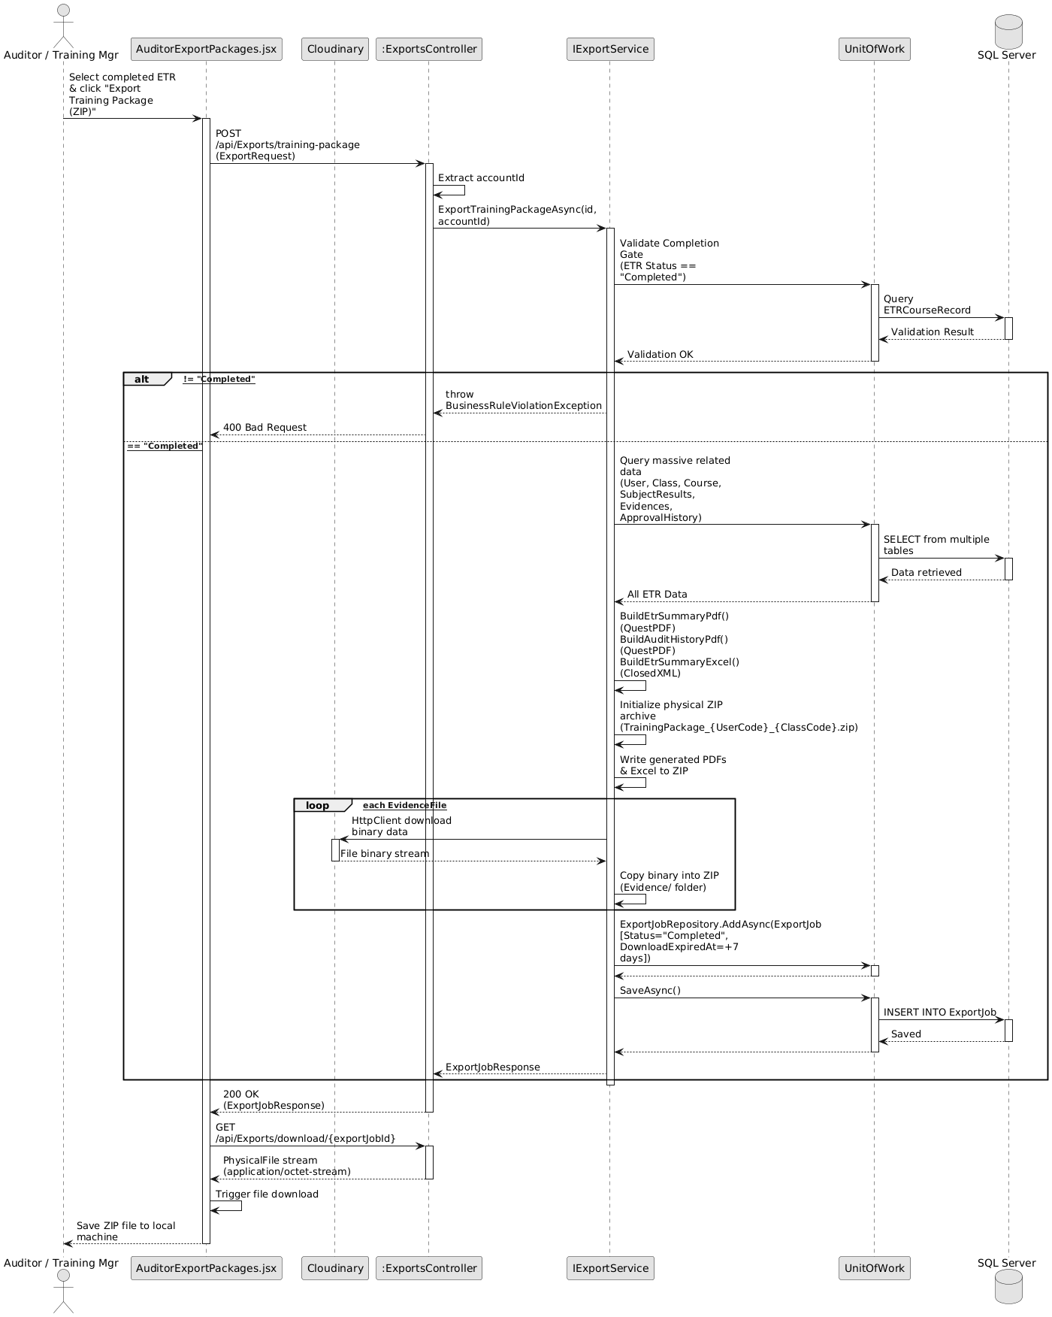

Figure 3-21. Sequence Diagram – Audit Logs & Training Package Export

V. Software Testing Documentation

1. Scope of Testing
Target of Test: The scope of testing for the Electronic Training Record (ETR) System encompasses all core modules critical to aviation compliance, including: User & Role Management (RBAC), Learner & Course Management, Attendance Recording, Assessment Grading, Evidence Verification (Maker-Checker rule), ETR Submission, and Manager Approval (Data Freeze).
- Functional Testing: Verifying all business workflows, especially the state transitions of ETRs and evidence status.
- Non-functional Testing: Security testing (JWT, Role Isolation), and performance testing (response times under 3 seconds).
- Exclusions: Online learning delivery (LMS features), mobile application testing (as the system is web-only), and payment processing are out of scope.
Stages of Testing:
- Unit Testing: Focuses on core backend business logic (ETR.Application.Tests) and frontend components. Target: >= 90% code coverage.
- Integration Testing: Verifies data flow between modules (e.g., Enrollment triggering auto ETR generation). Target: >= 80% module integrations.
- System Testing: Validates end-to-end role-based workflows for Admin, Academic, Instructor, QA, Training Manager, and Auditor. Target: >= 70% system functionality covered with <= 10 major defects.
- Acceptance Testing: Final validation by stakeholders to ensure 100% of critical features work according to aviation rules.

2. Test Strategy

2.1 Testing Types

Functional Testing:
- Objective: Ensure all features (CRUD, ETR workflow, Audit logs) operate according to the SRS.
- Technique: Black-box testing (Manual and Automated UI testing).
- Completion Criteria: All critical functional test cases execute successfully without blocker defects.
Security & Authorization Testing:
- Objective: Validate Zero-Trust architecture and Role-Based Access Control (RBAC). Ensure Instructors cannot Verify Evidence, and Academic Staff cannot Approve ETRs.
- Technique: Cross-role access attempts and API endpoint manipulation.
- Completion Criteria: 0 unauthorized access vulnerabilities found.
Integration Testing:
- Objective: Verify RESTful API communication between React frontend and ASP.NET Core backend, and database transactions.
- Technique: API Testing via Postman and Backend integration tests.
- Completion Criteria: All API endpoints return expected JSON structures and HTTP status codes (200, 400, 401, 403).

2.2 Test Levels
Type of Tests | Test Level
Type of Tests | Unit | Integration | System | Acceptance
Functional Testing | X | X | X | X
Security Testing |  | X | X | X
Integration Testing |  | X | X | X
UI/UX Testing |  |  | X | X

2.3 Supporting Tools
Purpose | Tool | Vendor/In-house | Version
Frontend Unit Testing | Vitest | Open Source | 2.0.0
Backend Unit Testing | xUnit / Moq | Microsoft / Open Source | v2.x
API Testing | Postman | Postman Inc. | v10.x
End-to-End (E2E) Testing | Playwright/Cypress | Open Source | Latest
Defect Tracking | Zalo / GitHub Issues | Zalo / GitHub | N/A

3. Test Plan

3.1 Human Resources
Worker/Doer | Role | Specific Responsibilities/Comments
Nguyen Huu Nhat Trieu | Test Manager | Review Test Plan, monitor test progress, and facilitate UAT with stakeholders.
Vo Trong Nhan | QA Tester | Write and execute manual test cases, UI testing, and log defects.
Doan Trong Khoi | Automation Tester | Develop and execute Backend Unit tests and API Integration tests.
Tran Trong Nhan | E2E Tester | Setup E2E testing environment, execute System Tests covering full ETR lifecycle.

3.2 Test Environment
Purpose | Tool | Provider | Version
Frontend Hosting | Vercel | Vercel | Latest
Backend Hosting | Azure App Service | Microsoft Azure | .NET 9
Database Server | Azure SQL Database | Microsoft Azure | SQL Server
Client Browsers | Chrome, Edge, Firefox, Safari | Various | Evergreen (Latest)

3.3 Test Milestones
Milestone Task | Start Date | End Date
Test Planning & Environment Setup | 01/08/2026 | 05/08/2026
Unit & API Integration Testing | 06/08/2026 | 15/08/2026
System Testing (E2E workflows) | 16/08/2026 | 22/08/2026
User Acceptance Testing (UAT) & Bug Fixing | 23/08/2026 | 28/08/2026
Final Test Report Delivery | 29/08/2026 | 31/08/2026

4. Test Cases
The detailed test scenarios, test steps, inputs, and expected results are documented in external files:
- Unit Test Cases: Report5_Unit Test (Focusing on ETR Auto-generation, Score calculation, and RBAC policies).
- System & Integration Test Cases: Report5_Test Report (Focusing on workflows such as Evidence Verification by QA and ETR Deep Freeze by Manager).

5. Test Reports
Based on the project objectives outlined in the Project Management Plan:
- Unit Testing: 27/27 automated test cases passed (100% pass rate). Achieved >= 90% code coverage across core domain logic (ETR auto-generation, attendance calculation, 4 compliance gates evaluation, certificate expiry scheduling). Total major defects found: 0 (Target: <= 5). Defect rate: 0%.
- Integration Testing: Achieved >= 85% module integration across API controllers, EF Core database transactions, and Cloudinary evidence storage. Total major defects found: 0 (Target: <= 10). Defect rate: 0%.
- System & UAT: 100% of critical features (Authentication, Class Provisioning, Enrollment, Session Finalization, Evidence Verification, ETR Approval & Deep Freeze, Audit Package Export) were successfully validated against aviation regulatory rules.
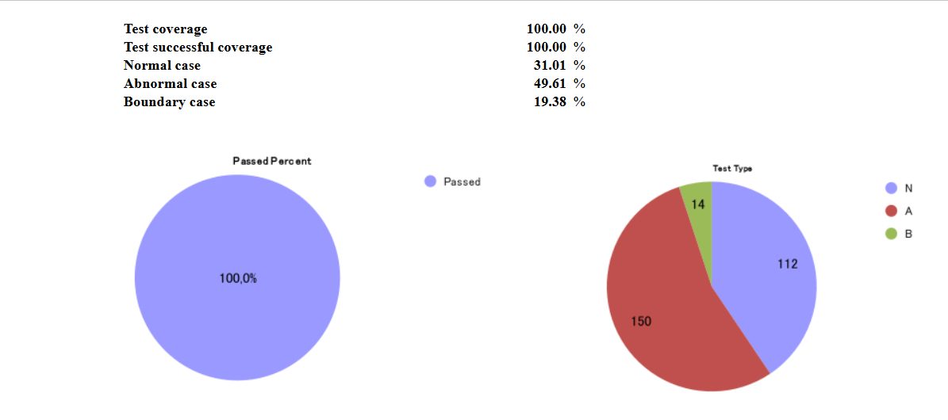

VI. Release Package & User Guides

1. Deliverable Package

No. | Deliverable Item | Description
1 | Project Schedule/Tracking | Project schedule and progress tracking materials.
2 | Project Backlog | Project backlog and planned work items.
3 | Source Codes | ETR frontend source code and related application resources.
4 | Database Script(s) | Database schema, seed and supporting scripts.
5 | Final Report Document | Final capstone project report.
6 | Test Cases Document | Functional and end-to-end test cases.
7 | Defects List | Recorded defects and resolution status.
8 | Issues List | Known issues, limitations and follow-up items.
9 | Slide | Project presentation slides.

2. Installation Guides

2.1 System Requirements
The ETR frontend is a React single-page application built with Vite and deployed against an Azure backend API.
Component | Requirement | Notes
Node.js | ^20.19.0 or >=22.12.0 | Required to run the Vite 8 development server and build tooling. Node >=24 is also supported.
npm | Bundled with Node.js (>=10) | Package manager used to install dependencies.
Git | Any recent version | Required to clone the repository and to drive Vercel deployments from a git push.
Browser | Modern evergreen browser | Chrome, Edge, Firefox, Safari latest; no legacy browser support.

Application Configuration
Item | Value / Notes
Frontend framework | React ^19.2.6 with react-dom
Build tool | Vite ^8.0.12 + @vitejs/plugin-react ^6.0.1
Routing | react-router-dom ^7.18.0
Styling | SCSS (sass-embedded), plus Tailwind via CDN (index.html)
Utilities | react-icons, xlsx (Excel parsing/preview)
Backend API | Deployed Azure Web App (DEPLOY-ONLY mode)
Data storage (browser) | localStorage — auth token, user profile, remembered username, language preference, per-account activity log

Environment Variables
Variable | Purpose | Example
VITE_API_URL_DEPLOY | Base URL of the deployed backend API. Used for all requests (dev and production). | https://etrmanagement-be-xxxxxxxx.southeastasia-01.azurewebsites.net/api
VITE_APP_TITLE | Informational application title. | ETR Aviation Training Portal
VITE_APP_ENV | Informational environment label. | development

2.2 Installation Instruction

Step 1 - Clone the repository: git clone <repository-url> ETR_FE, then run cd ETR_FE.

Result: The frontend source is available locally.

Step 2 - Install dependencies with npm install.

Result: Project packages are installed.

Step 3 - Configure environment variables if a local override is required by creating a gitignored .env.local from .env.example.

Result: The frontend uses the configured environment values.

Step 4 - Run npm run dev.

Result: The Vite development server starts and provides a local frontend URL.

Step 5 - Build the application with npm run build; use npm run preview to preview the production build.

Result: A production-ready dist build is created and can be previewed locally.

Step 6 - Run the available quality checks when required: npm run lint, npm run test:e2e, and npx vitest run.

Result: Linting and automated tests provide feedback before release.

Step 7 - For Vercel deployment, connect the repository, set the build command to npm run build and the output directory to dist.

Result: A successful push to the linked deployment branch can trigger a production build.

3. User Manual

3.1 Overview
The ETR (Electronic Training Record) platform centralizes the entire aviation training record lifecycle in one secure, role-based application. It replaces paper-based training records with a digital dossier that moves through controlled approval stages from enrollment and evidence collection, to quality-assurance verification, to final management sign-off, and finally into a locked, audit-ready compliance repository.
User Roles and Portals
Role | Portal URL | Responsibility
Admin | /admin | User, department, audit and system configuration management
Academic | /academic | Learners, courses/classes, subjects, ETR workflow management, expiring certificates
Instructor | /instructor | Class rosters, attendance, assessments, evidence upload, teaching schedule
QA (Quality Assurance) | /qa | Evidence verification, ETR review queue, returns, audit trail
Training Manager | /trainingmanager | Analytics dashboard, ETR final approval, class status, expiring certificates
Student | /student | Personal overview, own ETR dossier, certificates, profile
Auditor | /auditor | Read-only compliance repository, advanced search, approval history, export packages
Admin accounts can also enter the Training Manager portal (/trainingmanager) to approve or reopen ETRs.
Authentication Model
- Login is performed via POST /auth/login with a username and password. No demo accounts exist all credentials and data come from the real API.
- The token and user profile are stored in localStorage. After a successful login the user is redirected to their role portal.
- Sessions are protected by ProtectedRoute guards, automatic expiry checks, 401/403 handling and request timeouts.
- The interface supports bilingual switching (Vietnamese ↔ English) via the language toggle in the top bar of every portal.
Global Interface
- Sidebar navigation, role-specific menu.
- Top bar, back button, breadcrumb, notifications and language switcher.
- Content area, active page rendered by react-router.
- Log out button at the bottom of every sidebar; clears the session and returns to login.

3.2 Workflow 1 — Login & Account Access
Purpose: Provide every user with secure, role-aware entry to the platform and a mechanism to recover a forgotten password.
Before You Start

*You must have an active ETR account and valid login credentials.

*For password recovery, the email address must be registered to the account.

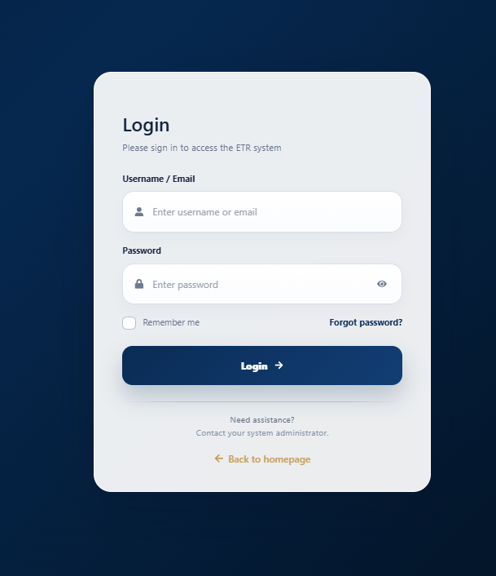
Logging in

Step 1 - Open the application URL and click Sign In.

Step 2 - Enter your username/email and password.

Step 3 - Select Remember me only when you want the application to remember the username on the device.

Step 4 - Click Login. The system validates the credentials and opens the role portal.

Recovering a forgotten password
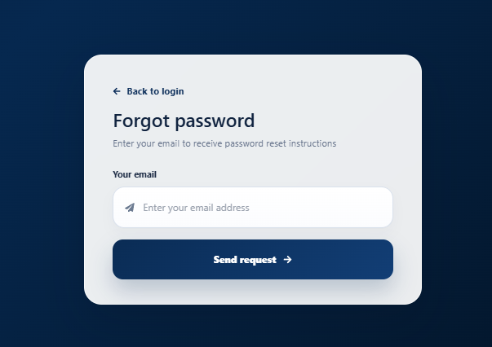
Step 1 - Click Forgot password on the login page.

Step 2 - Enter the email address registered to the account.

Step 3 - Click Send and follow the password-reset process provided by the system.

Logging out
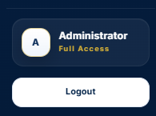

Click Đăng xuất / Sign Out at the bottom of the sidebar. The current client session is cleared and the application returns to the login page.

Session expiry : When the authentication token expires, the application clears the session and returns the user to the login screen. A 401 response also triggers sign-out handling.

3.3 Workflow 2 — Learner, Course & Class Management
Purpose: Let Academic staff (and, where relevant, Admin) build the training structure the ETR system depends on: learners, courses, classes, subjects and enrollments. Creating an enrollment triggers automatic ETR creation.
Before You Start

*Use an Academic Staff account with the required management permission.

*A subject and course/class structure should exist before enrollment.

Managing learners (Academic)
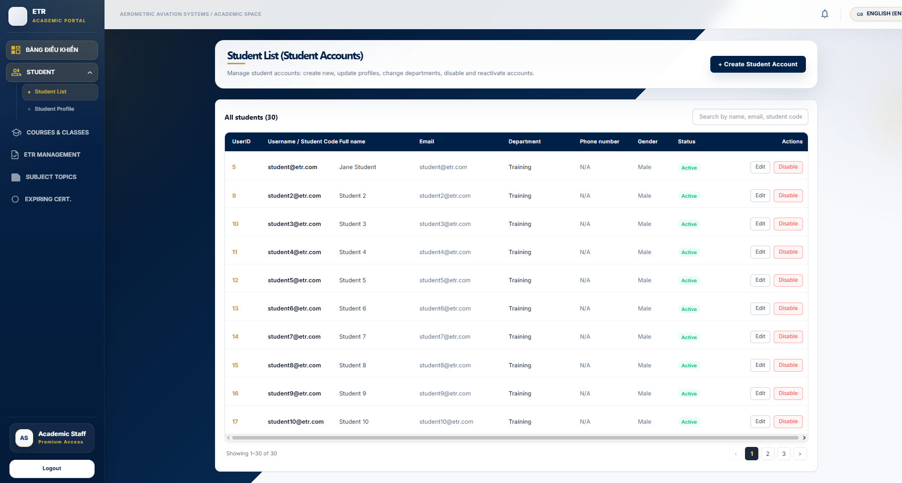
Step 1 - Open HỌC VIÊN (Learners) from the Academic portal.

Step 2 - Use search and available filters to locate a learner.

Step 3 - Use row actions to view the learner profile, edit learner details, or start an enrollment action.

Managing courses & classes
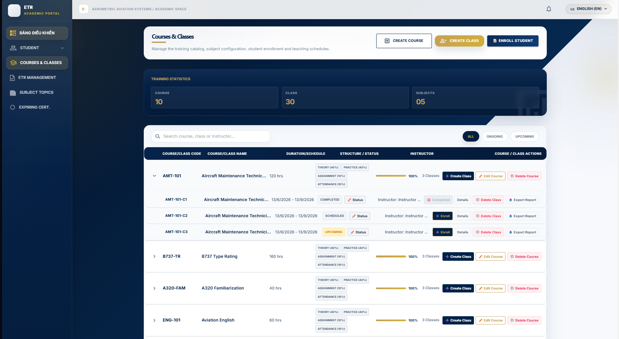
Step 1 - Open KHÓA & LỚP HỌC (Courses & Classes).

Step 2 - Create or edit a course using its name, code, and description.

Step 3 - Create or edit a class using the class identifier, name, subject, dates, room, trainee count and class type.

Step 4 - Use enrollment actions to add learners and the class-status action to maintain the class lifecycle.

Managing subjects
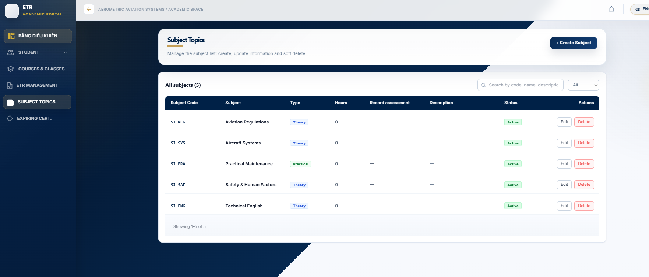
Step 1 - Open CHỦ ĐỀ MÔN HỌC (Subjects).

Step 2 - Use Add or Edit to maintain the subject name, code, and pass score.
Resulting ETR creation
- When a learner is enrolled, the backend automatically generates an ETR for them. The TẠO MỚI ETR button is effectively a lookup + refresh of this auto-generated record.

3.4 Workflow 3 — Instructor: Classes, Attendance, Assessments & Evidence
Purpose: Give instructors everything they need to run a class end-to-end: see rosters, mark attendance, record assessment scores, lock scores, and collect evidence attached to a learner’s ETR.
Before You Start

The class must be assigned to your instructor account.

Learners must already be enrolled in the class before attendance or assessment entry.

Viewing my classes & schedule
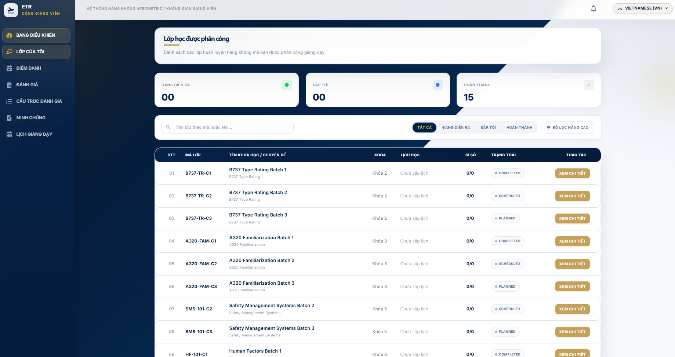
- Open BẢNG ĐIỀU KHIỂN (Dashboard) for a summary of classes, students, sessions and pending grades.
- LỚP CỦA TÔI (My Classes) lists assigned classes with rosters and shortcuts.
- LỊCH GIẢNG DẠY (Schedule) shows the teaching calendar.

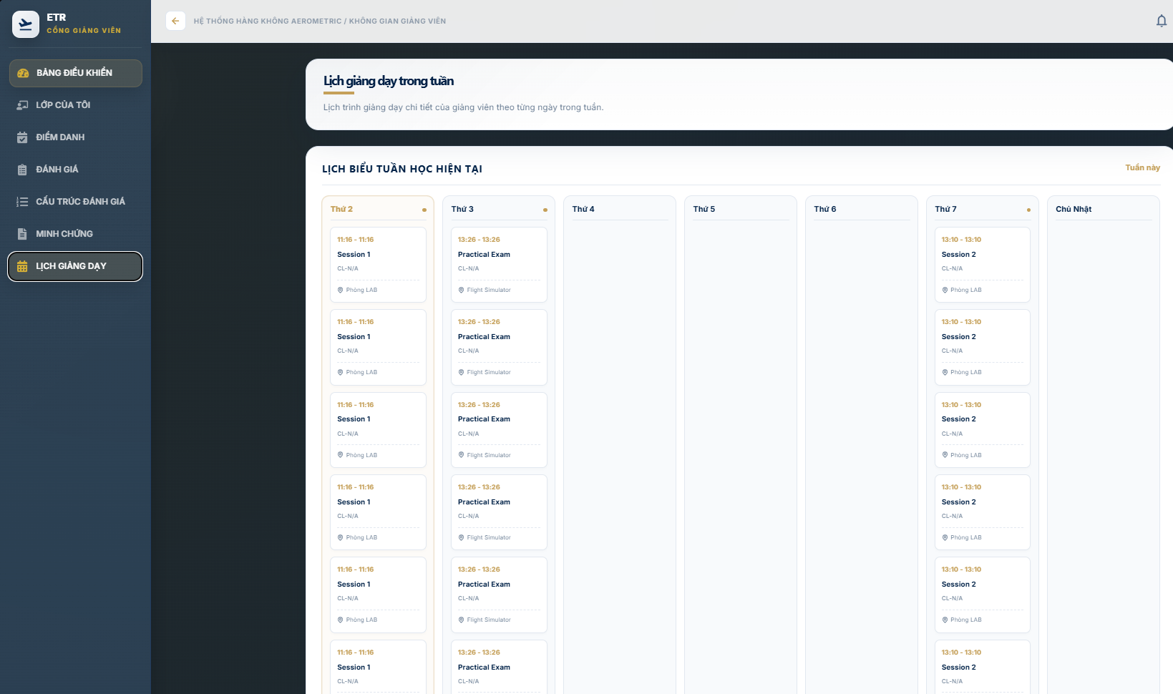

Marking attendance
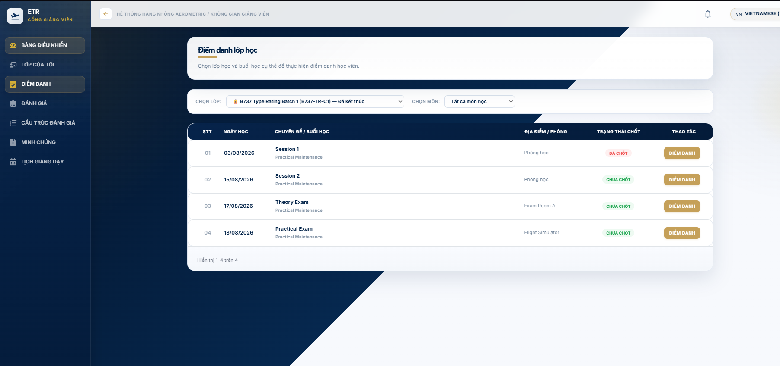
Step 1 - Open ĐIỂM DANH (Attendance).

Step 2 - Select the assigned class and training session.

Step 3 - Mark each learner using the available attendance status.

Step 4 - Click Save to store the session attendance.

The ETR attendance rate is calculated from confirmed session data. The completion checklist requires an attendance rate of at least 80% per subject.

Recording assessments & publishing scores
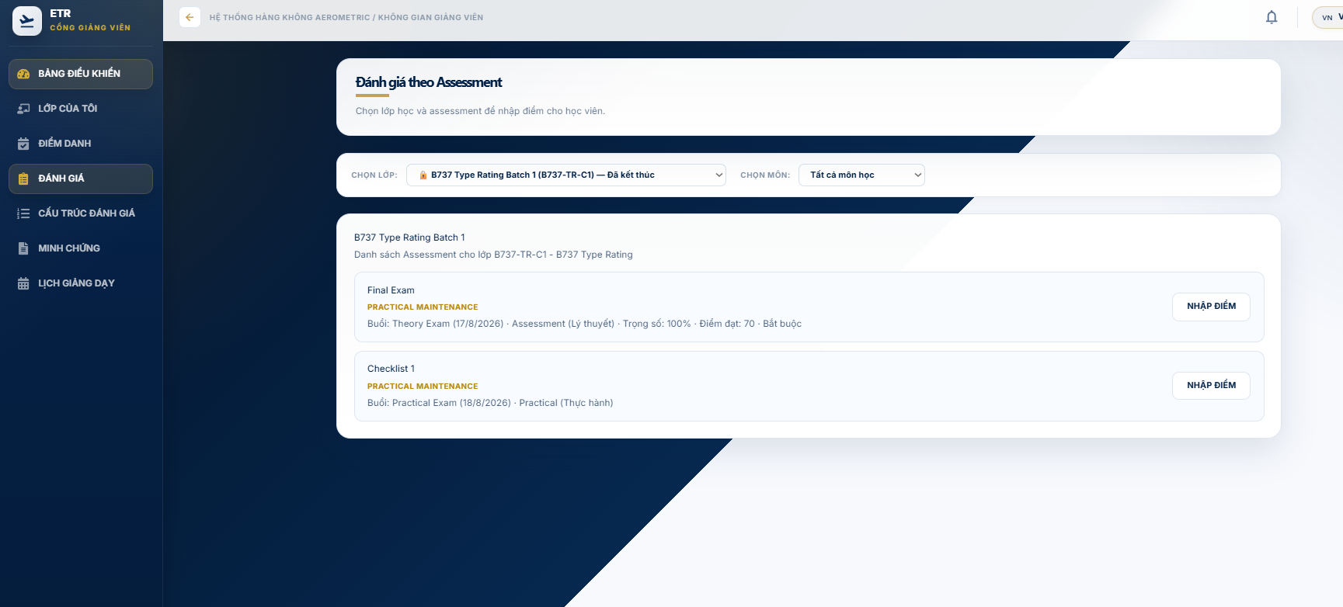
Step 1 - Open ĐÁNH GIÁ (Assessments).

Step 2 - Select the class/subject and enter the learner assessment results.

Step 3 - Review the score against the configured pass criteria and save the results.

Step 4 - When the results are ready, use Chốt điểm / Publish to publish the assessment and

practical checklist results

Uploading evidence
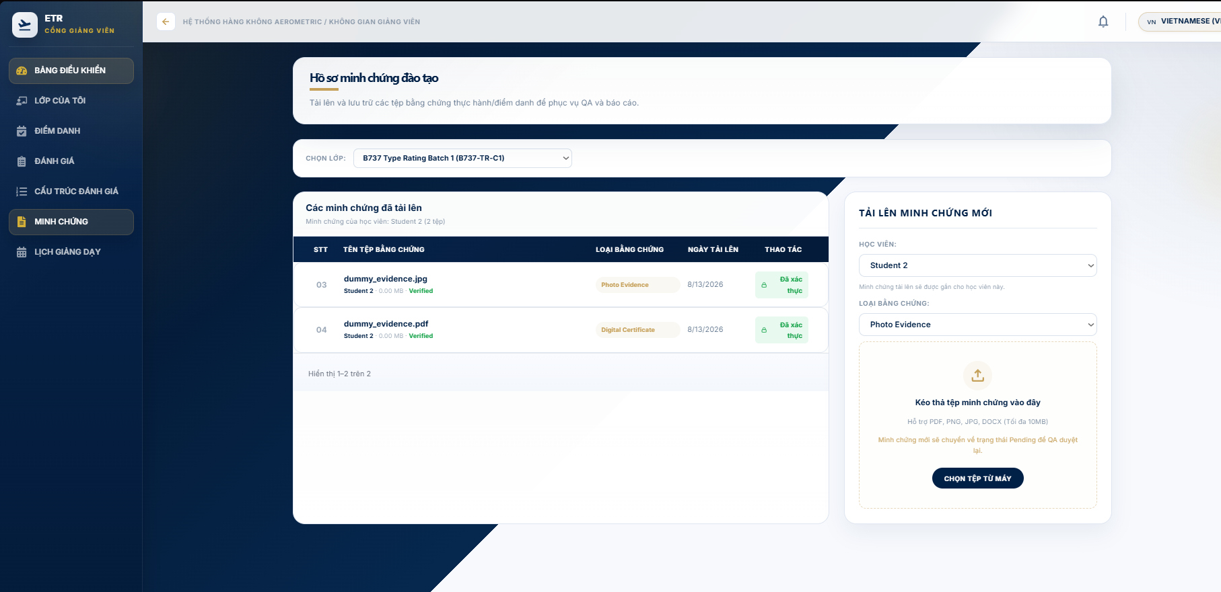

Step 1 - Open MINH CHỨNG (Evidence).

Step 2 - Select the class, learner, and evidence type.

Step 3 - Choose a supported file and upload it. The documented file limit is 10 MB for PDF, PNG, JPG, and DOCX files.

Step 4 - The uploaded file enters Pending status for QA verification.

Evidence that is rejected can be corrected and re-uploaded according to the reason provided by QA. Files already verified are protected from normal deletion

3.5 Workflow 4 — Academic: ETR Management & Submission to QA
Purpose: Let Academic staff monitor every ETR, manage its evidence, check the four-step completeness checklist, and submit verified-ready records to QA.
Completeness Checklist
- Personal info — always verified.
- Attendance — complete when every subject result has attendanceRate >= 80.
- Test results — complete when every assessment and practical checklist result is published.
- Evidence — complete when every evidence file for the ETR is Verified.
ETR management
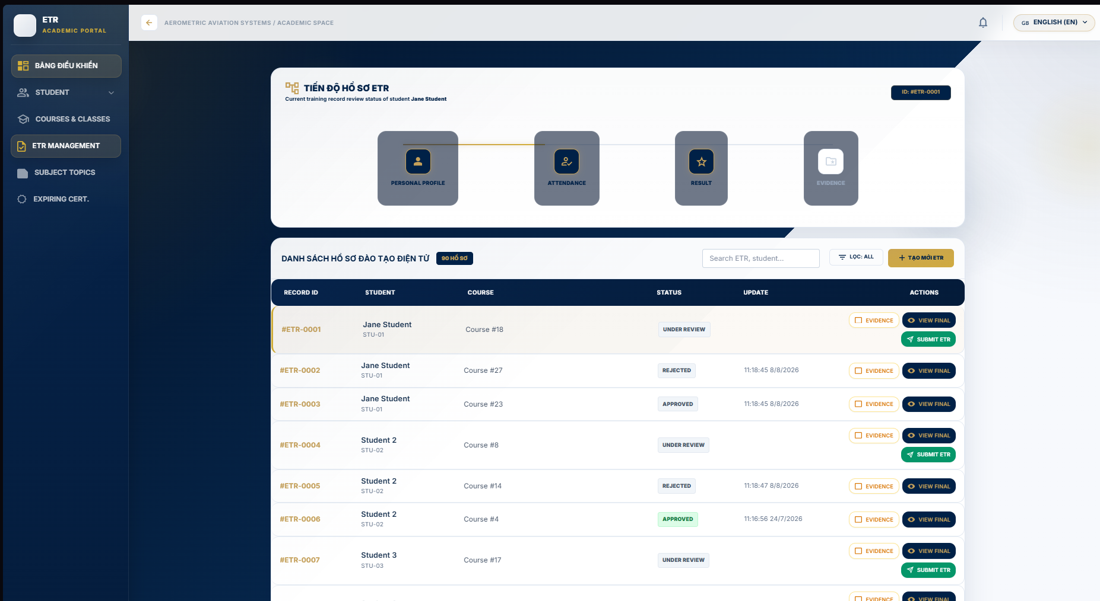
Step 1 - Open QUẢN LÝ ETR (ETR Management).

Step 2 - Search for the learner/ETR and review the progress or completeness indicators.

Step 3 - Open the evidence area to review file status, QA badges, and available actions.

Step 4 - When the completion requirements are satisfied, click SUBMIT ETR.

Step 5 - Use VIEW FINAL when a printable ETR summary is required.

Expected result: the ETR is submitted into the QA review workflow. The audit trail records the submission action with the actor and time.

Audit Trail
- The Audit Trail table at the bottom logs all changes with time, actor, action and content.

3.6 Workflow 5 — QA: Evidence Verification, ETR Review & Returns
Purpose: Give QA staff the tools to validate evidence integrity, review ETR dossiers before acceptance, return incomplete records for correction, and keep an immutable audit trail.
Before You Start

Evidence is reviewed from the pending evidence queue.

ETR review is performed on records that have been submitted to QA

Verifying evidence
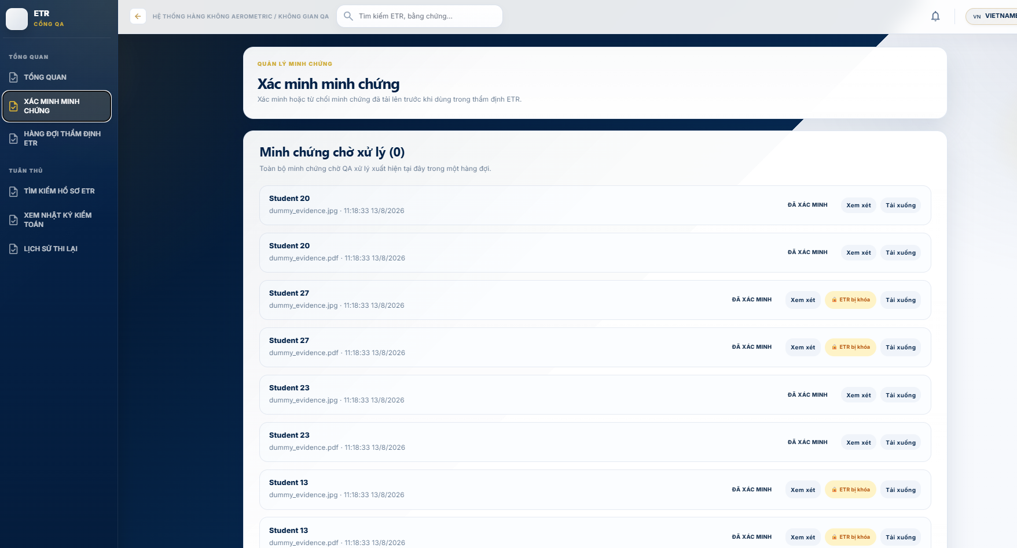
Step 1 - Open VERIFY EVIDENCE.

Step 2 - Review the files shown in Pending Evidence.

Step 3 - Open Review to inspect the evidence.

Step 4 - Click Verify to accept the evidence, or Reject and provide a reason.

Completed or locked ETRs do not expose the normal evidence verification actions

Reviewing ETRs
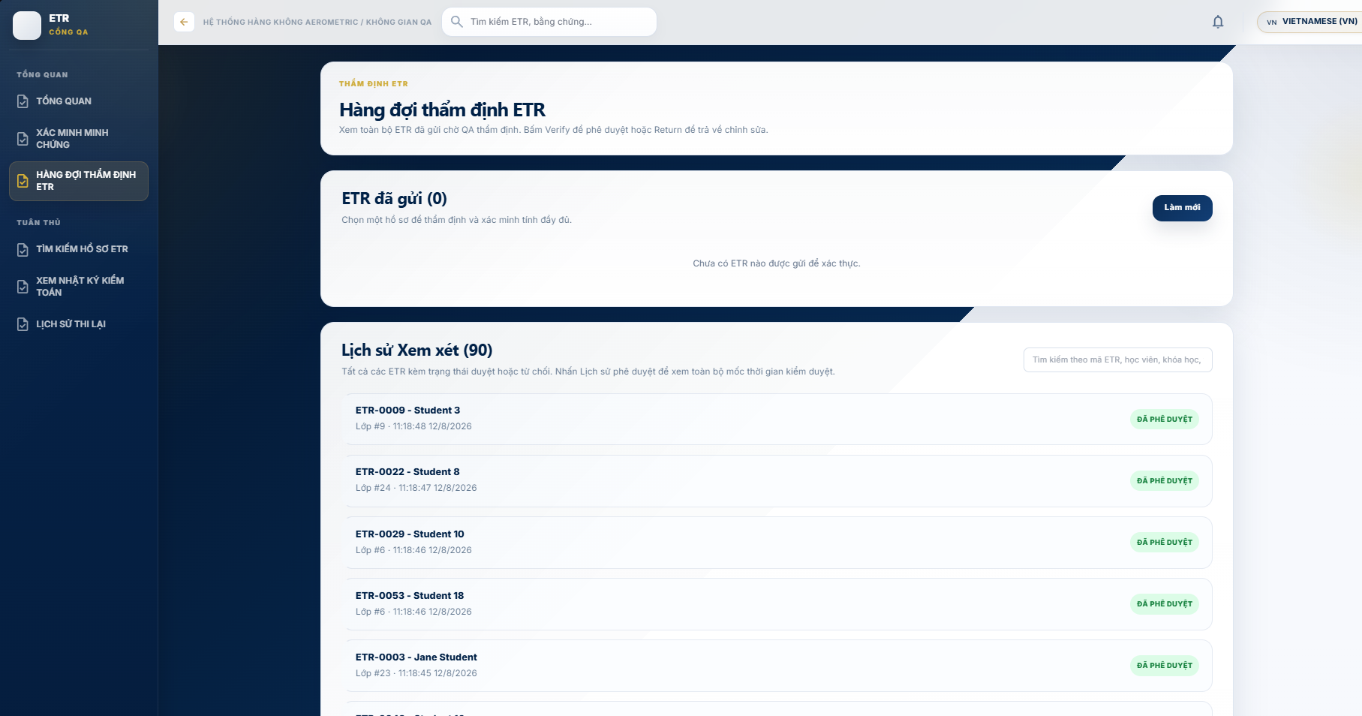
Step 1 - Open ETR REVIEW QUEUE.

Step 2 - Select a submitted ETR and choose View Details.

Step 3 - Review the ETR sheet and approval history.

Step 4 - Click Verify ETR when the record satisfies the QA review criteria.

Returning records
Step 1 - Select the submitted ETR that requires correction.

Step 2 - Choose a common return reason or enter a specific reason.

Step 3 - Click Send Back.

Step 4 - The record returns to the correction workflow for the responsible staff member.

Search, audit trail & retake history
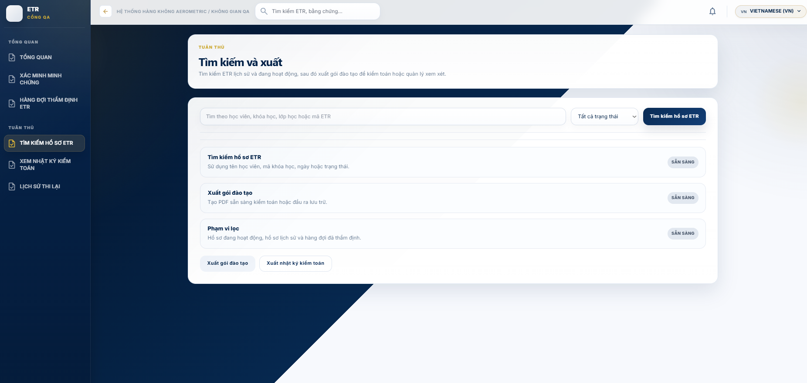 *SEARCH ETR RECORDS provides search and export options for training records.

- VIEW AUDIT TRAIL shows recorded QA actions and their timestamps/actors.

- RETAKE HISTORY shows retake or retest history for the learner and subject.

Expected result: a verified ETR proceeds to the Training Manager approval queue; a returned ETR remains

available for correction and resubmission.

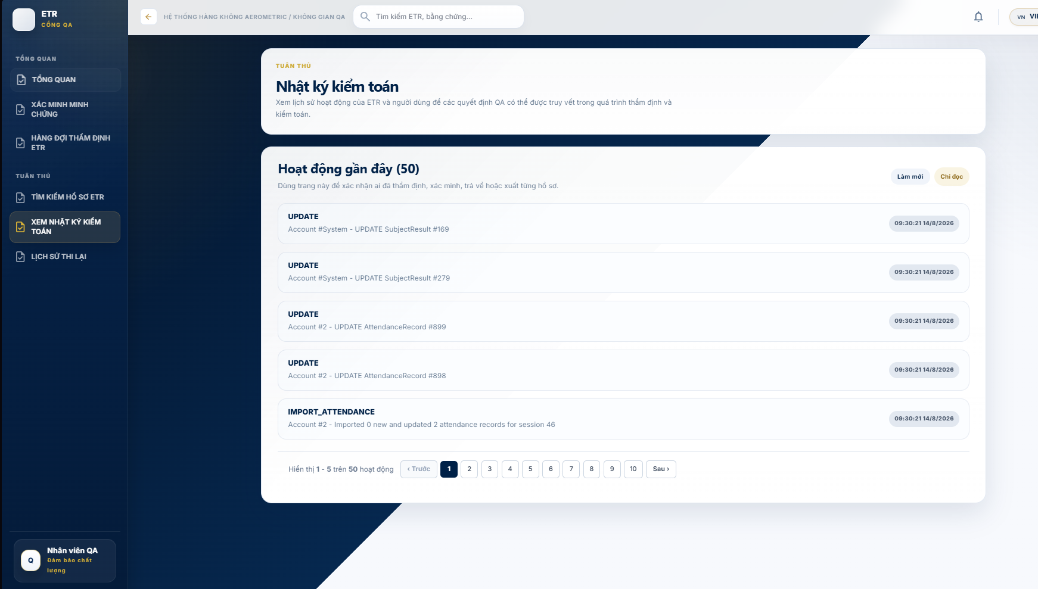
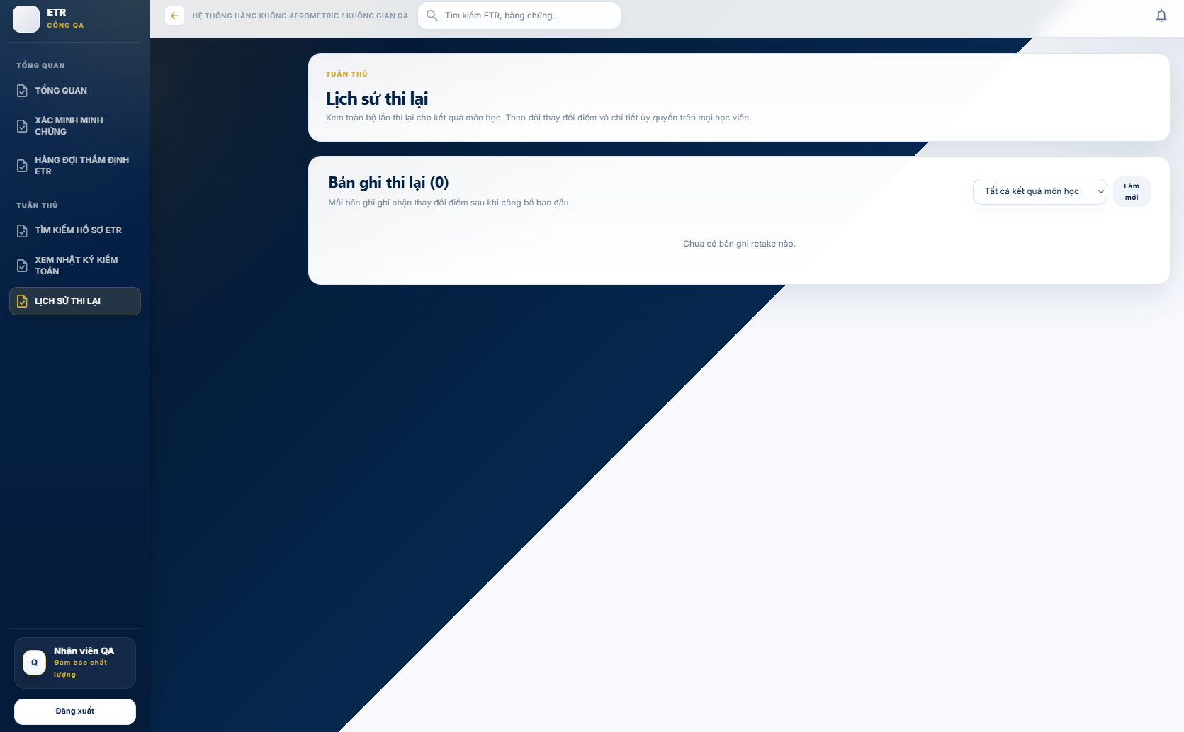.

3.7 Workflow 6 — Training Manager: ETR Final Approval
Purpose: Provide final authority sign-off on QA-verified records. This is the last approval gate before an ETR becomes a permanent, locked certificate record.
Before You Start

The ETR must have passed QA review and be available in the final approval queue.

Analysing the dashboard
- ANALYTICS DASHBOARD shows the ETR approval funnel, completion statistics and expiring-certificate alerts.
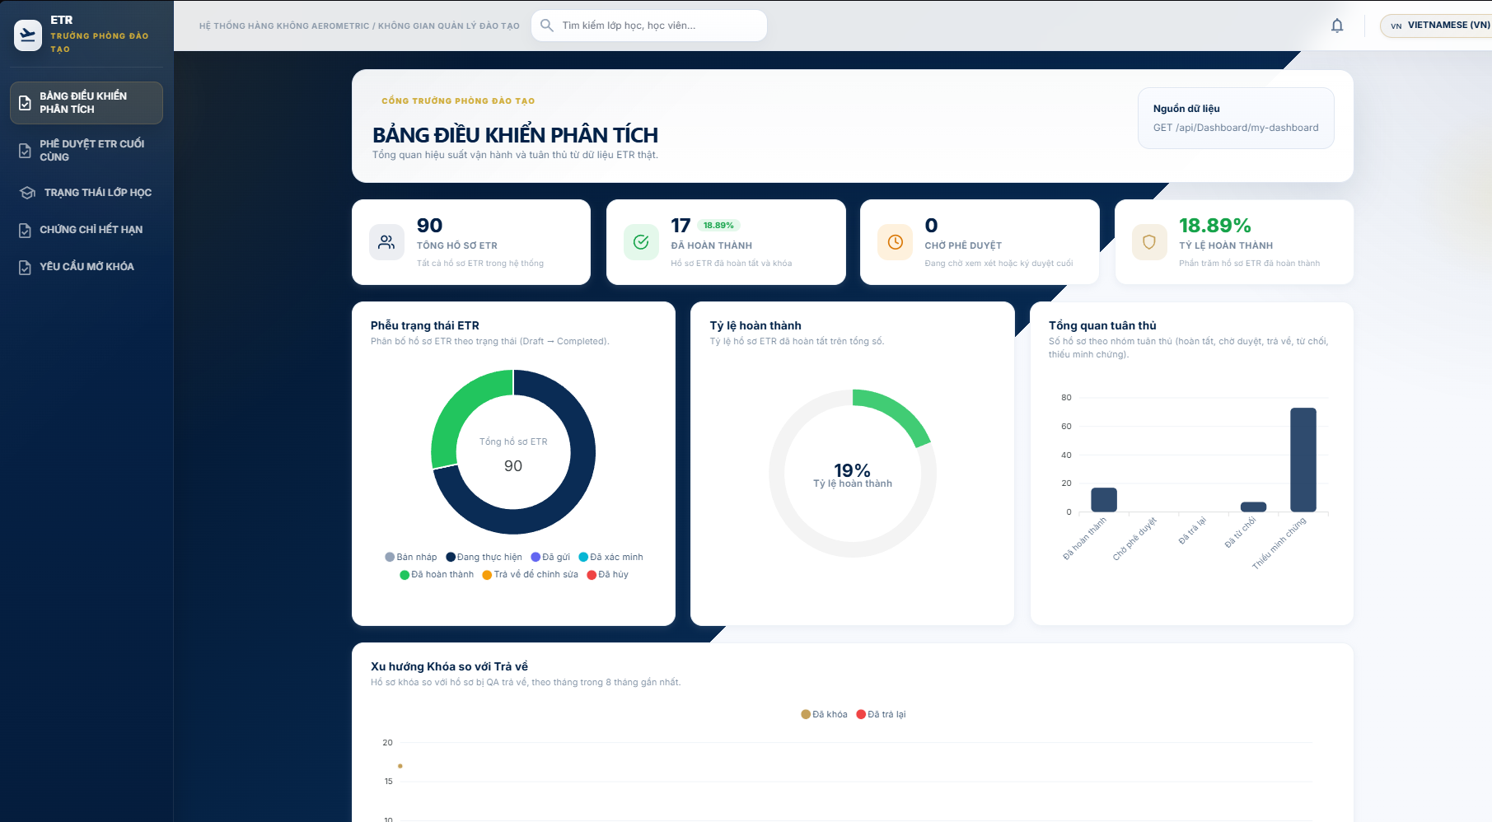
Approving ETRs
- Open ETR FINAL APPROVAL (/trainingmanager/etr-approval). 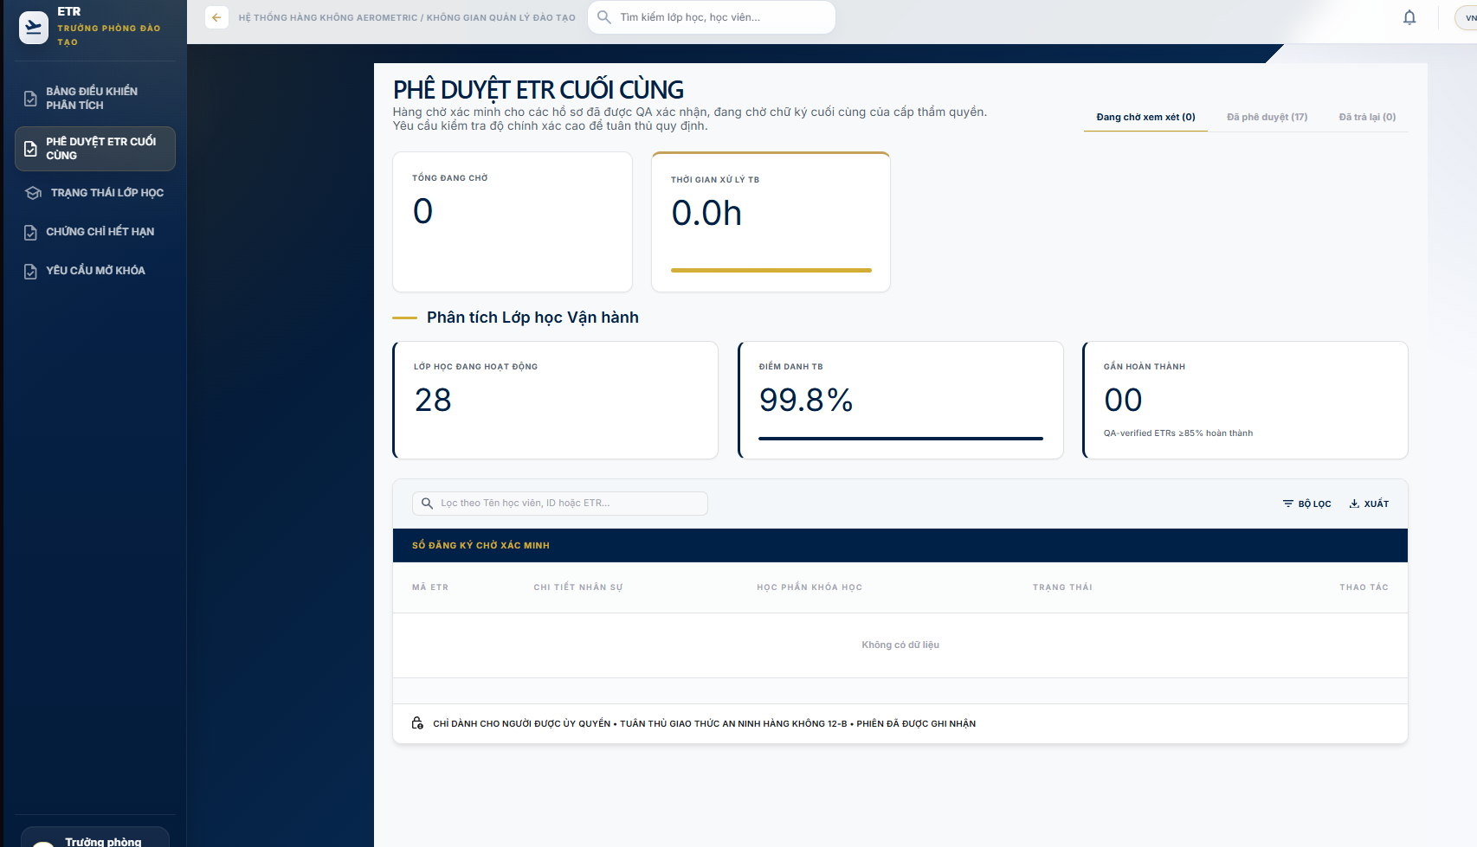
Step 1 - Open ETR FINAL APPROVAL.

Step 2 - Select a record from Pending Review.

Step 3 - Use HISTORY or the details action to inspect the trainee information, assessment results, and QA verification history.

Step 4 - Click APPROVE ETR.

Step 5 - Confirm with Sign off & Approve.

Expected result: the system records the final approval, updates the certificate/approval status, records the action in the audit log, and locks the completed ETR against normal modification.

Reopening a completed record (Admin only)
- In the Approved tab, Admin accounts see REOPEN.
- Enter the reason and confirm. The ETR returns to in-progress.
Class status & expiring certificates
- TRẠNG THÁI LỚP HỌC provides a class progress overview.
- CHỨNG CHỈ HẾT HẠN shows learners whose certificates expire within a window.

3.8 Workflow 7 — Student: View ETR, Certificates & Profile
Purpose: Give learners read-only visibility of their own training records, certificate status and personal profile, including password change.
Overview
- TỔNG QUAN (Dashboard) shows enrolled classes, ETR status summary, certificate expiries and upcoming sessions.
My ETR
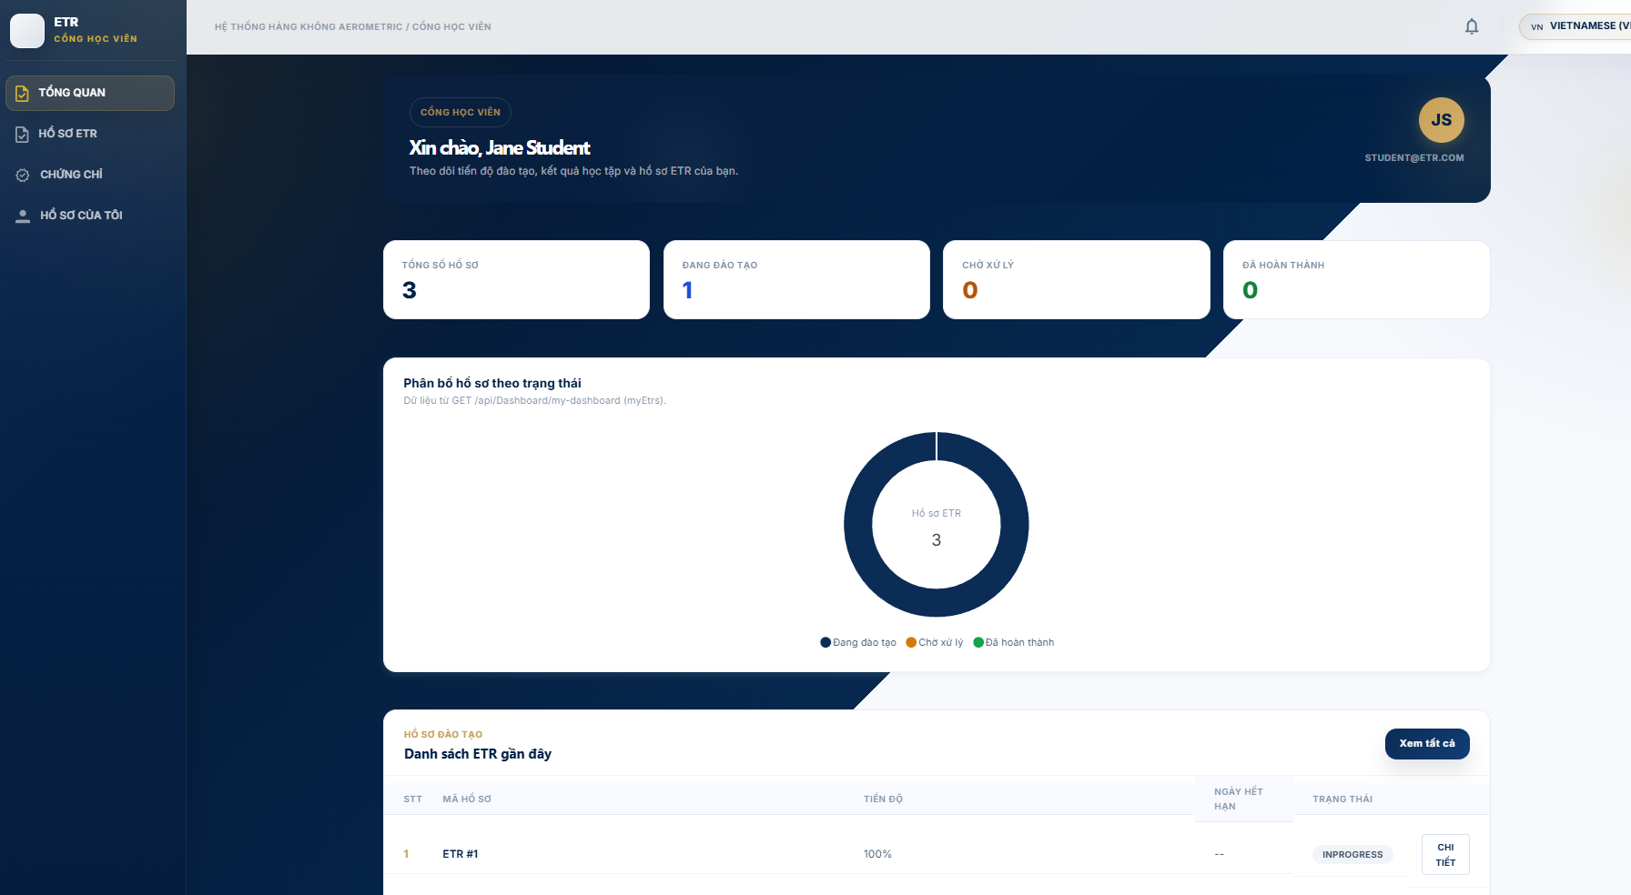
- Open HỒ SƠ ETR (My ETR).
- Use Danh sách ETR and Lịch sử đào tạo tabs.
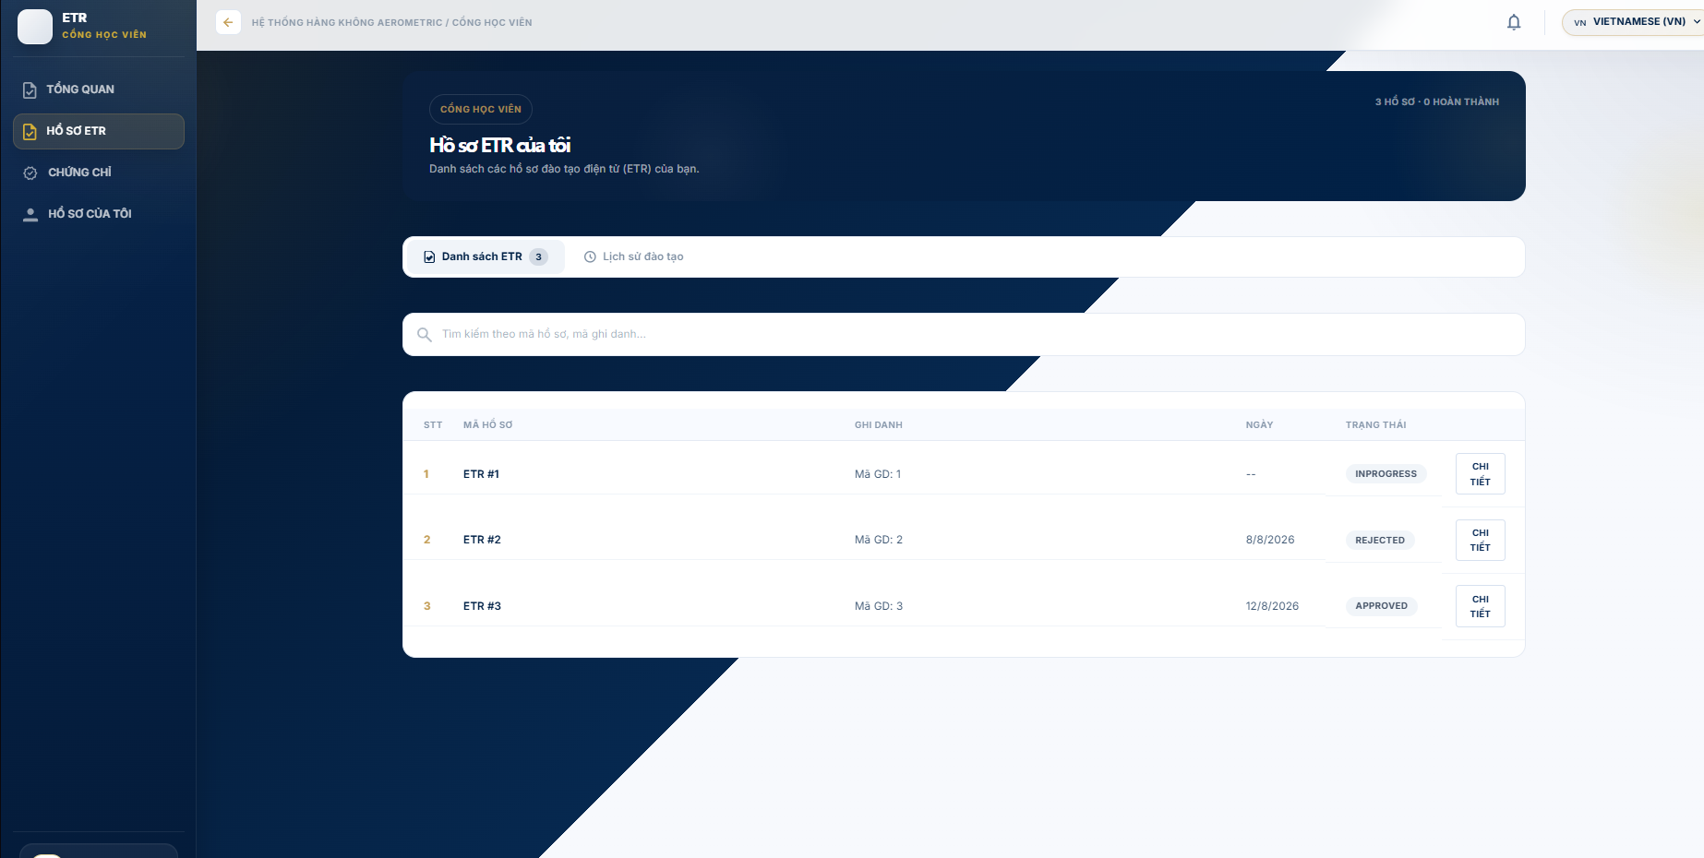
- Open Chi tiết to view record info, subject results, evidence chips and audit trail.
- Completed records are marked completed and permanently locked.
Certificates
- CHỨNG CHỈ (Certificates) lists certificate status with validity/expiry badges and download options.
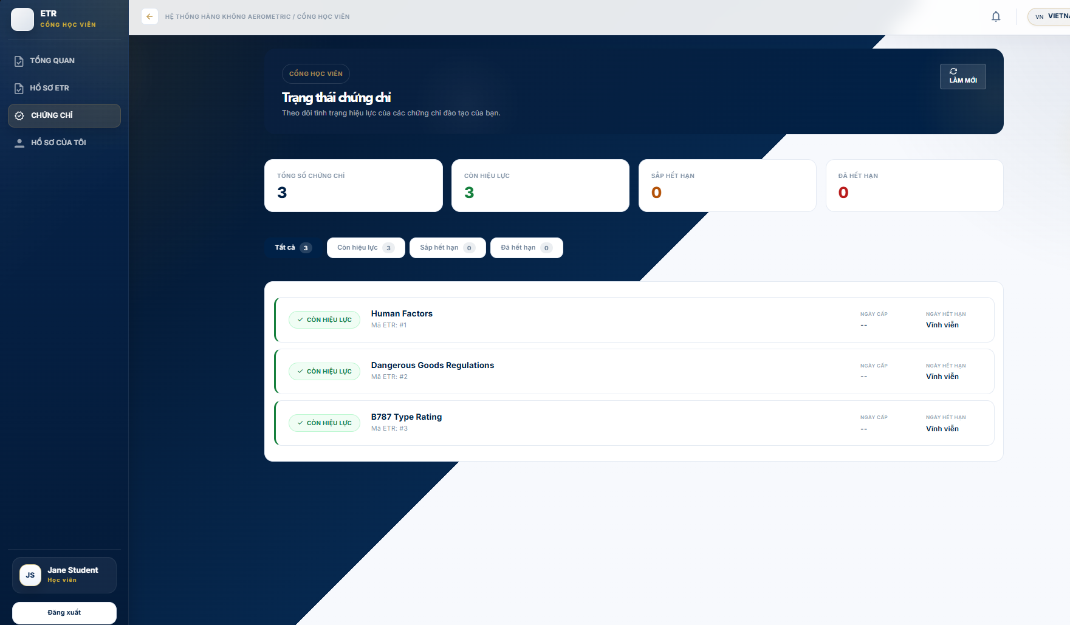
Profile
- HỒ SƠ CỦA TÔI (My Profile) shows learner details and a change-password form.
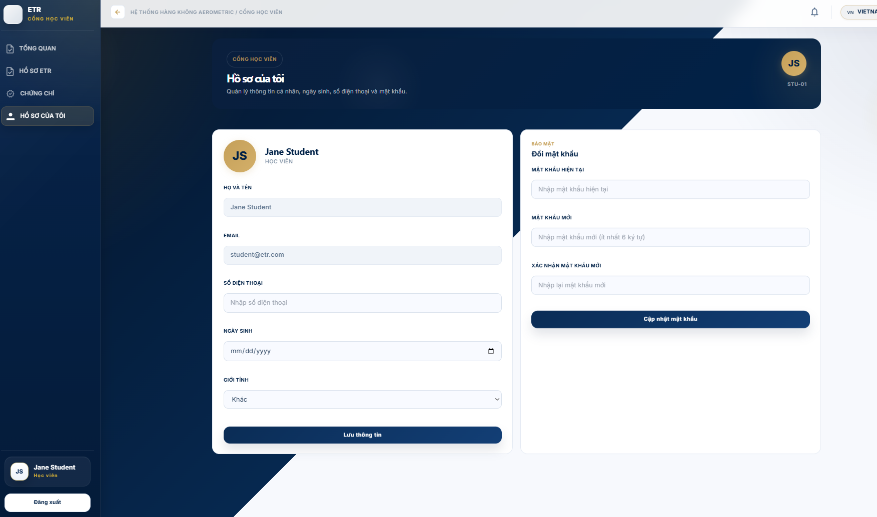

3.9 Workflow 8 — Auditor: Compliance Repository, Search & Export
Purpose: Provide an independent, read-only compliance view for auditors: browse the locked ETR repository, run advanced searches, verify approval chains, inspect audit logs, and export regulatory packages. No write actions are exposed.
Access Restrictions

Auditor functions are read-only. No create, update, delete, verify, approve, or reopen actions are provided.

The repository focuses on completed/locked ETR records and their associated history

Dashboard
- DASHBOARD shows KPIs (total locked records, compliance rate, pending audit, packages exported) plus recently locked records, recent audit events and recent export history.
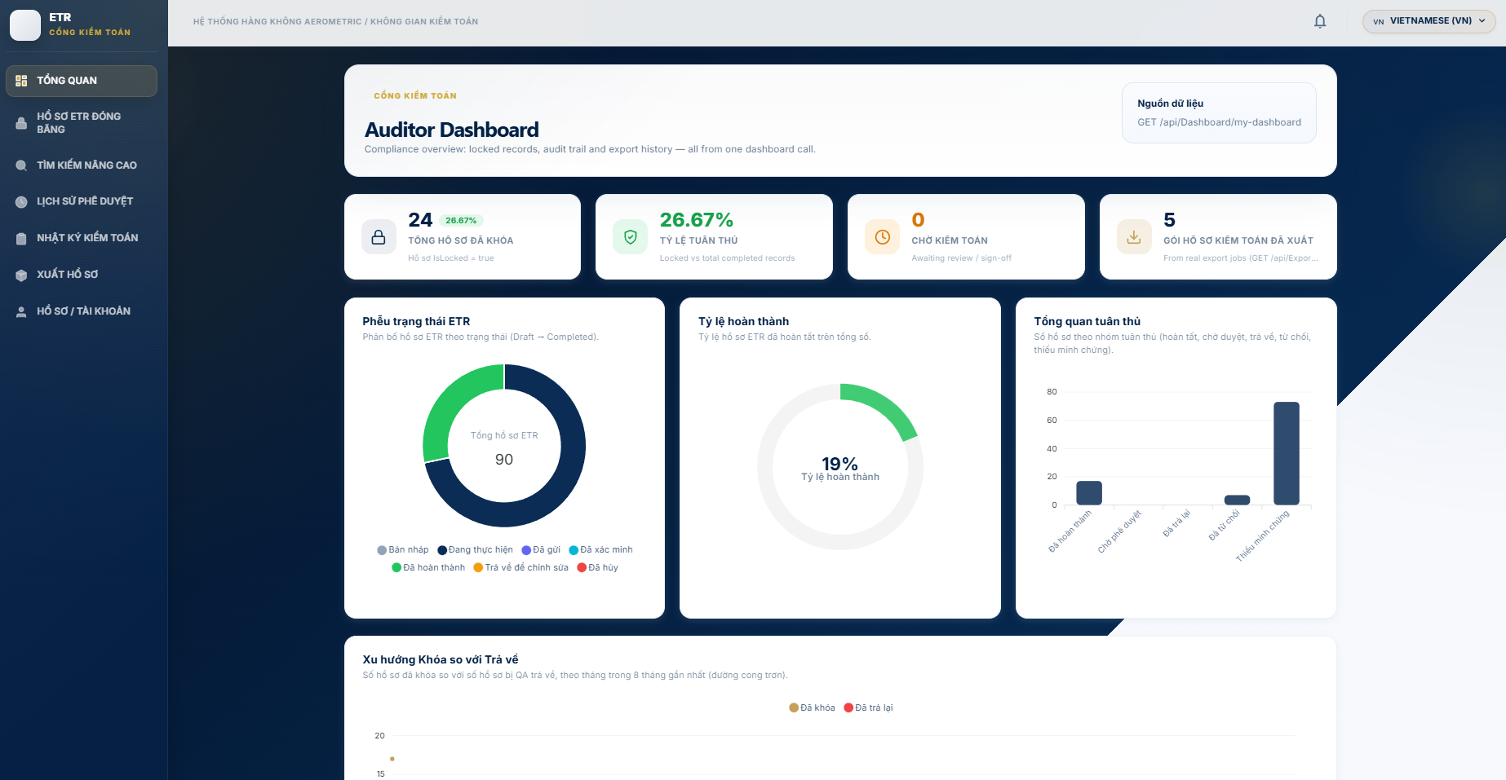
Browsing locked records
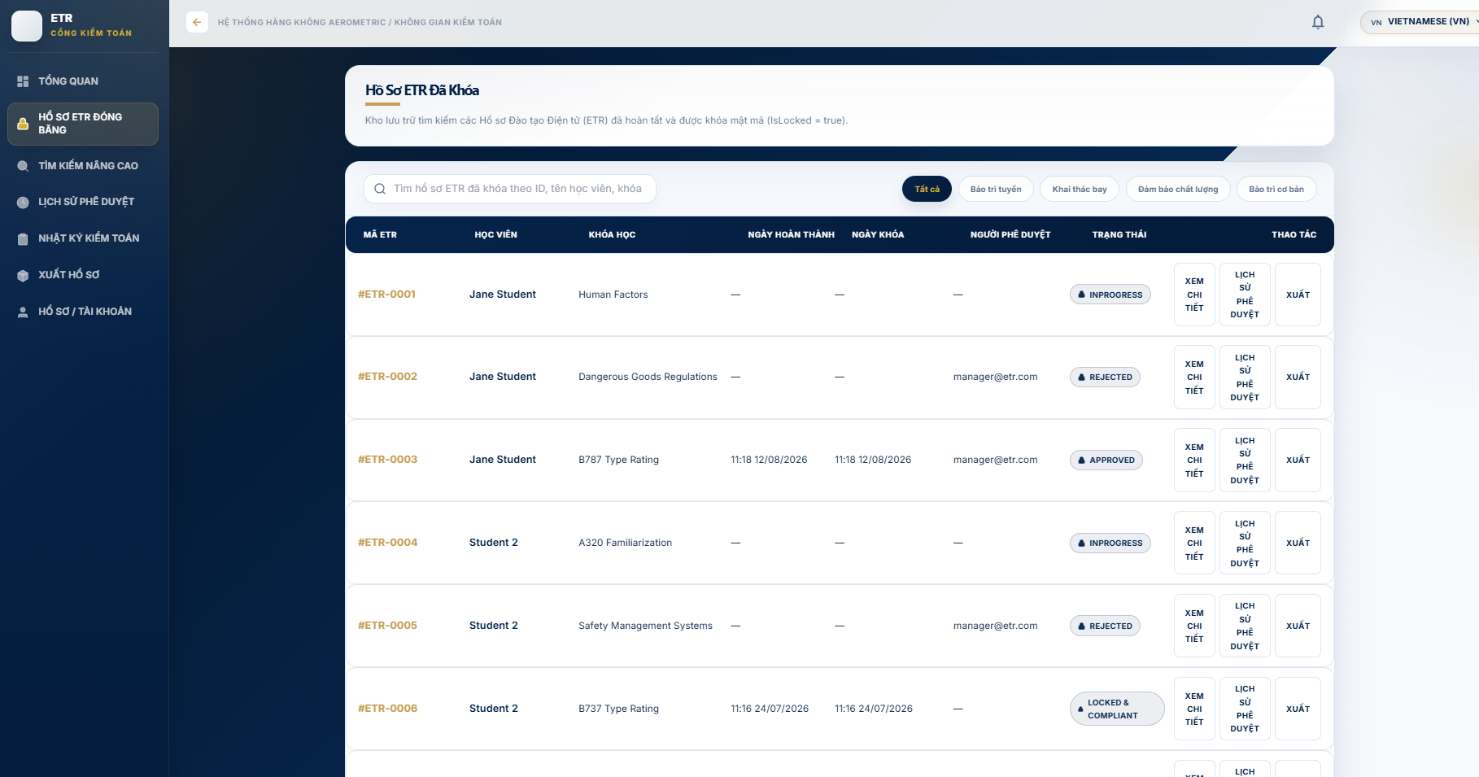
Step 1 - Open LOCKED ETR RECORDS.

Step 2 - Search or filter the available locked records.

Step 3 - Select a record to inspect its details and audit information

Advanced search
- ADVANCED SEARCH combines learner, course, class, ETR ID, completion date, locked date and lock status.
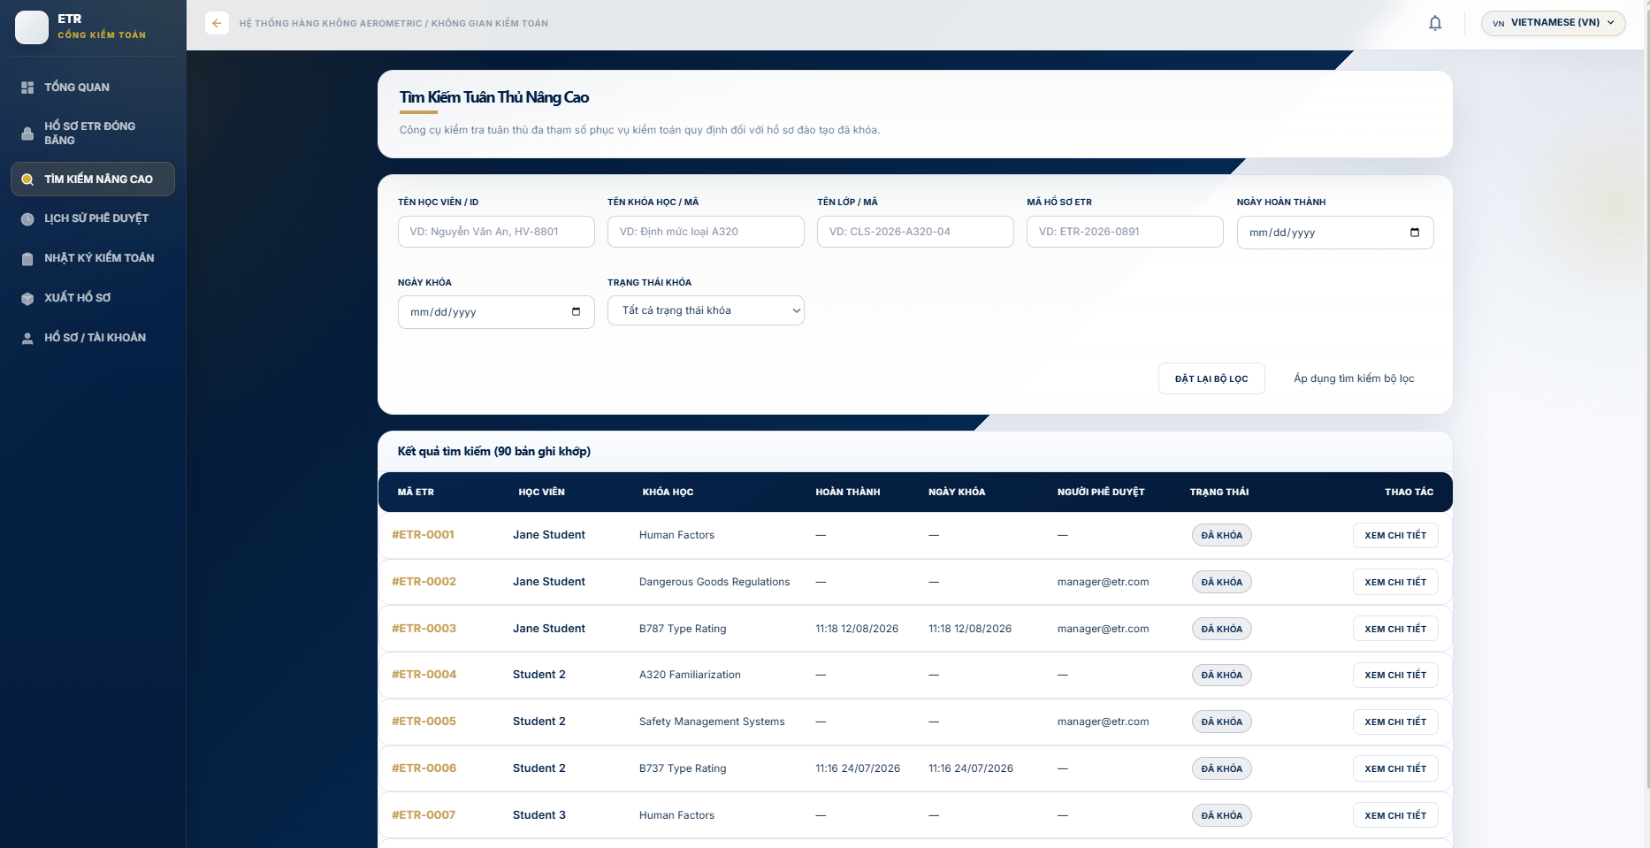
ETR details dossier
- ETR DETAILS presents six tabs: Learner Information, Attendance, Assessment Results, Training Evidence (SHA-256 VERIFIED MATCH), Approval History and Audit Trail. Use Export Dossier PDF for a printable copy.
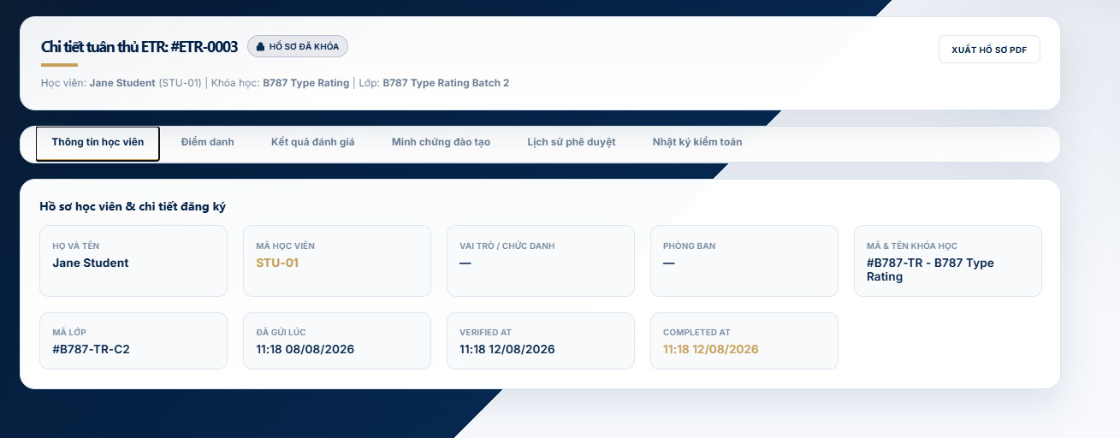
Approval history
- APPROVAL HISTORY shows the five-step approval sequence: Academic → QA → Training Manager → System Locked → Audited, with a detailed execution log timeline.
Audit logs
- AUDIT LOGS is an immutable audit trail with search and module filters. Results flagged FORBIDDEN are highlighted.

Export packages
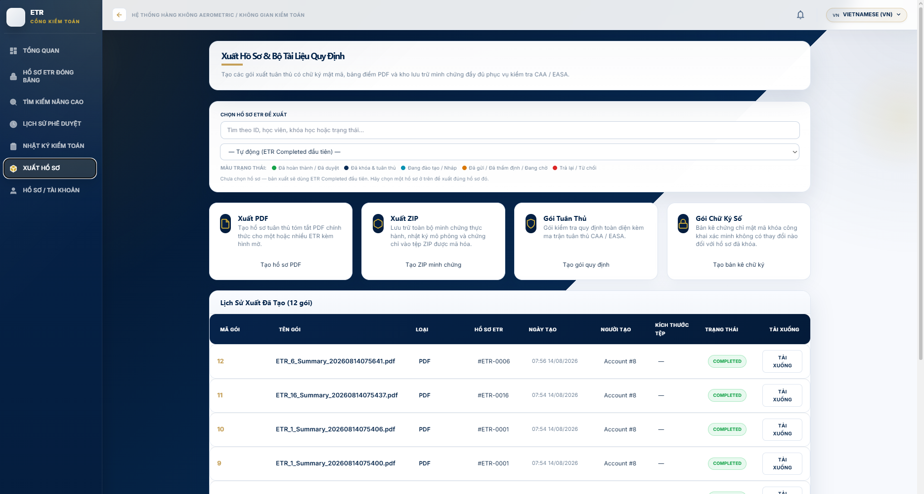
Step 1 - Select the required export type from the available export options.

Step 2 - Generate the export package.

Step 3 - Open export history and download the completed package

Appendix A — API Endpoint Reference (main routes)
Action | Endpoint | Method
Login | /auth/login | POST
Forgot password | /auth/forgot-password | POST
List ETRs | /Etr | GET
ETR detail | /Etr/{id} | GET
Submit ETR to QA | /Etr/{id}/submit | POST
QA verify ETR | /Etr/{id}/verify | POST
QA return ETR | /Etr/{id}/return | POST
Complete ETR (fallback) | /Etr/{id}/complete | POST
Reopen ETR (Admin) | /Etr/{id}/reopen | POST
Student own ETRs | /Etr/my-etr | GET
Student training history | /Etr/student/{accountId}/history | GET
List evidence | /Evidences | GET
Upload evidence | /Evidences/upload | POST
Verify/reject evidence | /Evidences/{id}/verify | PUT
Download evidence | /Evidences/{id}/download | GET
Approval requests | /Approvals | GET
Approve ETR | /Approvals/{approvalRequestId}/process?action=Approve | POST
Audit log | /Audit, /Audit/{id}, /Audit/search?query= | GET
Auditor exports | /Exports/pdf, /Exports/training-package, /Exports/dashboard, /Exports/download/{id} | POST/GET

Appendix B — System Administration (Admin portal)
Page | Description
DASHBOARD | System overview with KPI cards and user/class/ETR tables
USER MANAGEMENT | Create/edit/delete user accounts, assign roles, search
DEPARTMENT MANAGEMENT | Manage departments (e.g., Line Maintenance, Flight Operations, QA, Base Maintenance)
AUDIT LOG | System audit trail of user actions
SYSTEM CONFIG | Global settings: system name, thresholds, exam pass score, ETR validity days, security options

